

GRACO INC. 2025 OVERVIEW AND

ANNUAL REPORT ON FORM 10-K

M O V I N G M A T E R I A L S T H A T M A T T E R ™



T O O UR S HA R EHO L DER S

In reviewing the past year, Graco demonstrated resilience and disciplined execution amid uneven global demand and ongoing macroeconomic uncertainty. While several key end markets remained soft, our diversified portfolio, strong balance sheet and attention to operational excellence supported solid financial performance and progress on our strategic priorities.

At the start of 2025, we launched our One Graco operating model, and I am extremely proud of how quickly the organization has embraced this new structure to strengthen collaboration and improve how we serve our customers. We also made meaningful progress integrating the 2024 acquisition of Corob, our largest in more than a decade, advancing our inorganic growth strategy through the additions of Color Service and Radia to our portfolio. These acquisitions expand our leadership in paint, coatings and powder, broaden our automation and precision dispensing capabilities, and enhance our ability to deliver more comprehensive solutions to customers around the world.

We invested strategically in our global footprint to support long-term growth and strengthen supply chain flexibility. The establishment of our new manufacturing facility in Vietnam enables our Gema powder paint business to produce in the Asia Pacific region for the first time. We also expanded our presence in India, where favorable long-term demand trends support both local market growth and greater regional opportunities. While still early, these initiatives mark a significant milestone and reflect our commitment to developing a more diversified operating model.

Financial discipline remains a cornerstone of our culture and a key driver of long-term shareholder value. Strong operating cash flow in 2025 enabled us to make ongoing investments in innovation, advance the integration of recent acquisitions and enhance our manufacturing capabilities. At the same time, we returned nearly 90% of operating cash flow to shareholders through dividends and record share repurchases. We ended the year with a solid net cash position, underscoring the strength of our balance sheet and our ability to pursue multiple strategic opportunities.

Looking ahead, we are preparing to commemorate Graco’s centennial anniversary in 2026. For 100 years, our success has been grounded in a deep understanding of customer needs and the application of ingenuity to deliver reliable, high-performance solutions. With this deeply rooted foundation, we remain confident in our strategy and are well positioned to create long-term shareholder value.

Thank you for your continued trust and investment in Graco.


MARK W. SHEAHAN

President and CEO



A B O U T G R A C O

Selmer Eull is using a Hydra-Clean to pressure wash Russell Gray’s Cadillac.
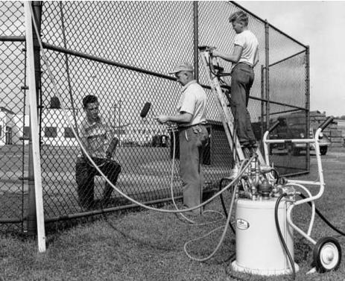

The Paintmaster was introduced in 1948 and was Graco’s first venture into painting equipment.


Two brothers, a garage and a relentless pursuit of an exceptional solution. That spirit has guided Graco for nearly 100 years. From those early beginnings, Graco has grown into a global leader in the design and manufacturing of equipment and systems that move, measure, control, dispense and spray a wide range of materials.

Today, Graco serves customers across industrial, commercial and residential applications around the world. Our solutions support the materials that shape everyday life, from coatings that protect buildings and infrastructure, to adhesives that assemble products, to fluids used in the production of food, vehicles and consumer goods. In demanding environments and critical applications, customers rely on Graco for performance, durability and precision.

At the heart of Graco is a clear focus: moving materials that matter. It reflects both the essential work our customers do and our role in helping them do it safely, eﬃciently and reliably. Our purpose is to provide customers with a legacy of expertise, reliable services and solutions that promote the highest standards of quality and safety, to help move the world forward.

As Graco approaches its centennial in 2026, we celebrate a legacy shaped by generations of employees, customers and partners. For nearly a century, our success has been built on problem-solving, craftsmanship and a deep understanding of customer needs. That foundation continues to guide how we innovate, operate and grow, honoring our history while building for the future.

The Chicago sales oﬃce was opened in 1946.


2 0 2 5 B Y T H E N U M B E R S
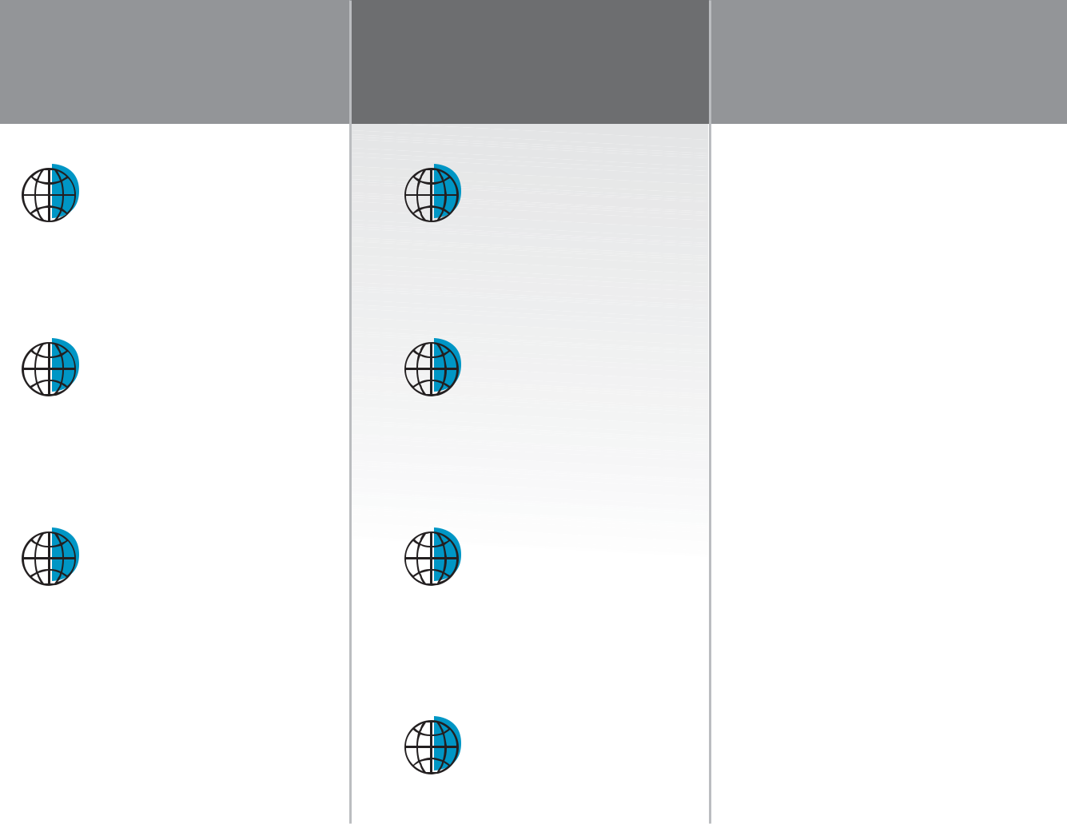

- GLOBAL FOOTPRINT WITH LOCAL IMPACT

SERVED CUSTOMERS

IN MORE THAN

100

COUNTRIES

SUPPORTED BY

30,000+

OUTLETS AND DISTRIBUTORS

OVER

75%

OF PRODUCTION

BASED IN THE U.S.

DELIVERING STRONG FINANCIAL RESULTS

NET SALES OF

$2.2

BILLION

ADJUSTED EARNINGS PER

SHARE OF

$2.95

SHARE REPURCHASES OF

$423

MILLION

DIVIDENDS PAID PER SHARE

INCREASED BY

8%

EMPLOYEES AT THE HEART OF EVERYTHING WE DO

~4,400


TOTAL EMPLOYEES

 ~1,900


EMPLOYEES OUTSIDE

THE U.S.

11

YEARS AVERAGE TENURE

FOR EMPLOYEES

 BY THE NUMBERS


2 0 2 5 NEW P R O DUCT S

Graco’s portfolio supports customers across a wide range of applications, from light duty use to complex, high-volume operations where performance, consistency and reliability are critical. Spanning fluid handling and transfer, spraying and coating, dispensing and mixing and finishing technologies, our solutions are designed to work together and integrate seamlessly into customer operations, including expansion markets that extend Graco’s capabilities in adjacent markets. In 2025, we expanded this customer driven portfolio with new products developed to meet specific application needs and help customers work more efficiently, reliably and safely.
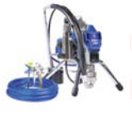

Reactor® 3 Hydraulic
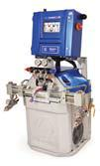

The Reactor 3 Hydraulic is a high-output spray foam and polyurea proportioner built for large projects, delivering sustained pressure and flow with smart drum-to-gun connectivity that ensures ratio consistency and optimized spray performance.

Ultra® 390-450

The Ultra 390–450 are lightweight, professional electric sprayers that deliver high pressure performance, extended pump life and rapid, tool-free serviceability to maximize uptime on residential and light commercial jobs.

ACCU-BEAD™
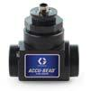

ACCU BEAD flow sensors provide precise, real time measurement of reflective bead flow at each gun, helping operators achieve target application rates while reducing waste and ensuring specification compliance.

King® E-Max XT™
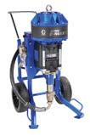

The King E-Max XT is a high-power electric airless sprayer that delivers pneumatic-level performance without compressors or fuel, supporting large-scale protective coatings and roofing applications with quiet, emission-free operation.

EFP-350 XT™
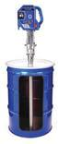

The EFP-350 XT is a fully electric transfer pump for high viscosity protective coatings that delivers consistent material flow on 120V or 230V power without the need for compressed air.


King® PC
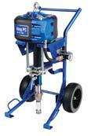

The King PC is a next generation air powered airless sprayer engineered for high pressure protective coatings, combining proven durability with a lighter frame, and quick pump swaps to minimize downtime.

Stellair™ ACE Gravity Gun
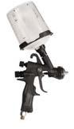

The Stellair ACE Gravity Gun is a lightweight, gravity-fed spray gun designed for small-batch coating, touch-up work and material testing that delivers high-quality finishes with minimal material use.

ProMix® V
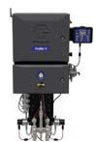

The ProMix V is a plural-component paint mixing system that delivers on-demand mixing, rapid color changeovers and real-time process data with accuracy within 1% to reduce waste and improve productivity.

E-Flo DCi™ Advanced

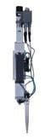

The E-Flo DCi Advanced is a compact, electric-driven paint supply and circulation pump that provides flexible flow and pressure control, PLC connectivity and data access while reducing energy use and maintenance.

G3® High Flow
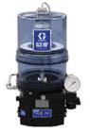

The G3 High Flow pump is a
next-generation automatic
lubrication solution built for
off-road and construction
equipment, delivering higher

flow rates with rugged durability,
enhanced safety and simplified
connectivity.

PSM Gen II

The PSM Gen II precision shot meter is designed for automated dispensing of single-component materials, delivering accurate, repeatable dosing through a robust construction and optimized fluid path.

GEM® PRO


The GEM PRO is the first in QED’s new PRO series and a modular landfill gas analyzer that allows operators to configure and maintain sensors in the field, enabling fast, flexible and downtime-free gas analysis without factory servicing.

Vertical Module ZA17
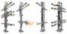

The ZA17 vertical module is a modular platform designed for precise spray gun positioning in compact spaces, enabling highly automated coating of complex geometries when combined with stationary and gun axes.

OptiFilter OFM02
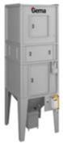

The OptiFilter OFM02 is a multi color overspray recovery system that ensures optimal coating conditions in the booth through robust jet pulse cleaning technology and a maintenance friendly filter cartridge design.

Weighing System for OptiCenter® All in One and OptiCenter® Series
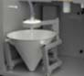
This optional weighing system measures real time powder consumption in OptiCenter® powder management centers, enabling batch level tracking and monitoring through the MagicControl 4.0 system control and GemaConnect® Dashboard.

G L O B A L F O O T P R I N T

Graco’s global footprint reflects how closely we work with customers around the world to support their diverse applications and industries. Through a network of manufacturing, sales and service locations, and the expertise of roughly 4,400 employees worldwide, we deliver products and solutions that help customers operate with greater efficiency, precision and reliability. Serving customers in more than 100 countries, our worldwide presence enables us to respond to local needs while delivering consistent performance and dependable results wherever our customers do business.
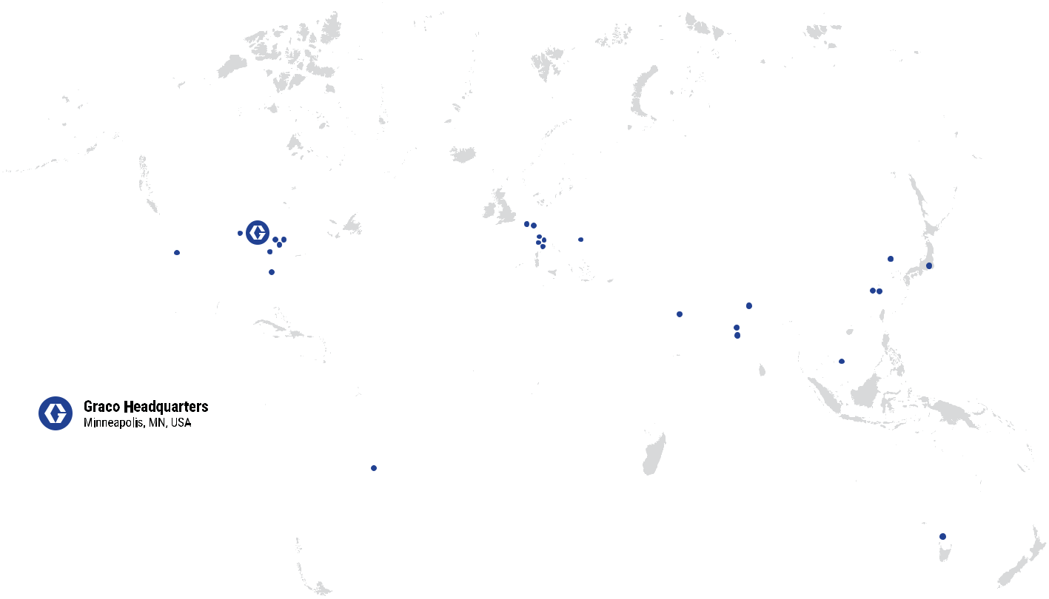

M O V I N G M A T E R I A L S T H A T M A T T E R ™

10 YEAR FINANCIAL SUMMARY

Graco Inc. & Subsidiaries

(in thousands, except per share amounts and other statistics)

Operations | 2025 | 2024 | 2023 | 2022 | 2021 | 2020 (1) | 2019 | 2018 | 2017 | 2016(2)
Net Sales | $2,236,604 | $2,113,316 | $2,195,606 | $2,143,521 | $1,987,608 | $1,650,115 | $1,646,045 | $1,653,292 | $1,474,744 | $1,329,293
Gross Profit | 1,173,183 | 1,122,461 | 1,161,021 | 1,057,439 | 1,033,949 | 854,937 | 859,756 | 882,539 | 795,202 | 710,869
Percent of Sales | 52.5% | 53.1% | 52.9% | 49.3% | 52.0% | 51.8% | 52.2% | 53.4% | 53.9% | 53.5%
Operating Earnings | 624,797 | 570,098 | 646,843 | 572,700 | 531,323 | 391,718 | 424,456 | 436,427 | 378,745 | 121,144
Percent of Sales | 27.9% | 27.0% | 29.5% | 26.7% | 26.7% | 23.7% | 25.8% | 26.4% | 25.7% | 9.1%
Net Earnings | 521,839 | 486,084 | 506,511 | 460,645 | 439,866 | 330,456 | 343,853 | 341,054 | 252,412 | 40,674
Percent of Sales | 23.3% | 23.0% | 23.1% | 21.5% | 22.1% | 20.0% | 20.9% | 20.6% | 17.1% | 3.1%
Net Earnings, Adjusted(3) | 498,818 | 477,085 | 523,885 | 455,554 | 425,653 | 335,179 | 325,385 | 326,075 | 249,472 | 202,132
Percent of Sales, Adjusted(3) | 22.3% | 22.6% | 23.9% | 21.3% | 21.4% | 20.3% | 19.8% | 19.7% | 16.9% | 15.2%
Financial Position
Current Assets | $1,471,881 | $1,497,441 | $1,365,809 | $1,205,620 | $1,363,621 | $1,023,801 | $791,468 | $723,216 | $643,338 | $503,362
Current Liabilities | 467,261 | 405,808 | 395,200 | 399,917 | 506,792 | 321,389 | 285,322 | 299,803 | 245,838 | 177,985
Working Capital | 1,004,620 | 1,091,633 | 970,609 | 805,703 | 856,829 | 702,412 | 506,146 | 423,413 | 397,500 | 325,377
Property, Plant & Equipment, Net | 755,064 | 771,656 | 741,713 | 607,609 | 451,061 | 350,750 | 325,546 | 229,295 | 204,298 | 189,596
Total Assets | 3,274,270 | 3,139,212 | 2,722,007 | 2,438,900 | 2,443,198 | 1,988,128 | 1,692,210 | 1,472,741 | 1,390,617 | 1,243,109
Long-term Debt (including current portion) | 1,624 | - | - | 75,000 | 150,000 | 150,000 | 164,298 | 266,391 | 226,035 | 305,685
Shareholders' Equity | 2,653,931 | 2,584,135 | 2,224,225 | 1,859,652 | 1,709,343 | 1,283,904 | 1,024,931 | 751,873 | 723,063 | 573,820
Capital (long-term debt plus shareholders' equity) | 2,655,555 | 2,584,135 | 2,224,225 | 1,934,652 | 1,859,343 | 1,433,904 | 1,189,229 | 1,018,264 | 949,098 | 879,505
Cash Provided (Used) By
Operations | $683,591 | $621,700 | $651,017 | $377,394 | $456,896 | $394,035 | $418,734 | $367,985 | $337,864 | $276,006
Investing, excluding marketable securities | (172,796) | (342,815) | (185,274) | (226,819) | (153,299) | (99,038) | (155,469) | (66,247) | (68,447) | (91,223)
Financing | (576,055) | (139,863) | (268,010) | (434,403) | (57,142) | (139,471) | (174,052) | (282,711) | (217,076) | (185,165)
Other Data
Depreciation and Amortization | $107,433 | $86,749 | $74,321 | $65,997 | $59,325 | $55,329 | $48,911 | $47,754 | $45,583 | $48,290
Property, Plant and Equipment Additions | 45,669 | 106,737 | 184,775 | 201,161 | 133,566 | 71,338 | 127,953 | 53,854 | 40,194 | 42,113
Per Common Share(4)
Basic Net Earnings | $3.14 | $2.88 | $3.01 | $2.73 | $2.59 | $1.97 | $2.06 | $2.04 | $1.50 | $0.24
Diluted Net Earnings | 3.08 | 2.82 | 2.94 | 2.66 | 2.52 | 1.92 | 2.00 | 1.97 | 1.45 | 0.24
Diluted Net Earnings, Adjusted(3) | 2.95 | 2.77 | 3.04 | 2.63 | 2.44 | 1.95 | 1.90 | 1.88 | 1.43 | 1.18
Dividends Paid | 1.10 | 1.02 | 0.94 | 0.84 | 0.75 | 0.70 | 0.64 | 0.53 | 0.48 | 0.44
Shareholders' Equity | 16.07 | 15.26 | 13.24 | 11.09 | 10.04 | 7.62 | 6.13 | 4.55 | 4.27 | 3.43
Other Statistics:
Sales Growth | 5.8 % | (3.7)% | 2.4 % | 7.8 % | 20.5 % | 0.2 % | (0.4)% | 12.1 % | 10.9 % | 3.3 %
Return on Average Shareholders' Equity | 19.9 % | 20.2 % | 24.8 % | 25.8 % | 29.4 % | 28.6 % | 38.7 % | 46.2 % | 38.9 % | 6.7 %
Return on Average Capital | 19.9 % | 20.2 % | 24.4 % | 24.3 % | 26.7 % | 25.2 % | 31.2 % | 34.7 % | 27.6 % | 4.3 %
Long-term Debt/Capital | 0.1 % | 0.0 % | 0.0 % | 3.9 % | 8.1 % | 10.5 % | 13.8 % | 26.2 % | 23.8 % | 34.8 %
Current Ratio | 3.2 | 3.7 | 3.5 | 3.0 | 2.7 | 3.2 | 2.8 | 2.4 | 2.6 | 2.8

- Operating results in 2020 included impairment charges related to the sale of the Company's U.K.- based valves business that reduced operating earnings by $35 million and net earnings by $34 million ($0.20 per diluted share).

- Operating results in 2016 included intangible asset impairment charges that reduced operating earnings by $192 million and net earnings by $161 million ($0.95 per diluted share).

- Adjusted amounts in 2025 exclude impacts of contingent consideration fair value adjustments, non-recurring income tax adjustments and excess tax benefits from option exercises. Adjusted amounts in 2024 exclude impacts of business reorganization charges and excess tax benefits from option exercises.
Adjusted amounts in 2023 exclude impacts of pension settlement loss, contingent consideration adjustment, impairment, excess tax benefits from option exercises, and non-recurring income tax benefits. Adjusted amounts in 2022 exclude impacts of excess tax benefits from option exercises.
Adjusted amounts in 2020, 2019 and 2018 exclude impacts of non-recurring income tax adjustments and excess tax benefits from option exercises.

Adjusted amounts in 2021 and 2017 exclude impacts of non-recurring income tax adjustments, excess tax benefits from option exercises and pension restructuring. Adjusted amounts exclude the effects of impairment charges in 2016. See (2) above.
- Per share data reflects three-for-one stock split distributed on December 27, 2017.

BOARD OF DIRECTORS

J. Kevin Gilligan
Chairman of the Board,
Graco Inc.,
Retired Chairman and
Chief Executive Oﬃcer,

Capella Education Company

Heather L. Anfang
President of Dairy Foods,
Executive Vice President,
Land O’Lakes, Inc.

Archie C. Black
Retired Chief Executive Oﬃcer, SPS Commerce, Inc.

Eric P. Etchart
Retired Senior Vice President, The Manitowoc Company, Inc.

Jody H. Feragen
Retired Executive Vice President
and Chief Financial Oﬃcer,
Hormel Foods Corporation

Martha A. Morfitt
President and
Chief Executive Oﬃcer,
River Rock Partners, Inc.

Andrea H. Simon
Executive Vice President and
Chief Financial Oﬃcer,
MasterBrand, Inc.

Mark W. Sheahan
President and
Chief Executive Oﬃcer,
Graco Inc.

Kevin J. Wheeler
Executive Chairman,

A. O. Smith Corporation

EXECUTIVE OFFICERS

Mark W. Sheahan | Claudio Merengo
President and | President,
Chief Executive Oﬃcer | Global Powder Division
Ronita Banerjee | Peter J. O’Shea
Executive Vice President and | President,
Chief Human Resources Oﬃcer | Global Industrial Division
Laura L. Evanson | Kathryn L. Schoenrock
Laura L. Evanson | Executive Vice President and Chief
Executive Vice President | Executive Vice President and Chief
Executive Vice President | Information Oﬃcer
and Chief Marketing Oﬃcer | Information Oﬃcer
and Chief Marketing Oﬃcer | David J. Thompson
Inge Grasdal | David J. Thompson
Inge Grasdal | President,
Executive Vice President, | President,
Executive Vice President, | Global Contractor Division
Corporate Development | Global Contractor Division
Corporate Development | Timothy R. White
Joseph J. Humke | Timothy R. White
Joseph J. Humke | President,
Executive Vice President, | President,
Executive Vice President, | Expansion Markets Division
General Counsel and | Expansion Markets Division
Corporate Secretary | Angela F. Wordell
Christopher D. Knutson | Executive Vice President and Chief
Christopher D. Knutson | Operations and Supply Chain Oﬃcer
Vice President, Controller and | Operations and Supply Chain Oﬃcer
Chief Accounting Oﬃcer
David M. Lowe
Chief Financial Oﬃcer and Treasurer

ANNUAL MEETING

This year’s Annual Meeting of Shareholders will be a virtual meeting. The meeting will commence at 1:00 p.m. Central Time on April 24, 2026. Shareholders can vote their shares electronically and submit questions for management during the meeting by visiting virtualshareholdermeeting.com/GGG2026. Please use the 16-digit control number printed on your Notice Regarding the Availability of Proxy materials to join the annual meeting.

CORPORATE INQUIRIES

Investors may obtain the Graco Inc. 2025 Annual Report on Form 10-K, quarterly reports on Form 10-Q, current reports on Form 8-K and other reports and amendments to the reports at graco.com. Requests for financial publications can also be addressed to:

Graco Inc.

Attention: Investor Relations
P.O. Box 1441
Minneapolis, Minnesota 55440-1441
USA

Or call: 612-623-6770

Graco is an equal opportunity employer.

UNITED STATES

SECURITIES AND EXCHANGE COMMISSION

WASHINGTON, D.C. 20549

FORM 10-K

  - Annual Report Pursuant to Section 13 or 15(d) of the Securities Exchange Act of 1934 for the fiscal year ended December 26, 2025, or

- Transition report pursuant to Section 13 or 15(d) of the Securities Exchange Act of 1934

for the transition period from to .

Commission File No. 001-09249

Graco Inc.

(Exact name of Registrant as specified in its charter)

Minnesota |  |  | 41-0285640
(State or other jurisdiction of incorporation or organization) |  |  |  | (I.R.S. Employer Identification No.)
88 - 11th Avenue N.E.
Minneapolis, Minnesota |  |  |  | 55413
(Address of principal executive offices) |  |  |  | (Zip Code)
 | (612) |  | 623-6000

(Registrant’s telephone number, including area code)

Securities registered pursuant to Section 12(b) of the Act:

Title of each class | Trading Symbol(s) | Name of each exchange on which registered
Common Stock, par value $1.00 per share | GGG | The New York Stock Exchange
Securities registered pursuant to Section 12(g) of the Act: None
Indicate by check mark if the registrant is a well-known seasoned issuer, as defined in Rule 405 of the Securities Act. ց Yes |  |  | տ
No
Indicate by check mark if the registrant is not required to file reports pursuant to Section 13 or Section 15(d) of the Act. տ Yes |  |  | ց
No

Indicate by check mark whether the registrant (1) has filed all reports required to be filed by Section 13 or 15(d) of the Securities Exchange Act of 1934 during the preceding 12 months (or for such shorter period that the registrant was required to file such reports), and (2) has been subject to such filing requirements for the past 90 days. ց Yes տ No

Indicate by check mark whether the registrant has submitted electronically every Interactive Data file required to be submitted pursuant to Rule 405 of Regulation S-T during the preceding 12 months (or for such shorter period that the registrant was required to submit such files). ց Yes տ No

Indicate by check mark whether the registrant is a large accelerated filer, an accelerated filer, a non-accelerated filer, a smaller reporting company, or an emerging growth company. See the definitions of “large accelerated filer,” “accelerated filer,” “smaller reporting company,” and “emerging growth company” in Rule 12b-2 of the Exchange Act:

Large accelerated filer Emerging growth company

ց

տ

Accelerated filer

տ

Non-accelerated filer

տ

Smaller reporting company

տ

If an emerging growth company, indicate by check mark if the registrant has elected not to use the extended transition period for complying with any new or revised financial accounting standards provided pursuant to Section 13(a) of the Exchange Act. տ

Indicate by check mark whether the registrant has filed a report on and attestation to its management’s assessment of the effectiveness of its internal control over financial reporting under Section 404(b) of the Sarbanes-Oxley Act (15 U.S.C. 7262(b)) by the registered public accounting firm that prepared or issued its audit report. ց

If securities are registered pursuant to Section 12(b) of the Act, indicate by check mark whether the financial statements of the registrant included in the filing reflect the correction of an error to previously issued financial statements. տ
Indicate by check mark whether any of those error corrections are restatements that required a recovery analysis of incentive-based compensation received by any of the registrant’s executive officers during the relevant recovery period pursuant

to §240.10D-1(b). տ

Indicate by check mark whether the registrant is a shell company (as defined by Rule 12b-2 of the Act). տ Yes ց No

The aggregate market value of 165,623,923 shares of common stock held by non-affiliates of the registrant was $14,268,500,967 as of June 27, 2025.

165,338,302 shares of common stock were outstanding as of January 23, 2026.

DOCUMENTS INCORPORATED BY REFERENCE

Portions of the Company’s definitive Proxy Statement for its Annual Meeting of Shareholders to be held on April 24, 2026, are incorporated by reference into Part III of this 2025 Annual Report on Form 10-K (this “Form 10-K”), as specifically set forth in said Part III of this Form 10-K.

 | TABLE OF CONTENTS
 |  | Page
Part I
Item 1 | Business | 4
Item 1A | Risk Factors | 9
Item 1B | Unresolved Staff Comments | 16
Item 1C | Cybersecurity | 16
Item 2 | Properties | 18
Item 3 | Legal Proceedings | 19
Item 4 | Mine Safety Disclosures | 19
 | Information About Our Executive Officers | 19
Part II
Item 5 | Market for Registrant’s Common Equity, Related Shareholder Matters and Issuer Purchases of Equity Securities | 22
Item 6 | [Reserved] | 23
Item 7 | Management’s Discussion and Analysis of Financial Condition and Results of Operations | 24
Item 7A | Quantitative and Qualitative Disclosures About Market Risk | 35
Item 8 | Financial Statements and Supplementary Data | 36
 | Reports of Independent Registered Public Accounting Firm (PCAOB ID No. 34) | 37
 | Consolidated Statements of Earnings | 39
 | Consolidated Statements of Comprehensive Income | 39
 | Consolidated Balance Sheets | 40
 | Consolidated Statements of Cash Flows | 41
 | Consolidated Statements of Shareholders’ Equity | 42
 | Notes to Consolidated Financial Statements | 43
Item 9 | Changes in and Disagreements With Accountants on Accounting and Financial Disclosure | 67
Item 9A | Controls and Procedures | 67
Item 9B | Other Information | 68
Item 9C | Disclosure Regarding Foreign Jurisdictions that Prevent Inspections | 68
Part III
Item 10 | Directors, Executive Officers and Corporate Governance | 69
Item 11 | Executive Compensation | 69
Item 12 | Security Ownership of Certain Beneficial Owners and Management and Related Stockholder Matters | 69
Item 13 | Certain Relationships and Related Transactions, and Director Independence | 69
Item 14 | Principal Accountant Fees and Services | 69
Part IV
Item 15 | Exhibits and Financial Statement Schedules | 70
 | Exhibit Index | 71
Item 16 | Form 10-K Summary | 73
 | Signatures | 74

ACCESS TO REPORTS

Investors may obtain access free of charge to the Graco Inc. Annual Report on Form 10-K, quarterly reports on Form 10-Q, current reports on Form 8-K, other reports and amendments to the reports by visiting the Graco website at www.graco.com. These reports will be available as soon as reasonably practicable following electronic filing with, or furnishing to, the Securities and Exchange Commission.

3

PART I

Item 1. Business

Graco Inc., together with its subsidiaries (“Graco,” “us,” “we,” or “our Company”), is a multi-national manufacturing company. We supply technology and expertise for the management of fluids and coatings in industrial and commercial applications. We design, manufacture and market systems and equipment used to move, measure, mix, control, dispense and spray fluid and powder materials. Our equipment is used in manufacturing, processing, construction and maintenance industries. Graco is a Minnesota corporation and was incorporated in 1926.

We specialize in providing equipment solutions for difficult-to-handle materials with high viscosities, abrasive or corrosive properties, and multiple component materials that require precise ratio control. We aim to serve niche markets, providing high customer value through product differentiation. Our products enable customers to reduce their use of labor, material and energy, improve quality and environmental performance.

We make significant investments in developing innovative, high-quality products. We strive to grow into new geographic markets by strategically adding commercial and technical resources and third-party distribution in growing and emerging markets. We have grown our third-party distribution to have specialized experience in particular end-user applications. We leverage our product technologies for new applications and industries.

We also make targeted acquisitions to broaden our product offerings, enhance our capabilities in the end-user markets we serve, expand our manufacturing and distribution base and potentially strengthen our geographic presence. These acquisitions may be integrated into existing Graco operations or may be managed as stand-alone operations. In 2025, we completed two acquisitions within the Contractor and Industrial segments. These acquisitions provide new product offerings, including mixing, shaking and automated material handling equipment for the Contractor segment and automated dosing systems for powder and liquid applications for the Industrial segment, while also expanding our manufacturing capabilities and strengthening our channel partner network. Note 12 (Acquisitions) to the Consolidated Financial Statements of this Form 10-K has additional information on recent acquisitions.

We have particularly strong manufacturing, engineering and customer service capabilities that enhance our ability to provide premium customer experience, produce high-quality and reliable products and drive ongoing cost savings.

Our investment in new products, targeted acquisitions and strong manufacturing, engineering and customer service capabilities comprise our long-term growth strategies, which we coordinate and drive across our geographic regions. Values central to our identity

- growth, product innovation, premium customer service, quality and continuous improvement - are leveraged to integrate and expand the capabilities of acquired businesses.

Effective January 1, 2025, the Company began to classify its business into three reportable segments: Contractor, Industrial and Expansion Markets. The Industrial segment consists of the newly formed Industrial Division and the Powder Division. The Company’s former Industrial and Lubrication Equipment Divisions, along with the Process Transfer Equipment business that was part of the Company’s former Process Division, were combined to form the new global Industrial Division. The Powder Division remains unchanged. The Expansion Markets segment consists of the Expansion Markets Division. The Company’s environmental, semiconductor, high-pressure valves and electric motors businesses, together with select future ventures and acquisitions, reside within this division. The Contractor segment, consisting of the Contractor Division, remains unchanged as a reportable segment relative to prior periods.

Each segment sells its products in North, Central and South America (the “Americas”), Europe, Middle East and Africa (“EMEA”), and Asia Pacific. For 2025, sales in the Americas represented approximately 60 percent of our Company’s total sales. Sales in EMEA represented approximately 24 percent and sales in Asia Pacific represented approximately 16 percent. We provide marketing and product design in each of these geographic regions. Our Company also provides application assistance to distributors and employs sales personnel in each of these geographic regions.

4

Financial information concerning our segments and geographic markets is set forth in Part II, Item 7, Management’s Discussion and Analysis of Financial Condition and Results of Operations and Note 2 (Segment Information) to the Consolidated Financial Statements of this Form 10-K.

For information about our Company and our products, services and solutions, visit our website at www.graco.com. The information on the website is not part of this report nor any other report filed or furnished to the Securities and Exchange Commission (“SEC”).

Manufacturing and Distribution

We manufacture a majority of our products in the United States (“U.S.”). We also manufacture products in Switzerland (Industrial segment), Italy (Industrial and Contractor segments), the People’s Republic of China (“P.R.C.”, or "China") (all segments), India (Contractor segment), Belgium (all segments) and Romania (Industrial segment). Our manufacturing is aligned with our business segments and is co-located with product development to accelerate technology improvements and improve our cost structure. We perform critical machining, assembly and testing in-house for most of our products to control quality, improve response time and maximize cost-effectiveness. We make our products in focused factories and product cells. We source raw materials and components from suppliers around the world.

For all segments, we primarily sell our equipment through third-party distributors worldwide, positioned throughout our geographic regions, and through selected retailers. Our products are sold from our warehouse to our third-party distributors or retailers who sell our products to end users. Certain of our businesses sell their products directly to end-user customers and have direct relationships with customers.

Outside of the U.S., our operations located in Australia, Belgium, Spain, Japan, Italy, Korea, India, the P.R.C., the United Kingdom and Brazil distribute our Company’s products and reinforce our commitment to those regions.

Our manufacturing capacity is sufficient for current business demand levels. In 2024 and 2023, we completed a number of significant expansion projects within the U.S., Switzerland and Romania. The completion of these projects represents the culmination of a period of significant investment in expansion and modernization of our key manufacturing and distribution facilities. Production requirements in the immediate future are expected to be met through existing facilities, the installation of new automatic and semi-automatic machine tools, efficiency and productivity improvements, the use of leased space and available subcontract services. For more details on our facilities, see Item 2, Properties.

Product Development

Our primary product development efforts are carried out in facilities located in Minneapolis, Anoka, Dayton and Rogers, Minnesota; North Canton, Ohio; Gossau, Switzerland; Modena, Italy; Barcelona, Spain; Suzhou, Shanghai, P.R.C.; Dexter, Michigan; Erie, Pennsylvania; and Kamas, Utah. The product development and engineering groups focus on new product design, product improvements, and new applications for existing products and technologies for their specific customer base. We continue to enhance our product capabilities with particular emphasis on automation and configurability, easier integration with end-user customer manufacturing and business systems, and increased focus on data and analytics. Our product development efforts focus on bringing new and supplemental return on investment value to end users of our products and enhance their ability to manage products and efficiency and support their sustainability initiatives.

Our Company consistently makes significant investments in new products. Total product development expenditures for all segments were $82 million in 2025, $87 million in 2024 and $83 million in 2023. The amounts invested in product development averaged approximately 4 percent of sales over the last three years. Our product development activities are focused both on upgrades to our current product lines to provide features and benefits that will provide a return on investment to our end-user customers and the development of products that will reach into new industries and applications to incrementally grow our sales. Sales of products that refresh and upgrade our product lines are measured and compared with planned results. Sales of products that provide entry into new industries and applications are also measured, with an additional focus on commercial resources and activities to build specialized third-party distribution and market acceptance by end users.

5

Our Company measures the results of acquired businesses as compared to historical results and projections made at the time of acquisition. We will invest in engineering, manufacturing and commercial resources for these businesses based on expected return on investment.

Business Segments

Contractor Segment

The Contractor segment represented approximately 48 percent of our total sales in 2025. Through this segment, we offer sprayers that apply paint to walls and other structures, with product models for users ranging from do-it-yourself homeowners to professional contractors. Contractor equipment also includes sprayers that apply texture to walls and ceilings, highly viscous coatings to roofs, and markings on roads, parking lots, athletic fields and floors as well as high-performance volumetric and gravimetric dispense, mixing, and shaking equipment.

This segment also manufactures two-component proportioning systems that are used to spray polyurethane foam ("spray foam") and polyurea coatings. Spray foam is commonly used for insulating building walls, roofs, water heaters, refrigerators, hot tubs and other items. Polyurea coatings are applied on storage tanks, pipes, roofs, truck beds, concrete and other items. We offer a complete line of pumps and proportioning equipment that sprays specialty coatings on a variety of surfaces for protection and fireproofing.

End users of this segment are primarily professional painters in the construction and maintenance industries, specialty contractors, tradesmen and do-it-yourselfers. Contractor products are marketed and sold in all major geographic areas. We continue to add distributors throughout the world that specialize in the sale of Contractor products. Globally, we are pursuing a broad strategy of converting contractors accustomed to manually applying paint and other coatings to spray technology.

Our Contractor products are distributed primarily though distributor outlets whose main products are paint and other coatings. Certain sprayers and accessories are distributed globally through the home center channel. Contractor products are also sold through general equipment distributors outside of North America.

Industrial Segment

The Industrial segment represented approximately 45 percent of our total sales in 2025. It includes the Industrial and Powder divisions. The Industrial segment markets equipment and solutions for moving and applying paints, powder coatings, sealants, adhesives and other fluids. Markets served include automotive and vehicle assembly and components production, including Electro or e-mobility, wood and metal products, rail, marine, aerospace, farm, construction, bus, recreational vehicles and various other industries. End users often invest in our equipment to gain process efficiencies, improve quality or save on material or energy costs. A majority of this segment's business is outside of North America.

Most Industrial segment equipment is sold worldwide through specialized third-party distributors, integrators, design centers, original equipment manufacturers and material suppliers. Some products are sold directly to end users and may include design and installation to specific customer requirements. We work with material suppliers to develop or adapt our equipment for use with specialized or hard-to-handle materials. Distributors promote and sell the equipment, hold inventory, provide product application expertise and offer on-site service, technical support and integration capabilities. Integrators implement large individual installations in manufacturing plants where products and services from a number of different manufacturers are aggregated into a single system. Design centers engineer systems for their customers using our products. Original equipment manufacturers incorporate our Industrial segment products into systems and assemblies that they then supply to their customers.

6

Industrial

The Industrial division designs and manufactures liquid finishing and advanced fluid dispensing equipment; pumps to move chemicals, petroleum, food, and other fluids; and systems, components, and accessories for the automatic lubrication of bearings, gears, and generators. These products are primarily used in industrial manufacturing applications, including automotive and commercial equipment, and are also utilized by manufacturers and processors in the food and beverage, dairy, pharmaceutical, cosmetic, electronics, mining, and ceramics industries. The Industrial division also manufactures and supplies equipment for equipment maintenance and vehicle servicing applications, including supply pumps, hose reels, meters, valves, and accessories used by fast oil change facilities, service garages, fleet service centers, automobile dealerships, auto parts stores, truck builders, and heavy equipment service centers.

Powder

The Powder division makes powder finishing products, automated dosing systems and complete powder finishing systems that coat powder on metals. These products are sold under the Gema®, SAT™ and ColorService® brands. Gema powder systems coat window frames, metallic furniture, automotive components and sheet metal. Primary end users of our powder finishing products include manufacturers in the construction, home appliance, automotive component and custom project coater industries. We strive to provide innovative solutions in powder coating for end users in emerging and developed markets.

Expansion Markets Segment

The Expansion Markets segment represented approximately 7 percent of our total sales in 2025 and includes pumps for use in the semiconductor industry; high pressure and ultra-high pressure valves used in the oil and natural gas industry; and environmental monitoring and remediation equipment that is used to conduct ground water sampling, ground water remediation, and for landfill liquid and gas management. This segment also provides product design and licensing services for the development of high torque electric motors used in a variety of applications, including heating, ventilation, and air conditioning equipment, pumps, sprayers and other material handling equipment.

Raw Materials

The primary materials and components in our products are steel of various alloys, sizes and hardness; specialty stainless steel and aluminum bar stock, tubing and castings; tungsten carbide; electric and gas motors; injection molded plastics; sheet metal; forgings; powdered metal; hoses; electronic components and high-performance plastics, such as polytetrafluoroethylene ("PTFE"). The materials and components that we use are generally available through multiple sources of supply. To manage cost, we source significant amounts of materials and components from outside the U.S., primarily in the Asia Pacific region.

We endeavor to address fluctuations in the price and availability of various materials and components through close management of current suppliers, price negotiations and an intensive search for new suppliers. We have performed risk assessments of our key suppliers, and we factor the risks identified into our commodity plans.

Intellectual Property

We own a number of patents across our segments and have patent applications pending in the U.S. and other countries. We also license our patents to others and are a licensee of patents owned by others. In our opinion, our business is not materially dependent upon any one or more of these patents or licenses. Our Company also owns a number of trademarks in the U.S. and foreign countries, including registered trademarks for "GRACO," "Gema," "Corob," several forms of a capital “G,” and various product trademarks that are material to our business, inasmuch as they identify Graco and our products to our customers.

7

Competition

We encounter a wide variety of competitors that vary by product, industry and geographic area. Each of our segments generally has multiple competitors. Our competitors are both U.S. and foreign companies and range in size. We believe that our ability to compete depends upon product quality, product reliability, innovation, design, customer support and service, specialized engineering and competitive pricing. Although no competitor duplicates all of our products, some competitors are larger than our Company, both in terms of sales of directly competing products and in terms of total sales and financial resources. We also face competitors with different cost structures and expectations of profitability, and these companies may offer competitive products at lower prices. We refresh our product lines and continue the development of our distribution channel to stay competitive. We also face competitors who illegally sell counterfeits of our products or otherwise infringe on our intellectual property rights. As this type of unfair competition grows or evolves, we may have to increase our intellectual property and unfair competition enforcement activities.

Compliance with Government Regulations

Our compliance with federal, state and local laws and regulations, including environmental regulations, did not have a material effect upon our capital expenditures, earnings or competitive position during the fiscal year ended December 26, 2025.

Human Capital Resources

As of December 26, 2025, we employed approximately 4,400 persons. Of this total, approximately 1,900 were employees based outside of the U.S., and 1,200 were hourly factory workers in the U.S. None of our U.S. employees are covered by a collective bargaining agreement. Various national industry-wide labor agreements apply to certain employees in various countries outside of the U.S. Compliance with such agreements has no material effect on our Company or our operations.

The location of the majority of our manufacturing operations within the U.S. allows us to flex employee resources as needed to respond to changes in demand of our business. Our manufacturing, product development, warehouse and administrative employees are generally located in the same or adjacent facilities, which we believe contributes to our culture of strong manufacturing, engineering and customer service capabilities.

Health, Wellness & Safety

The personal health, wellness and safety of each of our employees is of primary importance. The prevention of occupationally induced injuries and illnesses is given precedence over operating productivity. Our Health, Wellness and Safety program is designed to increase engagement, reduce absenteeism due to illness or injury, provide healthier lifestyle choices, and reduce health risk factors for our employees.

Total Rewards

Our reward programs connect all employees to the performance and success of the Company. As an employer of choice, we offer pay, benefits and a work environment that attracts and retains high-performing talent. We believe that an effective compensation program must be market competitive as well as fair and equitable. Our compensation program is designed to attract and retain top talent, drive and reward performance and enhance our reputation. Our total rewards program is comprised of various elements, including base pay, variable pay, equity-based compensation for all employees, and health, welfare and retirement benefits.

Talent

To achieve our strategic objectives, it is imperative that we attract, develop and retain qualified personnel. We seek to develop talent from within our organization and supplement our workforce with external hires as necessary. This approach has helped create among our employees an in-depth understanding of our business, products, competition and customers, while also adding new employee ideas and perspectives in support of our continuous improvement initiatives.

8

As of December 26, 2025, our executive officers responsible for setting overall strategy averaged nearly 22 years of tenure. Tenure of all employees averaged nearly 11 years, reflective of our positive workplace culture. Our recruiting team uses internal and external resources to recruit highly skilled and talented workers, and we encourage and reward employee referrals for open positions.

We are committed to maintaining a culture of trust that recognizes the dignity and uniqueness of the individual. We provide equal opportunities for professional growth and advancement based on performance, qualifications, demonstrated skill and achievements. All employees are encouraged, under a continuous improvement program with financial incentives, to submit ideas to improve profitability, quality, safety and environmental practices. New employee orientation and regular ethics training are required for all employees. We complete a biennial survey of our employees to assess our culture, benchmark us against industry leaders, and to make improvements as necessary.

Community

We have a long history of giving back to the communities where we live and work through the volunteer efforts of our employees and the giving efforts of the Graco Foundation. The Graco Foundation’s goal is to help organizations grow their ability to serve community needs through grants focused on capital projects, specific programs and technology needs. The Graco Foundation places emphasis on educational programs, especially STEM (science, technology, engineering and math) programs; human service programs promoting workforce development; and youth development programs. The Graco Foundation also supports several employee-based programs, including dollar-for-dollar gift matching, grants to support volunteerism, scholarships for children of employees, tutoring with a local middle school and an annual Paint-A-Thon that helps low-income seniors and people with permanent disabilities continue to live independently in their own homes.

Item 1A. Risk Factors

As a global manufacturer of systems and equipment designed to move, measure, mix, control, dispense and spray fluid and powder materials, our business is subject to various risks and uncertainties. Below are risk factors that could materially and adversely affect our business, financial condition and results of operations.

Economic, Financial and Political Risks

Economic Environment – Demand for our products depends on the level of commercial and industrial activity worldwide.

The demand for our products depends, in part, on the general economic conditions of the industries, geographies or economies in which our customers operate. An economic downturn, recession, depression, sustained inflationary pressures or financial market turmoil may depress demand for our equipment in all or some major geographies and markets. Economic uncertainty and volatility in various geographies and industries in which we conduct business may adversely affect our net sales and earnings. If any participant in our sales channel, including end users, are unable to, or have a diminished ability to, purchase our products because of unavailable credit or unfavorable credit terms, depressed end-user demand, or are simply unwilling to purchase our products, our net sales and earnings will be adversely affected. An economic downturn may have an adverse effect on our results of operations and financial condition and affect our ability to satisfy the financial covenants in the terms of our financing arrangements. We cannot predict the timing, severity or duration of any such downturn, or the timing of any recovery.

Currency – Changes in currency translation rates could adversely impact our revenue, earnings and the valuation of assets denominated in foreign currencies.

A significant number of routine transactions to which we are a party are conducted in foreign currencies. Changes and volatility in exchange rates have impacted, and in the future may impact, our sales, cost of materials and earnings and the valuation of assets denominated in foreign currencies. A majority of our manufacturing and cost structure is based in the U.S. In addition, the decreased value of local currency may make it difficult for some of our distributors and end users to purchase our products. A significant fluctuation in exchange rates may negatively impact our financial condition and results of operations.

Political Instability – Uncertainty surrounding political leadership, as well as geopolitical unrest, could cause economic conditions in the U.S. or abroad to deteriorate, which could limit our growth opportunities and otherwise harm our business.

9

Domestic political instability, including government shutdowns, may limit our ability to grow our business. International political instability (including tensions or conflicts between the U.S. and the countries in which we conduct business, rumors or threats of war, terrorism and other hostilities, and geopolitical activity or trade disruptions, such as those caused by the Russia-Ukraine and Israel-Hamas conflicts, or any conflict or threatened conflict between China and Taiwan) may cause economic conditions in the U.S. or abroad to deteriorate. The occurrence of any of these events could result in a prolonged economic slowdown, prevent us or our customers from expanding into certain geographies or limit our ability to grow our business. Civil disturbances may also harm our business.

Interest Rate Fluctuations and Credit Markets – Declines in interest rates, asset values and investment returns could increase our pension costs and required pension contributions. Increases in interest rates, or the reduced availability of credit due to instability in the financial markets, could limit our ability to pursue growth initiatives and our customers’ ability to invest in their businesses, which could adversely impact demand for our products.

The Company sponsors a qualified defined benefit pension plan for certain U.S. employees and retirees of the Company. The pension plan is funded with trust assets invested in a diversified portfolio of equity, fixed income and other investments. Declines in interest rates, the market value of plan assets, and investment returns could significantly increase our future estimated pension liabilities, net periodic pension costs and pension contribution requirements and, as a result, adversely affect our results of operations and financial condition.

While we believe our current cash position is strong and will enable us to fund many of our foreseeable growth initiatives, including acquisitions and capital investments, rising interest rates or reduced access to debt financing could impact our ability to pursue these initiatives. Reduced credit availability or a higher cost of capital may also limit the ability of end users of our products to invest in their businesses, which could depress demand for our equipment in all or some major geographies and markets.

10

Operational Risks

Global Sourcing – Risks associated with foreign sourcing, supply interruption, delays in raw material or component delivery, supply shortages and counterfeit components may adversely affect our production or profitability.

While we manufacture many of our parts and product components in the U.S., we source certain of our materials and components from suppliers outside the U.S., and from suppliers within the U.S. who engage in foreign sourcing. Long lead times or supply interruptions associated with a global supply base may reduce our flexibility and make it more difficult to respond promptly to fluctuations in demand or respond quickly to product quality problems. The availability and prices for raw materials, parts and components may be curtailed for a variety of reasons. Our suppliers may allocate the supply of certain raw materials, parts or components to other purchasers. Changes in exchange rates between the U.S. dollar and other currencies and fluctuations in the price of raw materials and components have impacted and may continue to impact the manufacturing costs of our products and affect our profitability.

Geopolitical instability (including in Europe, Asia, the Middle East, and South America), protective tariffs, unpredictable changes in duty rates, and changes in trade policies, agreements, relations and regulations have made and may continue to make certain foreign-sourced parts of limited availability or no longer competitively priced. Long supply chains may be disrupted by environmental events, public health crises, political or other factors. Raw materials may become limited in availability from certain regions. Port labor issues may delay shipments. We source a large volume and a variety of electronic components, which exposes us to an increased risk of counterfeit components entering our supply chain. If counterfeit components unknowingly become part of our products, we may need to stop delivery and rework our products. We may be subject to warranty claims and may need to recall products. While many of our raw materials, parts and components are generally commercially available from a number of sources, some of them are sourced from single suppliers, which has limited, and could continue to limit, their availability when those suppliers are unable or unwilling to meet our production requirements and we are unable to timely source such items from an alternative supplier. In addition, we source some of our materials, parts and components from suppliers located in China. As such, we are exposed to potential disruptions in deliveries from these suppliers due to political tensions, geopolitical risks, government-mandated facility closures due to public health matters or other causes. Shortages, delivery delays and price inflation in a wide variety of raw materials and components (including but not limited to electronic components, castings, engines and motors) and logistical challenges (including but not limited to increased freight costs, shipping container shortages, trucking shortages, ocean, railway and air freight capacity constraints, labor shortages and port delays) have adversely affected production and profitability and may adversely affect production and profitability in the future.

Information Systems – Interruption of or intrusion into information systems may impact our business.

We rely on information systems and networks to conduct and support our business. Some of these systems and networks are managed, hosted and provided by third parties. We use these systems and networks to record, process, summarize, transmit and store electronic information, and to manage or support our business processes and activities. We may experience interruptions, delays and outages in service and availability from time to time, including infrastructure changes, human or software errors, upgrade disruptions and capacity constraints. We also face the risk that the measures we have implemented to secure our information systems and networks and prevent unauthorized access to or loss of sensitive data are not effective and our information systems, networks, and those of our third-party service providers may be exposed to risks, including unauthorized access, operational errors, fraudulent activities, system failures, poor password management, and other potential irregularities. Our employees, customers and others may be the subject of social engineering attacks and induced to disclose confidential, proprietary or other sensitive information, including their network credentials, to cybercriminals, who may then gain access to our and our customers’ information, data and information technology systems. Cybersecurity threats are increasing in frequency, sophistication and severity. We have experienced and expect to continue to experience cybersecurity threats and attacks on our systems and networks and those of our third-party service providers. To date, none of the cybersecurity threats and attacks we have experienced have materially affected, or are reasonably likely to materially affect, our results of operations, business strategy or financial condition.

The tactics and capabilities of cybercriminals are growing increasingly sophisticated, and they will continue to evolve in their sophistication as artificial intelligence is leveraged to perpetrate cyberattacks. It is virtually impossible for any organization, including us, to completely eliminate the risk of cyberattacks. Security breaches or intrusion into our information systems or networks or the information systems or networks of the third parties with whom we do business pose a risk to the confidentiality, availability and integrity of our data and of our customers, suppliers and employees, and could lead to any one or more of the following: the compromising of confidential information; manipulation, unauthorized use, theft or destruction of data; product defects or malfunctions; production downtimes and operations disruptions; litigation; regulatory action; reputational harm, including loss of

11

confidence by our customers, suppliers and employees in our ability to adequately protect their information; fines; ransoms; and other costs and adverse consequences. As a manufacturer, our operating technology assets and systems are susceptible to disruption through cyberattacks. We anticipate that meaningful investments in our operating technology infrastructure will be necessary as we continue to assess our operating technology posture and respond to the increasingly-pronounced risks posed by third-party cyber actors. The occurrence of a security breach or an intrusion into an information system or a network, or the breakdown, interruption or inadequate upgrading or maintenance of our information processing software, hardware or networks or the internet, may adversely affect our business, reputation, results of operations and financial condition. We do not currently maintain specific cyber insurance coverage. Any insurance coverage we do have may be inadequate to compensate for losses arising from any security breach or cybersecurity incident, and may in the future not be available to us on economically reasonable terms, or at all.

The laws, regulations and customer-imposed controls governing cybersecurity and privacy continue to evolve and are becoming increasingly complex. We will be required to commit significant resources to keep pace with continued changes in information technology processes, legal, regulatory and customer requirements, and the increased frequency and severity of cyberattacks and the sophistication of the methods used by those who perpetrate them. There can be no assurance that our efforts will be successful. In addition, we are subject to new cybersecurity disclosure rules, and we may face increased costs and be required to incur significant costs in the event of an actual or perceived cybersecurity incident and to comply with these rules.

Intellectual Property – Demand for our products may be affected by new entrants who copy our products or infringe on our intellectual property. Competitors may allege that our products infringe the intellectual property of others.

From time to time, we have been faced with instances where competitors have infringed or unfairly used our intellectual property or taken advantage of our design and development efforts. The ability to protect and enforce intellectual property rights varies across jurisdictions. Competitors who attempt to copy our products are prevalent in Asia, and they are increasingly offering their low-cost copies outside of Asia, including in Europe and North America. While we believe these copies oftentimes are of inferior quality to our products and lack much of the technology and many of the features inherent in our products, if we are unable to effectively meet these challenges, they could adversely affect our revenues and profits and hamper our ability to grow. Competitors and others may also initiate litigation to challenge the validity of our intellectual property or allege that we infringe their intellectual property. We may be required to pay substantial damages if it is determined our products infringe their intellectual property. We may also be required to develop an alternative, non-infringing product that could be costly and time-consuming, or acquire a license (if available) on terms that are not favorable to us. Regardless of whether infringement claims against us are successful, defending against such claims could significantly increase our costs, divert management’s time and attention away from other business matters, and otherwise adversely affect our results of operations and financial condition.

Generative Artificial Intelligence ("AI") – Use of generative AI technologies in the conduct of our business could result in the unintentional loss of confidential or proprietary information and have other adverse impacts on us.

The development and adoption of generative AI technologies are rapidly evolving, and the increased use of these technologies in the conduct of our business poses risks which, if they materialize, could adversely impact our business, financial condition, results of operation and reputation. The deployment of generative AI tools creates opportunities for the potential loss or misuse of personal data, the inadvertent dissemination of our confidential or proprietary information, or the unintentional use of third parties’ intellectual property. In addition, the content, analyses, recommendations or other output that generative AI tools produce could be deficient, inaccurate or biased or be based on flawed or insufficient datasets. The Company’s ability to execute its strategic objectives could be adversely affected if it is unable to successfully integrate new technologies, including artificial intelligence, in a timely, cost effective, compliant, and appropriate manner, or if the processes and methods used to develop, deploy, or otherwise utilize such technologies are determined to be inconsistent with evolving or newly enacted regulatory requirements.

Foreign Operations – Conducting business internationally exposes our Company to risks that could harm our business.

In 2025, approximately 48 percent of our sales were generated by customers located outside the U.S. Operations and sales outside of the U.S. expose us to certain risks that could adversely impact our sales volume, rate of growth or profitability. These risks include: complying with foreign legal and regulatory requirements; international trade factors (export controls, customs clearance, trade policy, trade sanctions, trade agreements, duties, tariff barriers and other restrictions); trade disruptions arising out of geopolitical activity (such as those caused by the Russia-Ukraine and Israel-Hamas conflicts, or any conflict or threatened conflict between China and Taiwan); protection of our proprietary technology in certain countries; potentially burdensome taxes; potential difficulties staffing and managing local operations; and changes in exchange rates.

12

Catastrophic Events – Our operations are at risk of damage, destruction or disruption by natural disasters and other unexpected events.

The loss of, or substantial damage to, one of our facilities, our information system infrastructure or the facilities of our suppliers could make it difficult to manufacture products, fulfill customer orders and provide our employees with work. Flooding, tornadoes, hurricanes, unusually heavy precipitation or other severe weather events, earthquakes, tsunamis, fires, explosions, acts of war, terrorism, civil unrest or outbreaks, epidemics or pandemics of infectious diseases could adversely impact our operations.

Personnel – Our success may be affected if we are not able to attract, develop and retain qualified personnel.

Our success depends in large part on our ability to identify, recruit, develop and retain qualified personnel. If we are unable to successfully identify, recruit, develop and retain qualified personnel or adapt to changing worker expectations and working arrangements, it may be difficult for us to meet our strategic objectives and grow our business, which could adversely affect our results of operations and financial condition.

Public health – Crises, such as an epidemic or pandemic, could have a material and adverse effect on our business, results of operations and financial condition.

A significant public health crisis, and any associated governmental, business and societal responses, could have an adverse effect on our operations, employees, supply chains, distribution channels, and end-user customers. Any such public health crisis could have negative impacts similar to those we experienced during the COVID-19 pandemic, including: employees being infected by, or exposed to, the virus; adverse impacts on the efficiency and productivity of our workforce and our operations; adverse impacts on our ability to manufacture products and provide related services in a timely manner; supply chain disruptions, including increased costs of raw materials and components, and delays, shortages and difficulties in sourcing raw materials and components; volatility in demand for certain of our products; inability to meet end-user customer demand; distribution and logistics challenges, including increased freight costs, reduced freight capacity, and shipping delays; restrictions on our employees’ ability to meet customers in person and the cancellation, postponement and reformatting of trade shows, industry events and product demonstrations, which impacted our selling activities and our ability to convert those activities into actual sales; and a significant investment of time, energy and resources by management in mitigating the effects of the pandemic on our employees and our business and complying with existing, new or modified governmental rules, regulations, standards and mandates. We could experience similar or additional, and potentially more significant, adverse effects on our business, results of operations and financial condition as a result of any future pandemic. The extent to which a public health crisis impacts us will depend on numerous factors and future developments that are uncertain and that we are not able to predict, including: the severity of the virus and new variants of the virus; the duration and scope of the pandemic; the efficacy, distribution and adoption rate of vaccines and therapeutic treatments; infection rates in the areas in which we or our suppliers, distributors or end-user customers operate; governmental, business, societal, individual and other actions taken in response to the pandemic; the effect on our suppliers and distributors, and disruptions to the global supply chain; the impact on economic activity; the effect on our end-user customers and their demand and buying patterns for our products and services; the effect of any closures or other changes in operations of our and our suppliers’, distributors’ and end-user customers’ facilities; the health of and the effect on our employees and our ability to meet staffing needs; our ability to sell our products and services and provide product support; restrictions or disruptions to transportation, including reduced availability of ground, sea or air transport; and the effect on our ability to access capital on favorable terms and continue to meet our liquidity needs, all of which are highly uncertain and cannot be predicted. Even after a public health crisis subsides, we may continue to experience adverse effects to our business as a result of ongoing or new economic impacts. A public health crisis, including a pandemic, could also exacerbate or trigger other risks discussed in this report, any of which could have a material and adverse effect on our business, results of operations and financial condition.

Strategic Risks

Growth Strategies and Acquisitions – Our growth strategies may not provide the return on investment desired if we are not successful in implementation of these strategies.

Making acquisitions, investing in new products, expanding geographically and targeting new industries are among our growth strategies. We may not obtain the return on investment desired if we are not successful in implementing these growth strategies. The success of our acquisition strategy depends on our ability to successfully identify and properly value suitable acquisition candidates, negotiate appropriate acquisition terms, obtain financing at a reasonable cost, prevail against competing acquirers, complete the acquisitions and integrate or add the acquired businesses into our existing businesses or corporate structure. There is significant

13

competition for quality acquisition opportunities, and there is no assurance that we will be successful in securing those opportunities, particularly in situations where other interested acquirers with greater resources than ours are involved. Once successfully integrated into our existing businesses or added to our corporate structure, an acquired business may not perform as planned, be accretive to earnings, generate positive cash flows, provide an acceptable return on investment or otherwise be beneficial to us. We may not realize projected efficiencies and cost-savings from the businesses we acquire. We cannot predict how customers, competitors, suppliers, distributors and employees will react to the acquisitions that we make. Acquisitions may result in the assumption of undisclosed or contingent liabilities, the incurrence of increased indebtedness and expenses, and the diversion of management’s time and attention away from other business matters, any of which may have an adverse effect on our business, results of operations and financial condition. We make significant investments in developing products that have innovative features and differentiated technology in their industries and in niche markets. We are adding to the geographies in which we do business with third-party distributors. We cannot predict whether and when we will be able to realize the expected financial results and accretive effect of the acquisitions that we close, the new products that we develop and the channel expansions that we make.

Impairment – If acquired businesses do not meet performance expectations, acquired assets could be subject to impairment.

Our total assets reflect goodwill from acquisitions, representing the excess cost over the fair value of the identifiable net assets acquired. We test annually whether goodwill has been impaired, or more frequently if events or changes in circumstances indicate the goodwill may be impaired. If future operating performance at one or more of our operating units were to fall significantly below forecast levels or if market conditions for one or more of our acquired businesses were to decline, we could be required to incur a non-cash charge to operating income for impairment. Any impairment in the value of our goodwill would have an adverse non-cash impact on our results of operations and reduce our net worth.

Competition – Our success depends upon our ability to develop or acquire, and market and sell, new products that meet our customers’ evolving needs and desires, and anticipate industry and market changes.

Our profitability will be affected if we do not develop or acquire new products and technologies that meet our customers’ evolving needs and desires. Our ability to develop or acquire, and market and sell, products that meet our customers’ needs and desires depends upon a number of factors, including anticipating the features and products that our customers will need or want in the future, successfully implementing our acquisition strategies, identifying and entering into new markets, training our distributors, and anticipating market trends. Changes in industries and markets that we serve, including consolidation of competitors, distributors and customers, could affect our success. Changes in the competitive landscape, increases in the market reach of competitors, and improvements in the quality of competitive products could also affect our success. Price competition and competitor strategies could negatively impact our growth and have an adverse impact on our results of operations.

Major Customers – Our Contractor segment depends on a few large customers for a significant portion of its sales. Significant declines in the level of purchases by these customers could reduce our sales and impact segment profitability.

Our Contractor segment, which is our largest reporting segment by sales, derives a significant amount of revenue from a few large channel partners. Substantial decreases in purchases by these customers, difficulty in collecting amounts due or the loss of their business would adversely affect the profitability of this segment. The business of these customers is dependent upon prevailing levels of residential, commercial, industrial and institutional building and remodeling activities. If these activities decline, the business of our customers could be adversely affected and their purchases of our equipment could decrease which could have an adverse impact on our results of operations.

Cyclical Industries – Our success may be affected by variations in the construction, automotive, electronics, aerospace, semiconductor, and agriculture and construction equipment industries.

A substantial portion of our revenues is attributable to sales to customers in cyclical industries. Downturns in these industries could result in a deterioration of our customers’ businesses and, in turn, a reduced demand for some of our products. Our business may be affected by fluctuations in residential, commercial, industrial and institutional building and remodeling activities. Changes in construction materials and techniques may also impact our business. Our business may also be affected by fluctuations of activity in the automotive, electronics, aerospace, semiconductor, and agriculture and construction equipment industries.

Legal, Regulatory and Compliance Risks

14

Laws and Regulations – Changes in laws and regulations, and the imposition of new or additional laws and regulations, may impact how we can do business and the cost of doing business around the world.

We are subject to many laws and regulations in the jurisdictions where we operate, and as the nature and geographic scope of our business grows and expands, we may become subject to additional laws and regulations previously inapplicable to our business. Changes to laws and regulations to which we are currently subject, exposure to additional laws and regulations previously inapplicable to our business, and the imposition of new laws and regulations increase our cost of doing business, may affect the manner in which our products will be produced or delivered, may affect the locations and facilities from which we conduct business, and may impact our long-term ability to provide returns to our shareholders.

Climate-Related Laws, Regulations and Accords – Climate-related laws, regulations and accords may adversely impact our operations, the industries in which we operate, and increase our cost of doing business.

Growing concerns over climate change have resulted in, and may continue to result in, new laws, regulations and accords intended to reduce emissions of certain greenhouse gases and to require reporting on such emissions and other climate-related matters. Existing and new laws, regulations and accords relating to emissions of certain greenhouse gases and the reporting of such emissions and other climate-related matters may be difficult and costly to comply with, may adversely impact certain aspects of our operations (including but not limited to the manufacture and distribution of our products), may adversely impact certain industries in which we operate, may result in increased energy, input, compliance and other costs, and may decrease demand for certain of our products.

ESG Expectations and Requirements – Expectations and requirements relating to environmental, social and governance ("ESG") matters may increase our cost of doing business and expose us to reputational harm and potential liability.

Many regulators, investors, employees, vendors, customers, community members and other stakeholders are increasingly focused on ESG matters such as climate change, greenhouse gas emissions, human capital, and diversity, equity and inclusion. As the nature, scope and complexity of ESG reporting, diligence and disclosure requirements expand, we may have to devote more resources, and incur additional costs, to control, assess and report on ESG metrics. We may make public statements about various ESG-related matters and initiatives from time to time, including on our website, in our press releases, in our ESG report, and in other communications. Addressing stakeholder expectations and regulatory requirements relating to ESG matters requires an investment of time, money and other resources, any or all of which may increase our cost of doing business. As investor and other stakeholder expectations relating to ESG matters change and evolve over time, any failure or perceived failure by us to adequately address those expectations may damage our reputation and adversely affect our business and results of operations. In addition, our stakeholders have evolving, varied and sometimes conflicting expectations regarding many aspects of our business, including our operations and ESG-related matters.

Anti-Corruption and Trade Laws – We may incur costs and suffer damages if our employees, agents, distributors or suppliers violate anti-bribery, anti-corruption or trade laws and regulations.

As a global manufacturer, we are subject to a variety of complex and stringent laws and regulations related to bribery, corruption and trade. The continued geographic expansion of our business increases our exposure to, and the cost of complying with, these laws and regulations. Changes in export control or trade sanction laws may restrict our business practices, including cessation of business activities in sanctioned countries or with sanctioned entities, and may result in modifications to our compliance programs and increase compliance costs. If our internal controls and compliance program do not adequately prevent or deter our employees, agents, distributors, suppliers and other third parties with whom we do business from violating anti-bribery, anti-corruption or trade laws and regulations, we may incur defense costs, fines, penalties, reputational damage and business disruptions.

Tax Rates and New Tax Legislation – Changes in tax rates or the adoption of new tax legislation may affect our results of operations, cash flows and financial condition.

The Company is subject to taxes in the U.S. and a number of foreign jurisdictions where it conducts business. The Company’s effective tax rate has been and may continue to be affected by changes in the mix of earnings in jurisdictions with differing statutory tax rates, changes in the valuation of deferred tax assets and liabilities, and changes in tax laws or their interpretation, such as the 15% global minimum tax under the Organization for Economic Cooperation and Development ("OECD") Pillar Two, Global Anti-Base Erosion Rules. If the Company’s effective tax rate were to increase, or if the ultimate determination of the Company’s taxes owed is

15

for an amount in excess of amounts previously accrued, the Company’s results of operations, cash flows and financial condition could be adversely affected.

Tariff and Trade Policies – Changes and uncertainty in U.S. trade policies, including tariffs, trade agreements and other regulations, as well as in those of other countries, may affect our operating results, cash flows and financial condition.

The Company’s business can be impacted by changes in U.S. trade policies, including tariffs, trade agreements and other related regulations, as well as trade restrictions and retaliatory actions imposed or taken by foreign governments. The U.S. government has imposed and significantly increased tariffs on foreign imports, with many foreign governments implementing retaliatory tariffs on U.S. exports into their countries. This has resulted in higher costs to the Company for certain raw materials and components it imports and uses in the manufacture of its products, as well as higher prices to purchasers of the Company’s products in certain foreign geographies and opportunities for competitors to enhance their presence in markets in which we participate. The U.S.-imposed tariffs have been the subject of numerous legal challenges, including before the U.S. Supreme Court, the outcome of which has yet to be determined. Even if those challenges are successful, it is uncertain as to whether the Company will be able to recover any tariffs it has previously paid, or whether the U.S. government will attempt to reimpose the tariffs under some other authority.

Further changes in U.S. or foreign trade policies, tariffs and other trade-related regulations, and continued uncertainty around the foregoing, could adversely impact the Company’s business, financial condition and results of operations.

Legal Proceedings – Costs associated with claims, litigation, administrative proceedings and regulatory reviews, and potentially adverse outcomes, may affect our profitability.

The nature of our business, including the equipment we develop, manufacture and sell, or have in the past developed, manufactured and sold, exposes us to the risk of product liability, warranty and tort (including toxic tort), commercial and employment-related claims, demands and litigation. As we grow, we are at an increased risk of being a target in matters related to the assertion of claims and demands, litigation, administrative proceedings and regulatory reviews. We may also need to pursue claims or litigation to protect our interests. The cost of pursuing, defending and insuring against such matters is increasing, particularly in the U.S. A claim against us could cause us to incur substantial and unexpected costs and affect customer confidence in our products, which may adversely affect our profitability. Further, due to adverse changes in costs to insure against such matters, we have increased our self-insured retention and deductibles and procured lower coverage limits under certain policies, which may increase our risk exposure for certain types of claims and adversely affect our profitability if we are ultimately held responsible for such claims. In some cases, our insurers may have the right to compel us to settle litigation we are defending and make a payment in connection with the settlement, even where we have a strong conviction in our defenses and believe our exposure is limited. Successful claims against the Company and settlements may adversely affect our results.

Item 1B. Unresolved Staff Comments

None.

Item 1C. Cybersecurity

Our cybersecurity program seeks to identify, assess and monitor material cybersecurity and other information technology risks and threats that may affect our information systems, networks and operations, including those systems and networks managed by third parties. We regularly assess potential risks and execute a layered cybersecurity strategy based on prevention, detection, mitigation, and remediation. The Company’s cybersecurity risks are evaluated at least annually through our enterprise risk management program, which is a company-wide effort to identify, assess, manage, report and monitor material risks that may affect our ability to achieve our business objectives.

To manage our cybersecurity program, we have established a cybersecurity team led by our Chief Information Officer ("CIO"). Our cybersecurity team, with the support of external cyber-specialist resources, include technical experts in cybersecurity risk management, incident response and security operations with extensive experience in the operations of networks, network security and infrastructure management. In addition, members of our cybersecurity team have cybersecurity experience or certifications, such as the Certified Information Systems Security Professional certification. Our CIO is informed about and monitors prevention, detection, mitigation, and remediation efforts through regular communication and reporting from professionals on the cybersecurity management team and through the use of technological tools and software.

16

Policies, procedures and controls under our cybersecurity program are designed in consideration of published frameworks, including the National Institute of Standards and Technology (“NIST”) Cybersecurity Framework, and routinely evaluated for ongoing adherence to those frameworks. Our cybersecurity program includes a process for incident response and continuous improvement. We periodically enlist outside advisors to evaluate the maturity of our cybersecurity program, review processes and policies, conduct penetration and vulnerability tests and simulation exercises, and to monitor and help identify potential cybersecurity incidents. We provide annual cybersecurity awareness training to our employees and contractors to help identify potential cybersecurity threats and attacks, perform targeted phishing campaigns, use multifactor authentication for secure access to our systems and networks and tabletop exercises to simulate and prepare for potential incidents. When considering to engage with third-party service providers, we assess the risks from cybersecurity threats posed by such engagement and continue to evaluate those risks throughout the duration of the relationship.

The Audit Committee of the Board of Directors oversees the Company’s cybersecurity risks and strategy. Management provides regular updates to the Audit Committee on cybersecurity risks facing the Company, the systems management has in place to mitigate and manage those risks, the status of key cybersecurity initiatives through a review of the Company’s cybersecurity strategic roadmap and whether any material cybersecurity incidents have occurred. The Audit Committee performs an annual review of the Company’s cybersecurity program, which includes an update of the cybersecurity threat landscape, discussion of management’s actions to identify and detect threats, and a review of assessments, penetration tests and other audits performed by internal and external parties.

None of the risks from cybersecurity threats, including as a result of any prior cybersecurity incidents we have experienced, have materially affected, or are reasonably likely to materially affect, our results of operations, business strategy or financial condition.

17

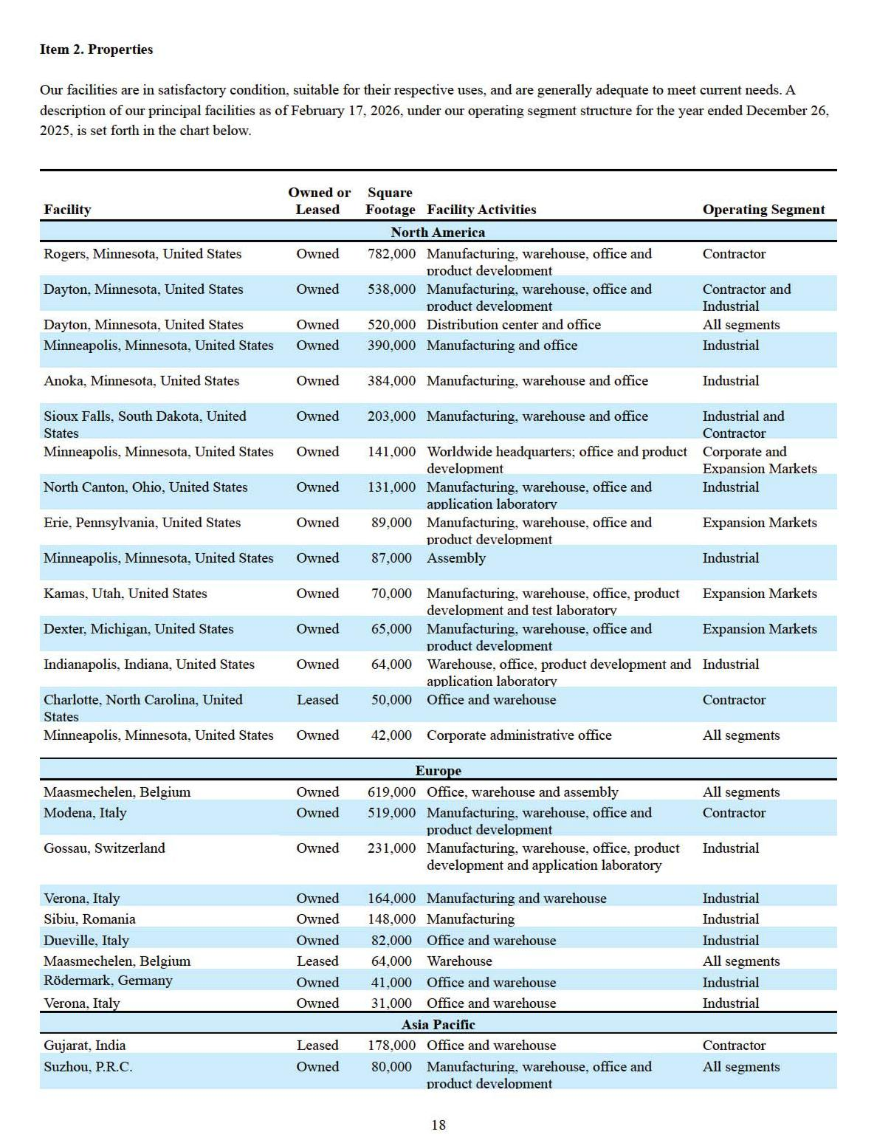

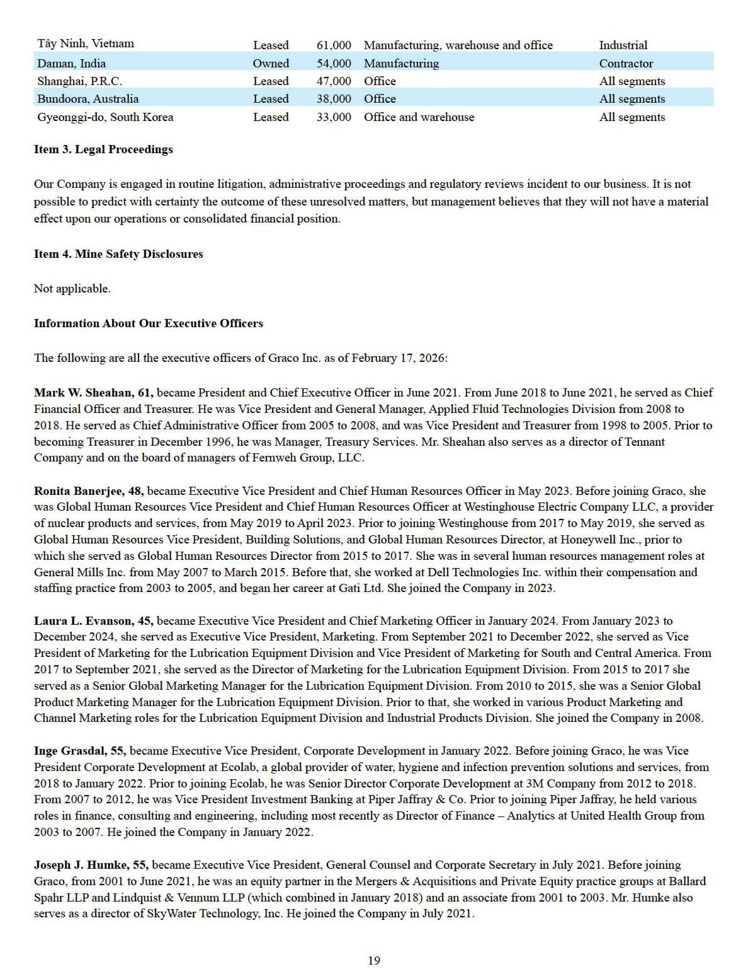

Christopher D. Knutson, 48, became Vice President, Controller and Chief Accounting Officer in January 2025. From May 2023 to December 2024, he served as Executive Vice President, Corporate Controller. He has also served as the Company's principal accounting officer since May 2023. From April 2020 to May 2023, he was Director of Corporate Treasury and Investor Relations, and from 2017 to April 2020, was Director of Corporate Treasury and Regional Controller, South and Central America. He served as Vice President of Finance from 2016 to 2017 at United Skin Specialists, after which he returned to Graco. From 2010 to 2016 he served in several Controller roles, including in the Applied Fluid Technology Division, Asia Pacific, and Lubrication Equipment Division. He first joined Graco as the Internal Audit Manager from 2008 to 2010. Prior to joining Graco, he worked at PricewaterhouseCoopers for seven years within their audit practice. He joined the Company in 2008.

David M. Lowe, 70, became Chief Financial Officer and Treasurer in June 2021. From April 2020 to June 2021, he served as President, Worldwide Process Division. He was President, Worldwide Industrial Products Division from June 2018 until April 2020. From 2012 until 2018, he was Executive Vice President, Industrial Products Division. From 2005 to 2012, he was Vice President and General Manager, Industrial Products Division. He was Vice President and General Manager, European Operations from 1999 to 2005. Prior to becoming Vice President, Lubrication Equipment Division in December 1996, he was Treasurer. He joined the Company in 1995.

Claudio Merengo, 56, became President, Global Powder Division in January 2025. From February 2024 to December 2024, he served as President, Worldwide Powder Division. He was previously President, Worldwide Gema from 2007 to February 2024. During this time, he also served as Group President, ITW Finishing from 2010 to 2012 and Group President, ITW Dynatec from 2008 to

2009. From 2004 to 2007 he was President, Gema Europe. From 1999 to 2004, he was Managing Director, Gema Italy. From 1994 to 1999, he held different positions in R&D, Sales and After Sales for Gema. He joined Gema in 1994. Gema has been part of Graco since the acquisition of the ITW Finishing Group in 2012.

Peter J. O’Shea, 61, became President, Global Industrial Division in January 2025. From January 2022 to December 2024, he served as President, Worldwide Lubrication Equipment Division, and President, South and Central America. From July 2021 to January 2022, he was President, Worldwide Industrial Products Division, and President, South and Central America. From April 2020 to January 2022, he was President, Worldwide Industrial Products Division. From 2018 to April 2020, he was President, Worldwide Lubrication Equipment Division. From 2016 to 2018, he was Vice President and General Manager, Lubrication Equipment Division. From 2012 to 2015, he was Vice President and General Manager, Asia Pacific. From 2012 to 2012, he was Director of Sales & Marketing, Industrial Products Division, and from 2008 to 2012, he was Director of Sales & Marketing, Industrial Products Division and Applied Fluid Technology Division. He was Country Manager, Australia - New Zealand from 2005 to 2008, and from 2002 to 2005 he served as Business Development Manager, Australia - New Zealand. Prior to becoming Business Development Manager, Australia - New Zealand, he worked in various Graco sales management positions. He joined the Company in 1995.

Kathryn L. Schoenrock, 48, became Executive Vice President and Chief Information Officer in February 2024. She was previously Executive Vice President and Chief Technology Officer from May 2023 to February 2024. From January 2022 to May 2023, she was Executive Vice President, Corporate Controller and Information Systems. From August 2020 to January 2022, she was Executive Vice President, Corporate Controller. She has also served as the Company’s principal accounting officer from August 2020 to May 2023. From 2017 to August 2020, she was Director of Corporate Finance. She served as Director of Financial Reporting from 2012 to 2018. Prior to joining Graco, she served as a Senior Manager in the audit practice of Deloitte & Touche LLP from 2008 to 2012, and held various positions in the audit practice of Deloitte & Touche LLP from 2002 to 2008 and in the audit practice of Arthur Andersen LLP from 2000 to 2002. She joined the Company in 2012.

David J. Thompson, 58, became President, Global Contractor Division in January 2025. From January 2024 to December 2024, he served as President, Worldwide Contractor Equipment Division. He was previously Vice President of Engineering, Contractor Equipment Division, a role he had held since 2021. He held a series of positions of increasing responsibility within the Contractor Equipment Division throughout his career, including Engineering Manager, Senior Engineering Manager and Director of Engineering. He joined the Company in 1988.

Timothy R. White, 56, became President, Expansion Markets Division in January 2025. From June 2021 to December 2024, he served as President, Worldwide Process Division. From August 2020 to June 2021, he served as President, White Knight and QED Environmental Systems. He served as President, EMEA from 2018 to August 2020. From 2015 to 2018, he was the President of QED Environmental Systems. He served as Director of Sales and Marketing, Applied Fluid Technologies Division, from 2012 to 2015. From 2011 to 2012, he was the North American Sales Manager, Applied Fluid Technologies Division. From 2008 to 2011, he was

20

Operations Director, Contractor Equipment Division. Prior to becoming Operations Director, Contractor Equipment Division, he held various manufacturing management positions. He joined the Company in 1992.

Angela F. Wordell, 54, became Executive Vice President and Chief Operations and Supply Chain Officer in January 2025. From January 2022 to December 2024, she served as Executive Vice President, Operations. From April 2020 to January 2022, she was Executive Vice President, Operations, and President, Worldwide Oil & Natural Gas Division. From 2018 to April 2020, she was Executive Vice President, Operations. From 2017 to 2018, she was Purchasing Director. From January 2017 to April 2017, she served as Strategic Sourcing Director. From 2010 to 2017, she was Operations Director, Industrial Product Division and China Factory. Prior to that, she held various manufacturing management and engineering positions. She joined the Company in 1993.

21

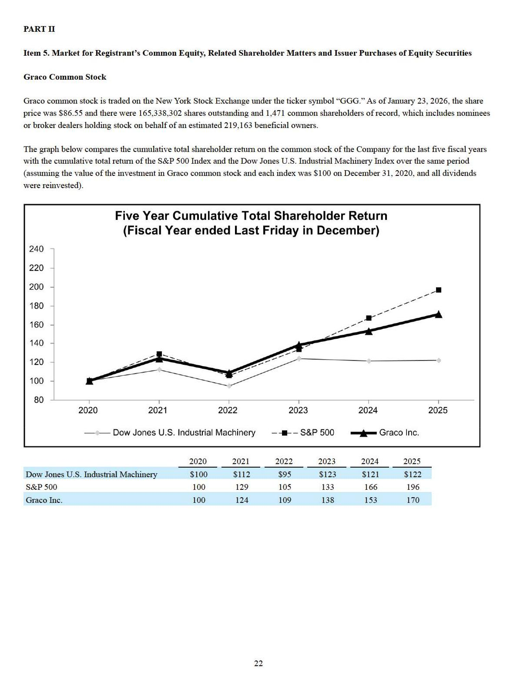

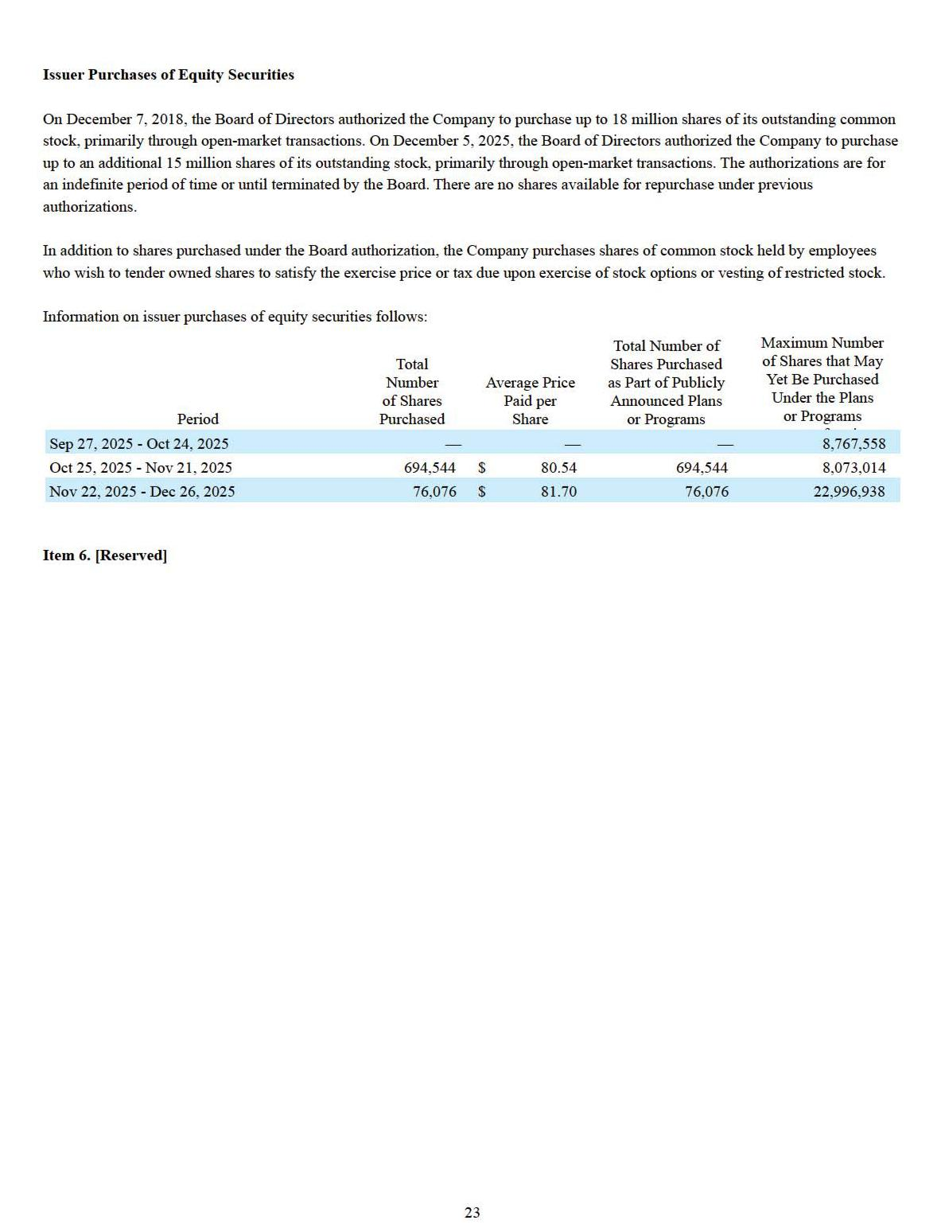

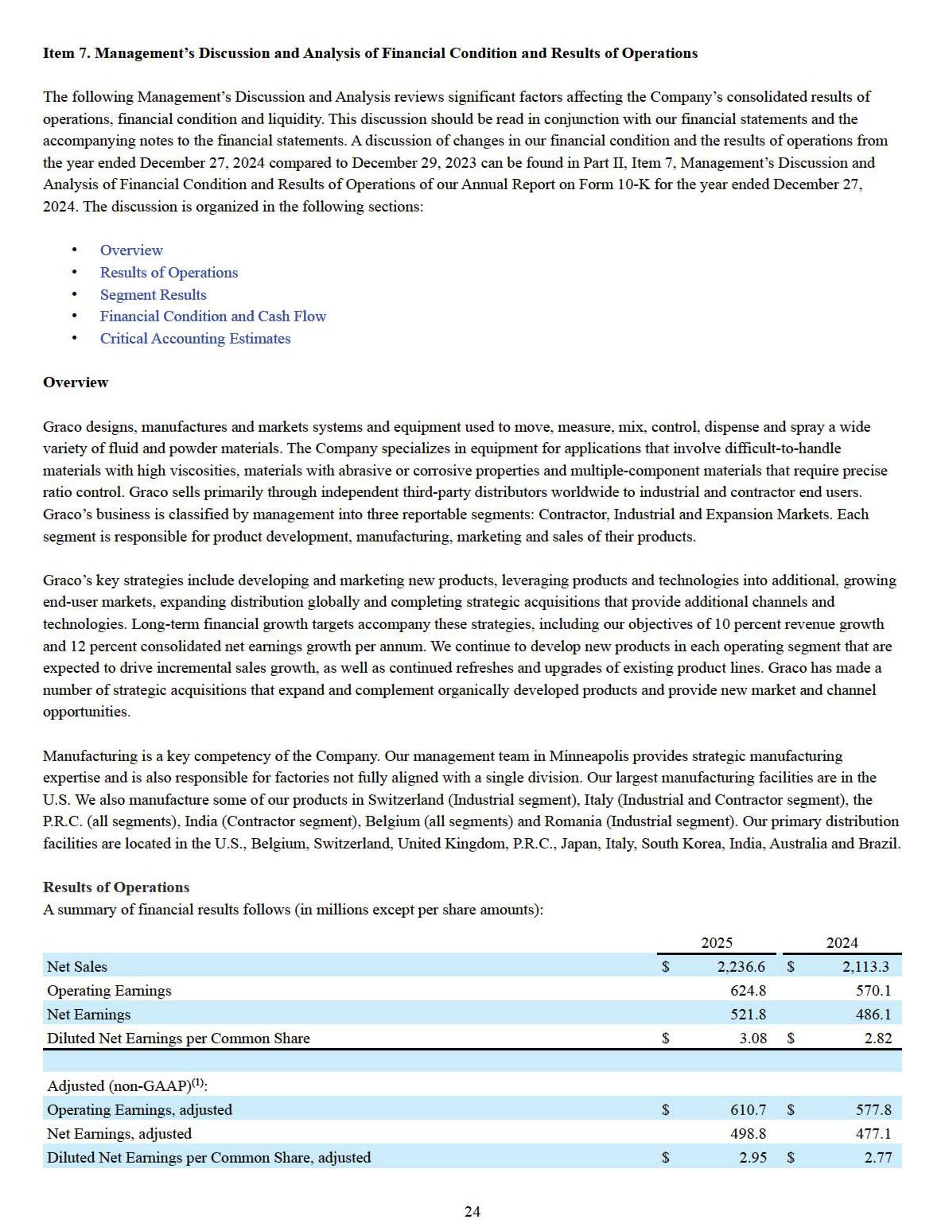

- Excludes the impact of excess tax benefits from stock option exercises, contingent consideration fair value adjustments, certain non-recurring tax provision adjustments and prior year business reorganization charges. See Financial Results Adjusted for Comparability below for a reconciliation of adjusted non-GAAP financial measures to GAAP.

25

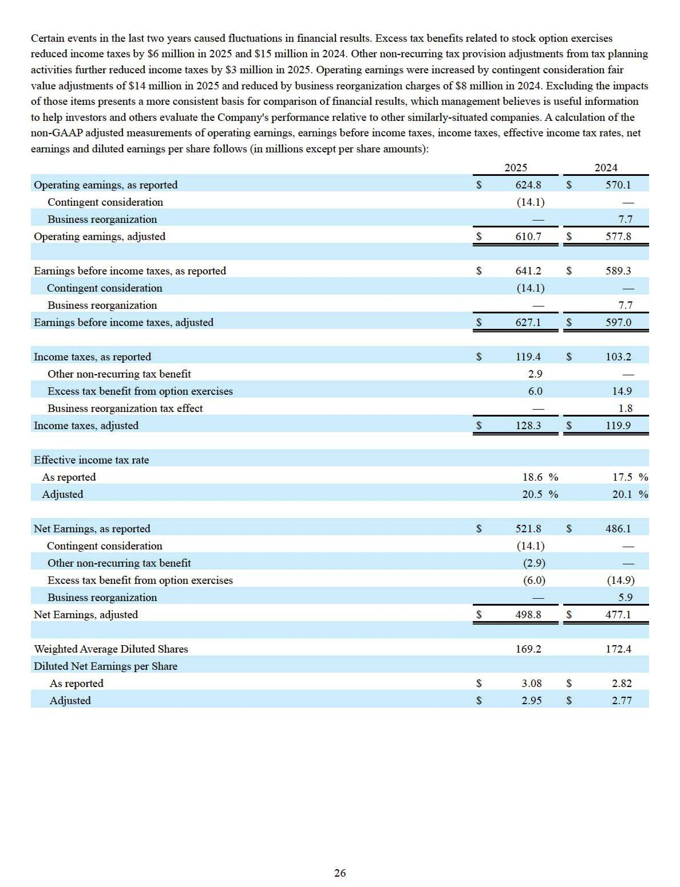

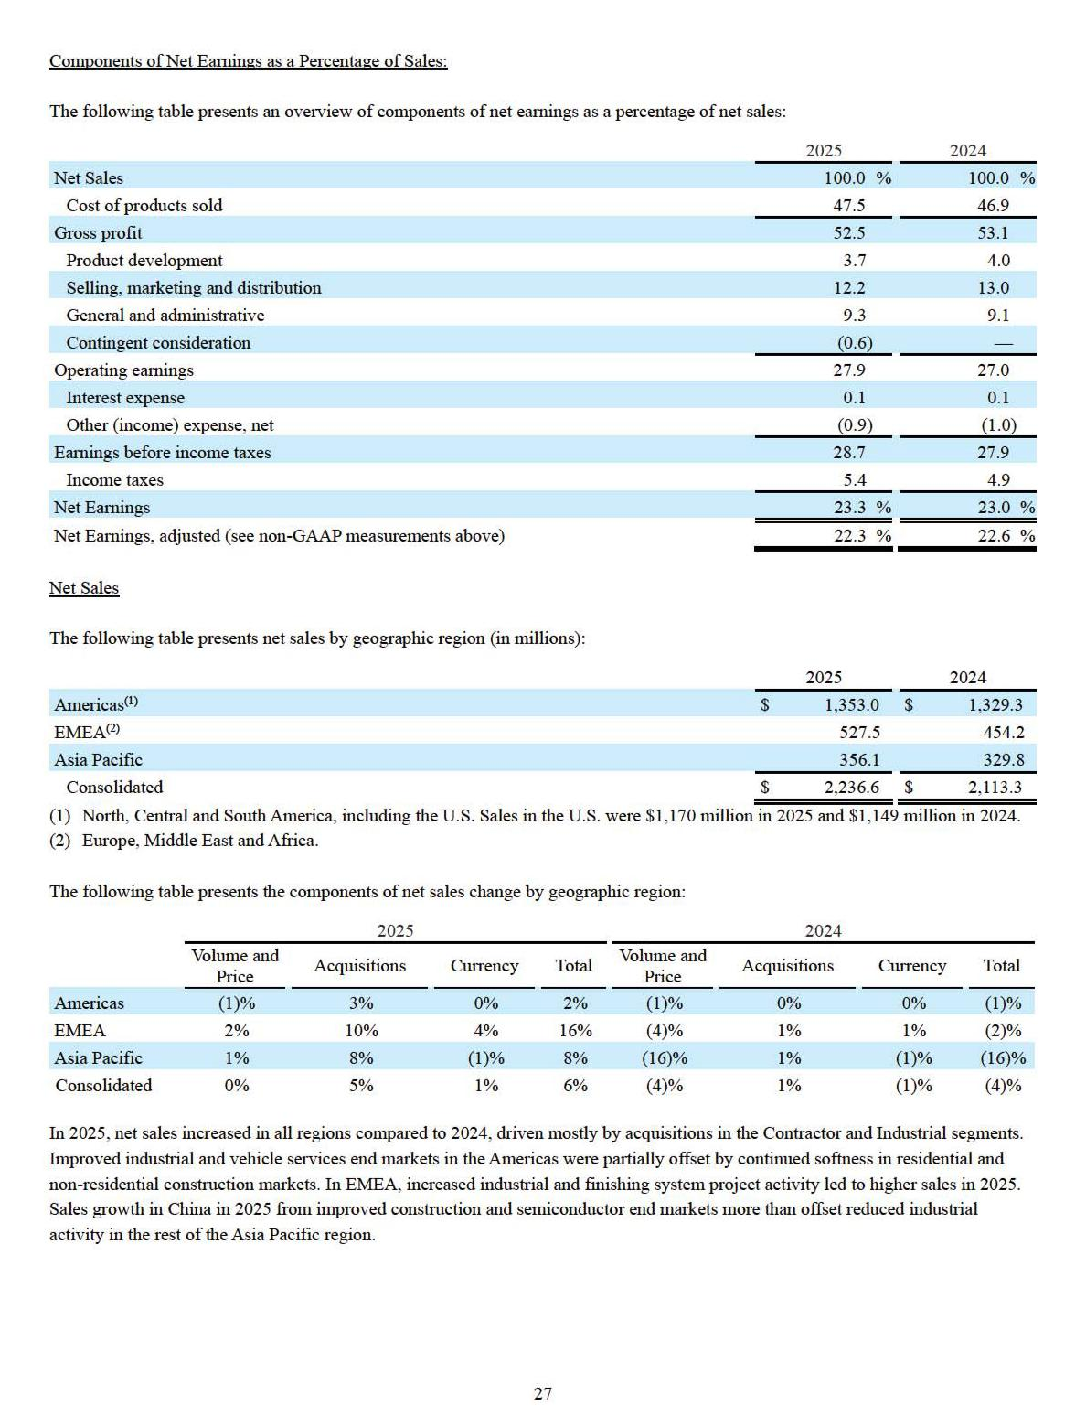

Gross Profit

The gross profit margin rate for 2025 decreased approximately 1 percentage point compared to 2024 as price realization was unable to offset higher product costs, including $14 million of increased tariff costs, and the unfavorable effect of lower margin rates of acquired operations.

Operating Expenses

Total operating expenses decreased $4 million (1 percent) for 2025 compared to 2024. Operating expenses for 2025 included $36 million of expenses from acquired operations and were mostly offset by a $14 million non-cash gain from the reduction in the fair value of acquisition-related contingent consideration recognized in the current year and $21 million of litigation and business reorganization costs from the prior year that did not repeat. Investment in new product development in 2025 was $82 million, approximately 4 percent of sales.

Operating Earnings

Sales growth and decreased operating expenses led to a 10 percent increase in operating earnings. Operating earnings expressed as a percentage of sales in 2025 increased approximately 1 percentage point compared to 2024 primarily due to a $14 million non-cash gain from the reduction in the fair value of acquisition-related contingent consideration in 2025.

Interest & Other (Income) Expense

Interest expense for 2025 was flat compared to 2024. Other income decreased $3 million in 2025 compared to 2024 and included higher exchange losses on net liabilities of certain foreign operations of $8 million and decreased interest income of $8 million. Partially offsetting these items were a $5 million gain in 2025 from the sale of a former manufacturing and distribution facility in Switzerland and $2 million of favorable market valuation changes on investments held to fund certain retirement benefits.

Income Taxes

The effective income tax rate for 2025 was 19 percent, up 1 percentage point from 2024. The increase in 2025 was largely due to variations in excess tax benefits from stock option exercises.

Segment Results

The Company has four operating segments which are aggregated into three reportable segments: Contractor, Industrial and Expansion Markets. Refer to Part I Item 1. Business, for a description of the Company’s three reportable segments. Management assesses the performance of segments by reference to operating earnings excluding unallocated corporate expenses and asset impairments.

28

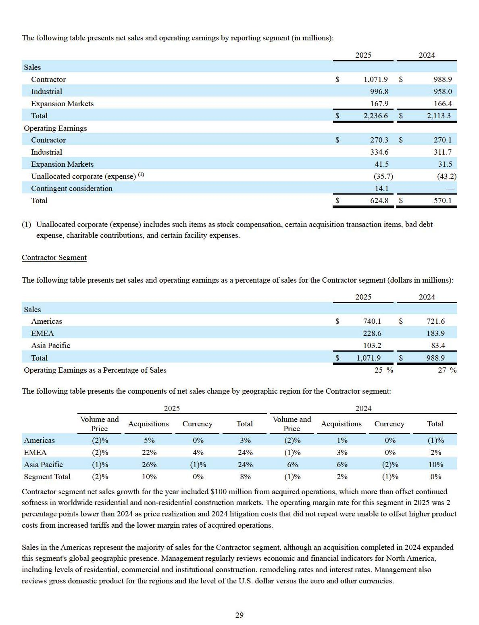

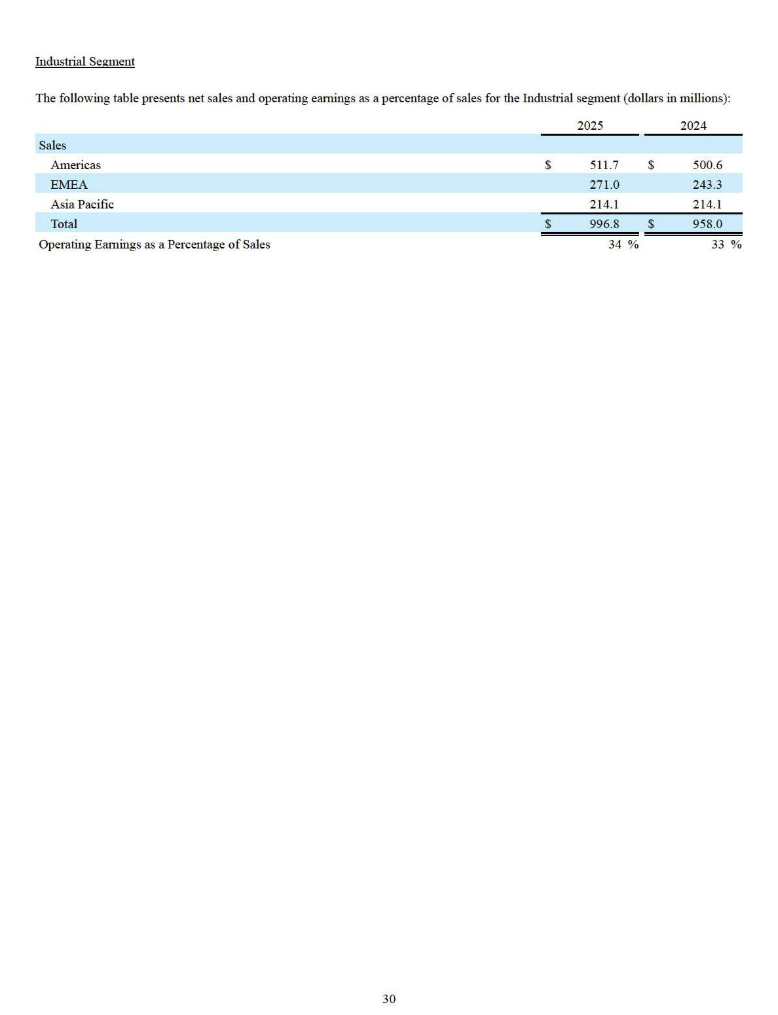

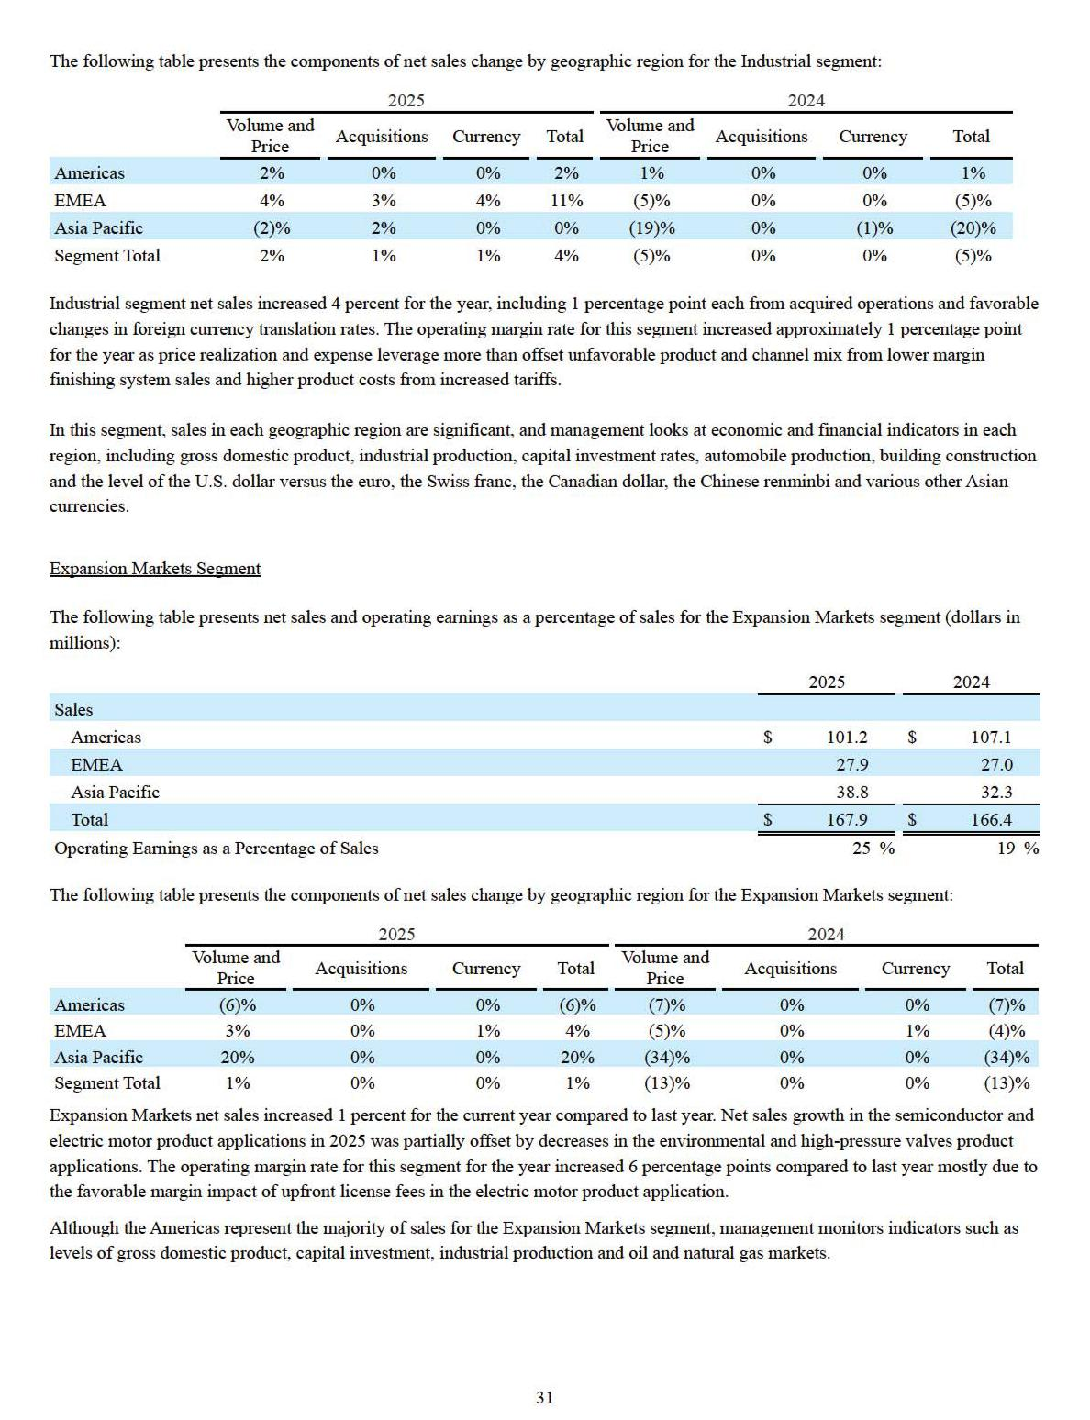

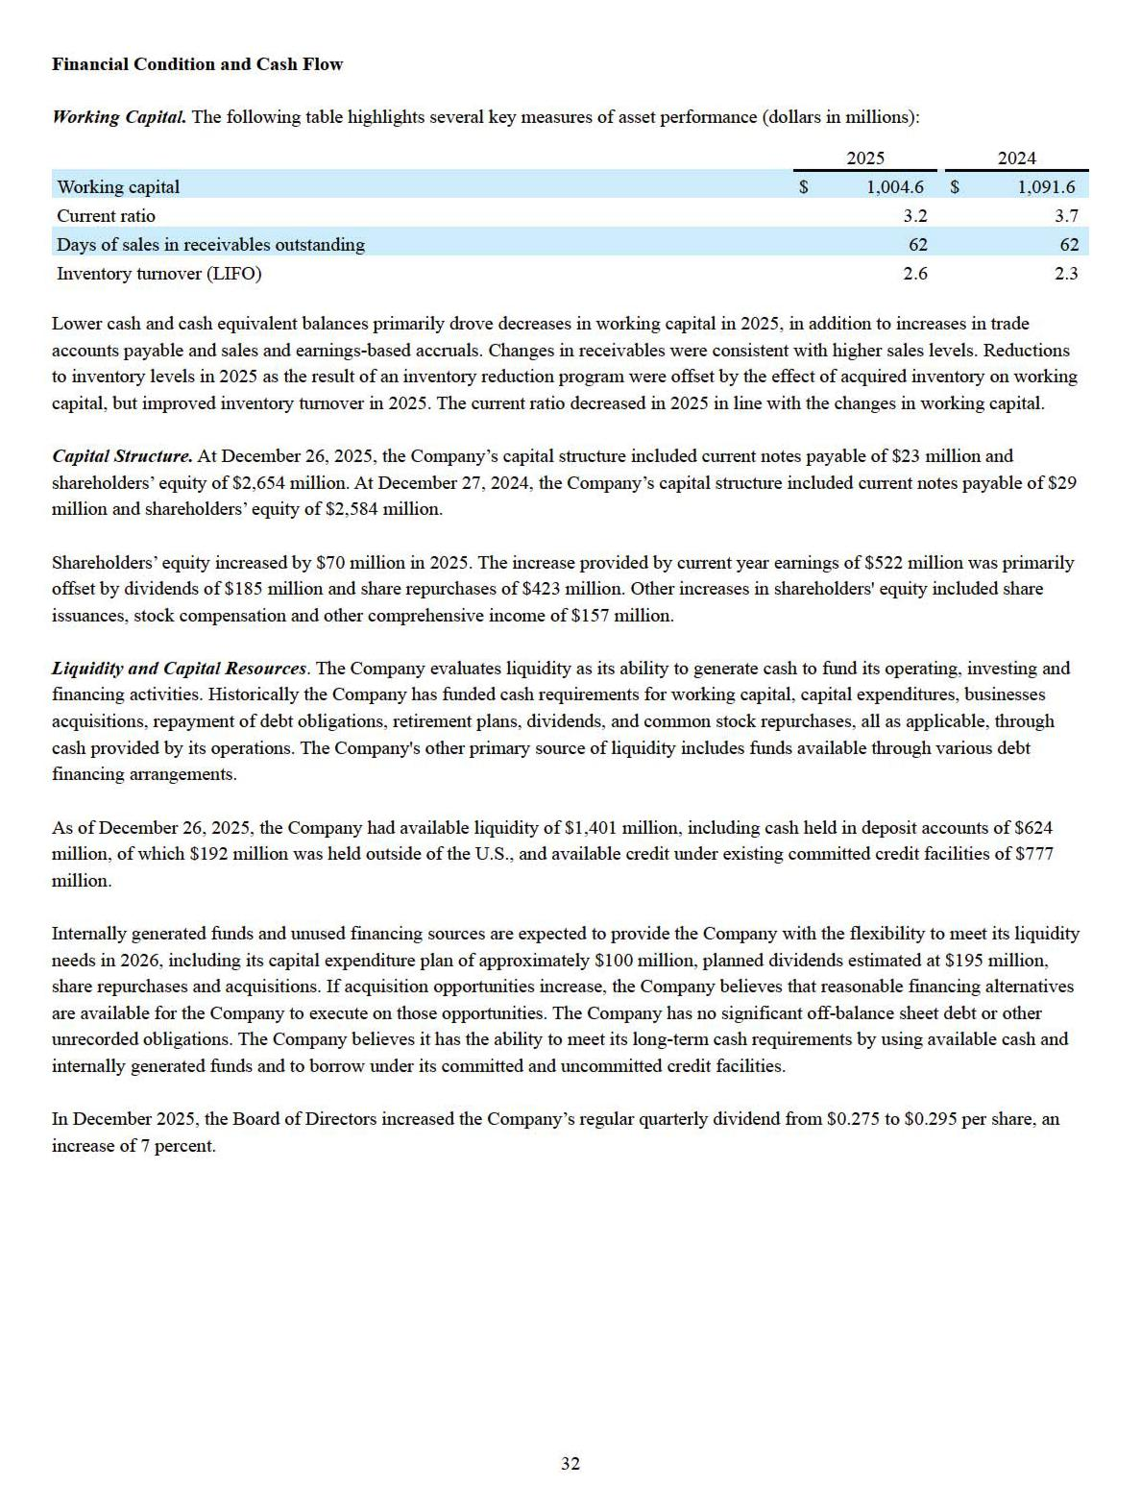

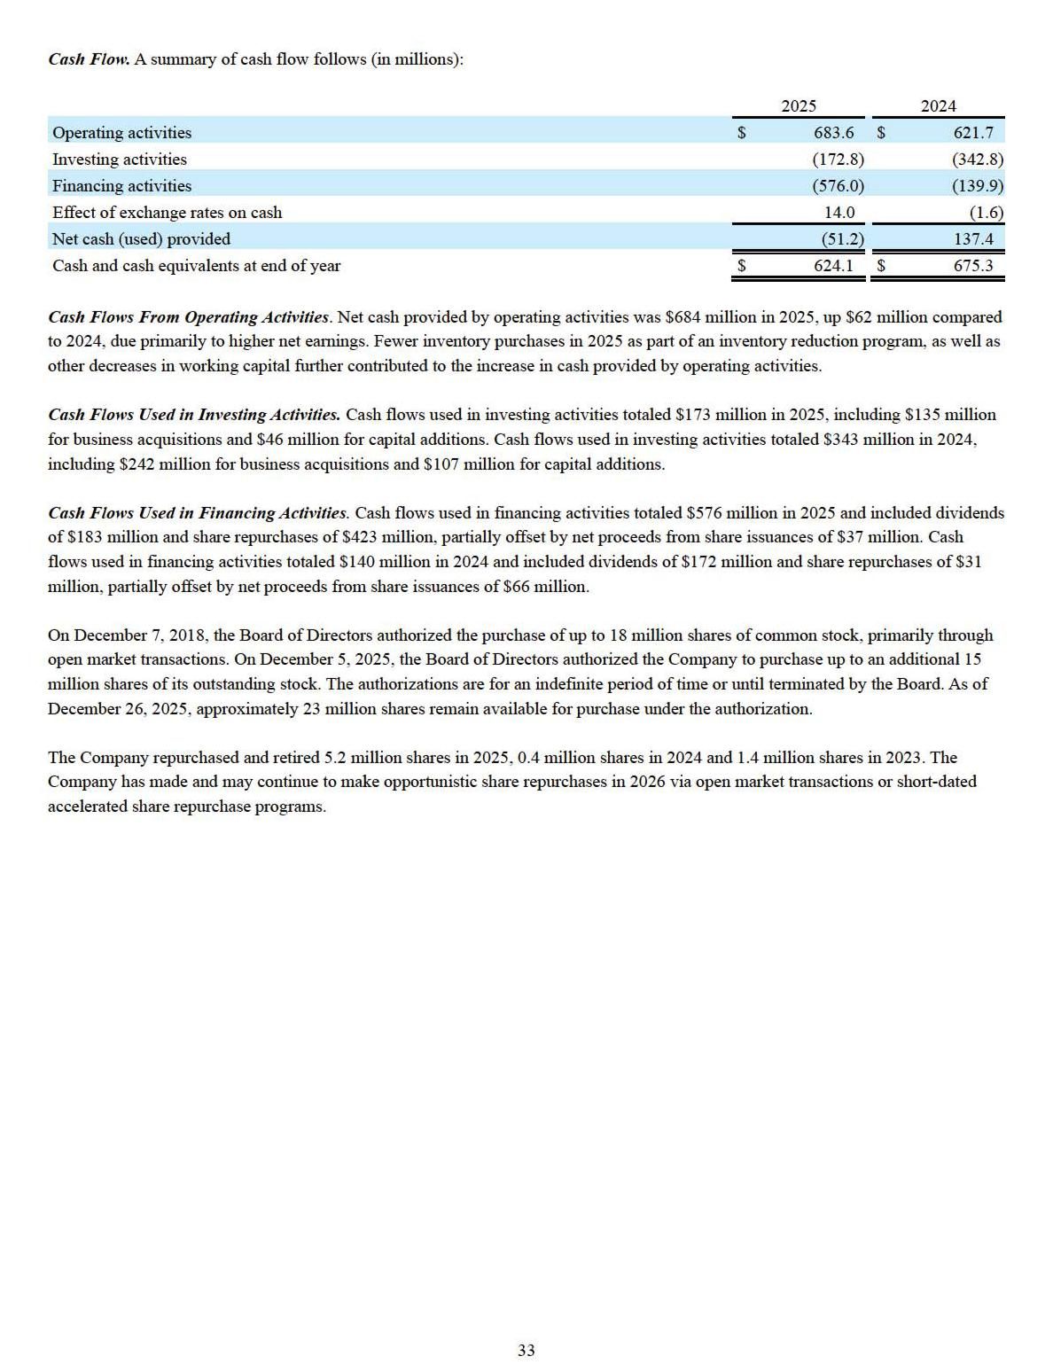

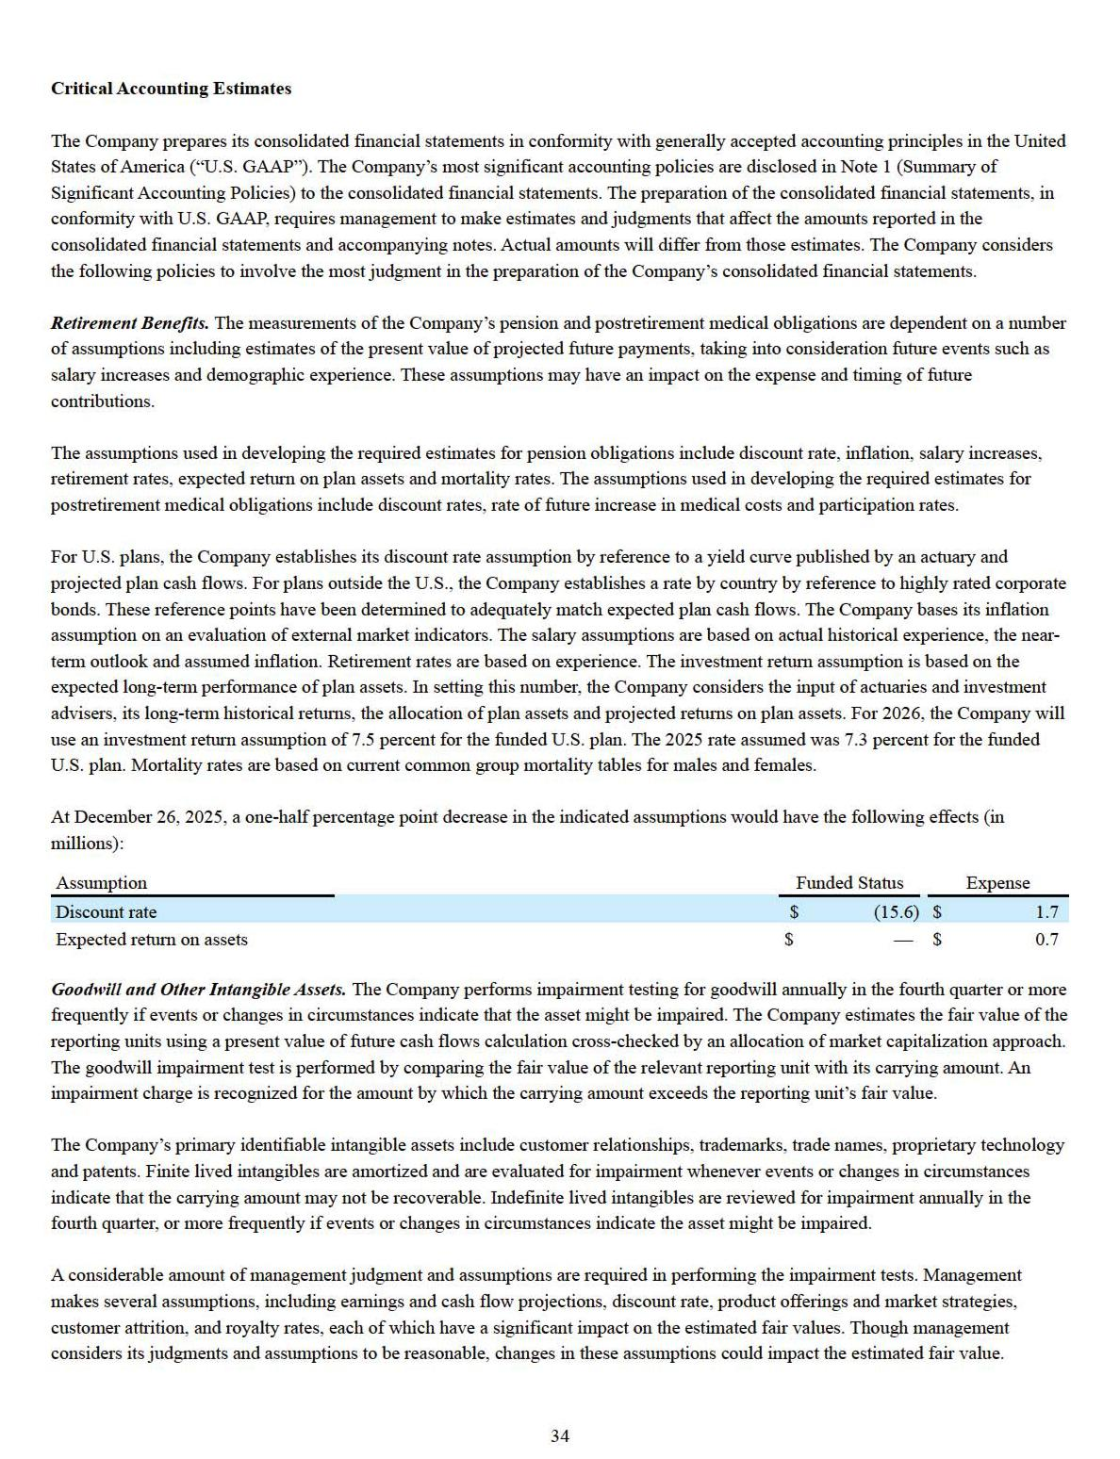

We completed our annual impairment test of goodwill and other intangible assets in the fourth quarter of 2025. No impairment charges were recorded as a result of that review.

Income Taxes. In the preparation of the Company’s consolidated financial statements, management calculates income taxes. This includes estimating current tax liability as well as assessing temporary differences resulting from different treatment of items for tax and financial statement purposes. These differences result in deferred tax assets and liabilities, which are recorded on the balance sheet using statutory rates in effect for the year in which the differences are expected to reverse. These assets and liabilities are analyzed regularly, and management assesses the likelihood that deferred tax assets will be recoverable from future taxable income. A valuation allowance is established to the extent that management believes that recovery is not likely. Liabilities for uncertain tax positions are also established for potential and ongoing audits of federal, state and international issues. The Company routinely monitors the potential impact of such situations and believes that liabilities are properly stated. Valuations related to amounts owed and tax rates could be impacted by changes to tax codes and the Company’s interpretation thereof, changes in statutory rates, the Company’s future taxable income levels and the results of tax audits.

Item 7A. Quantitative and Qualitative Disclosures About Market Risk

The Company sells and purchases products and services in currencies other than the U.S. dollar and pays variable interest rates on borrowings under certain credit facilities. Consequently, the Company is subject to profitability risk arising from exchange and interest rate movements. The Company may use a variety of financial and derivative instruments to manage foreign currency and interest rate risks. The Company does not enter into any of these instruments for trading purposes to generate revenue. Rather, the Company’s objective in managing these risks is to reduce fluctuations in earnings and cash flows associated with changes in foreign currency exchange and interest rates.

The Company may use forward exchange contracts, options and other hedging activities to hedge the U.S. dollar value resulting from anticipated currency transactions and net monetary asset and liability positions. At December 26, 2025, the currencies to which the Company had the most significant balance sheet exchange rate exposure were the euro, Swiss franc, Canadian dollar, British pound, Japanese yen, Australian dollar, Chinese renminbi, South Korean won, Brazilian real and Indian rupee. It is not possible to determine the true impact of currency rate changes; however, the direct translation effect on net sales and net earnings can be estimated. In 2025, changes in currency translation rates increased sales by approximately $13 million and increased net earnings by approximately $3 million. In 2024, changes in currency translation rates reduced sales by approximately $3 million and reduced net earnings by approximately $3 million.

2026 Outlook

Entering 2026, Graco remains committed to its key initiatives: driving product innovation, pursuing strategic acquisitions, and advancing the One Graco operating model. For 2026, the Company expects low single digit organic sales growth on a constant currency basis and mid single digit sales growth on a constant currency basis including acquisitions.

At January 26, 2026 exchange rates, assuming the same volumes, mix of products and mix of business by currency as in 2025, the movement in foreign currencies would have a favorable impact of approximately 1 percentage point on net sales and net earnings for 2026.

The Company's backlog is not a good indicator of future long-term business levels. In addition to economic growth, the successful launch of new products and expanded distribution coverage, the sales outlook is dependent on many factors, including realization of price increases and stable foreign currency exchange rates.

35

Forward-Looking Statements

The Company desires to take advantage of the “safe harbor” provisions regarding forward-looking statements of the Private Securities Litigation Reform Act of 1995 and is filing this Cautionary Statement in order to do so. From time to time various forms filed by our Company with the Securities and Exchange Commission, including our Form 10-K, Form 10-Qs and Form 8-Ks, and other disclosures, including our 2025 Overview report, press releases, earnings releases, analyst briefings, conference calls and other written documents or oral statements released by our Company, may contain forward-looking statements. Forward-looking statements generally use words such as “expect,” “foresee,” “anticipate,” “believe,” “project,” “should,” “estimate,” “will,” and similar expressions, and reflect our Company’s expectations concerning the future. All forecasts and projections are forward-looking statements. Forward-looking statements are based upon currently available information, but various risks and uncertainties may cause our Company’s actual results to differ materially from those expressed in these statements. The Company undertakes no obligation to update these statements in light of new information or future events.

Future results could differ materially from those expressed, due to the impact of changes in various factors. These risk factors include, but are not limited to, risks relating to the demand for our products and the level of commercial, industrial and construction activity worldwide; changes in currency translation rates; international and domestic instability; interest rate fluctuations and changes in credit markets; global sourcing of materials; inflationary cost pressures and our ability to raise prices without decreasing demand for our products; interruptions of or intrusions into our information systems; intellectual property rights; the use of generative artificial intelligence and other emerging technologies; conducting business internationally; catastrophic events; our ability to attract, develop and retain qualified personnel; public health crises; our growth strategies and acquisitions; potential goodwill impairment; our ability to compete effectively; our dependence on a few large customers; our dependence on cyclical industries; changes in laws and regulations; climate-related laws, regulations and accords; environmental, social and governance-related expectations and requirements; compliance with anti-corruption and trade laws; changes in tax or tariff rates or the adoption of new tax or tariff legislation; and costs associated with legal proceedings; and other risks and uncertainties including those discussed in Item 1A of this Form 10-K. Shareholders, potential investors and other readers are urged to consider these factors in evaluating forward-looking statements and are cautioned not to place undue reliance on such forward-looking statements.

Investors should realize that factors other than those identified in Item 1A might prove important to the Company’s future results. It is not possible for management to identify each and every factor that may have an impact on the Company’s operations in the future as new factors can develop from time to time.

Item 8. Financial Statements and Supplementary Data

36

REPORT OF INDEPENDENT REGISTERED PUBLIC ACCOUNTING FIRM

To the shareholders and the Board of Directors of Graco Inc.

Opinion on the Financial Statements

We have audited the accompanying consolidated balance sheets of Graco Inc. and subsidiaries (the "Company") as of December 26, 2025 and December 27, 2024, the related consolidated statements of earnings, comprehensive income, shareholders' equity, and cash flows, for each of the three years in the period ended December 26, 2025, and the related notes (collectively referred to as the "financial statements"). In our opinion, the financial statements present fairly, in all material respects, the financial position of the Company as of December 26, 2025 and December 27, 2024, and the results of its operations and its cash flows for each of the three years in the period ended December 26, 2025, in conformity with accounting principles generally accepted in the United States of America.

We have also audited, in accordance with the standards of the Public Company Accounting Oversight Board (United States) (PCAOB), the Company's internal control over financial reporting as of December 26, 2025, based on criteria established in Internal Control — Integrated Framework (2013) issued by the Committee of Sponsoring Organizations of the Treadway Commission and our report dated February 17, 2026, expressed an unqualified opinion on the Company's internal control over financial reporting.

Basis for Opinion

These financial statements are the responsibility of the Company's management. Our responsibility is to express an opinion on the Company's financial statements based on our audits. We are a public accounting firm registered with the PCAOB and are required to be independent with respect to the Company in accordance with the U.S. federal securities laws and the applicable rules and regulations of the Securities and Exchange Commission and the PCAOB.

We conducted our audits in accordance with the standards of the PCAOB. Those standards require that we plan and perform the audit to obtain reasonable assurance about whether the financial statements are free of material misstatement, whether due to error or fraud. Our audits included performing procedures to assess the risks of material misstatement of the financial statements, whether due to error or fraud, and performing procedures that respond to those risks. Such procedures included examining, on a test basis, evidence regarding the amounts and disclosures in the financial statements. Our audits also included evaluating the accounting principles used and significant estimates made by management, as well as evaluating the overall presentation of the financial statements. We believe that our audits provide a reasonable basis for our opinion.

Critical Audit Matter

The critical audit matter communicated below is a matter arising from the current-period audit of the financial statements that was communicated or required to be communicated to the audit committee and that (1) relates to accounts or disclosures that are material to the financial statements and (2) involved our especially challenging, subjective, or complex judgments. The communication of critical audit matters does not alter in any way our opinion on the financial statements, taken as a whole, and we are not, by communicating the critical audit matter below, providing a separate opinion on the critical audit matter or on the accounts or disclosures to which it relates.

Retirement Benefits – U.S. Pension Benefit Obligation – Refer to Note 10 to the financial statements

Critical Audit Matter Description

The Company has both funded and unfunded defined benefit pension plans. The actuarial determination of the present value of the pension obligation on an annual basis requires management to make significant assumptions related to the selection of the discount rates used in the calculation of the net present value of future pension benefits. The Company establishes the discount rate assumptions for the U.S. pension plans by reference to a yield curve published by an actuary based on yields of highly rated corporate bonds and projected plan cash flows.

37

Given the significance of the U.S. pension obligation and the requirement of management to make significant assumptions related to the selection of the discount rates, performing audit procedures to evaluate the reasonableness of the discount rates selected for the U.S. pension plans required a high degree of auditor judgment and an increased extent of effort, including the need to involve our actuarial specialists.

How the Critical Audit Matter Was Addressed in the Audit

Our audit procedures related to selection of the discount rates for the U.S. pension obligation included the following, among others:

- We tested the effectiveness of internal controls over the valuation of the pension obligation, including management’s controls over selection of the discount rates.

- With the assistance of our actuarial specialists, we evaluated the reasonableness of the discount rates by:

  - Evaluating the methodology utilized to select the discount rates for conformity with applicable accounting guidance.

  - Testing the source information underlying the determination of the discount rates, including the methodology used to construct the yield curve, the characteristics of the bonds underlying the yield curve analysis, and the mathematical accuracy of the calculation.

  - Developing independent estimates using external published yield curves and comparing them to the discount rates selected by management.

/s/ DELOITTE & TOUCHE LLP

Minneapolis, Minnesota

February 17, 2026

We have served as the Company’s auditor since at least 1969, however, an earlier year could not be readily determined.

38

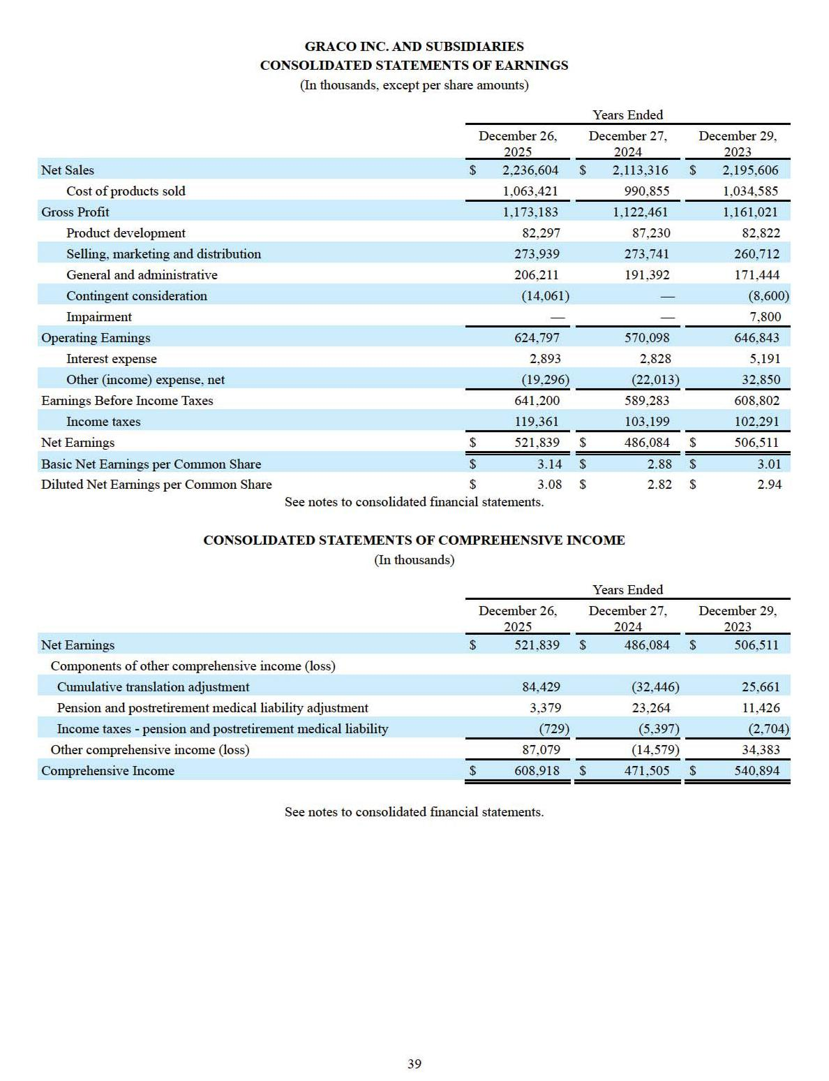

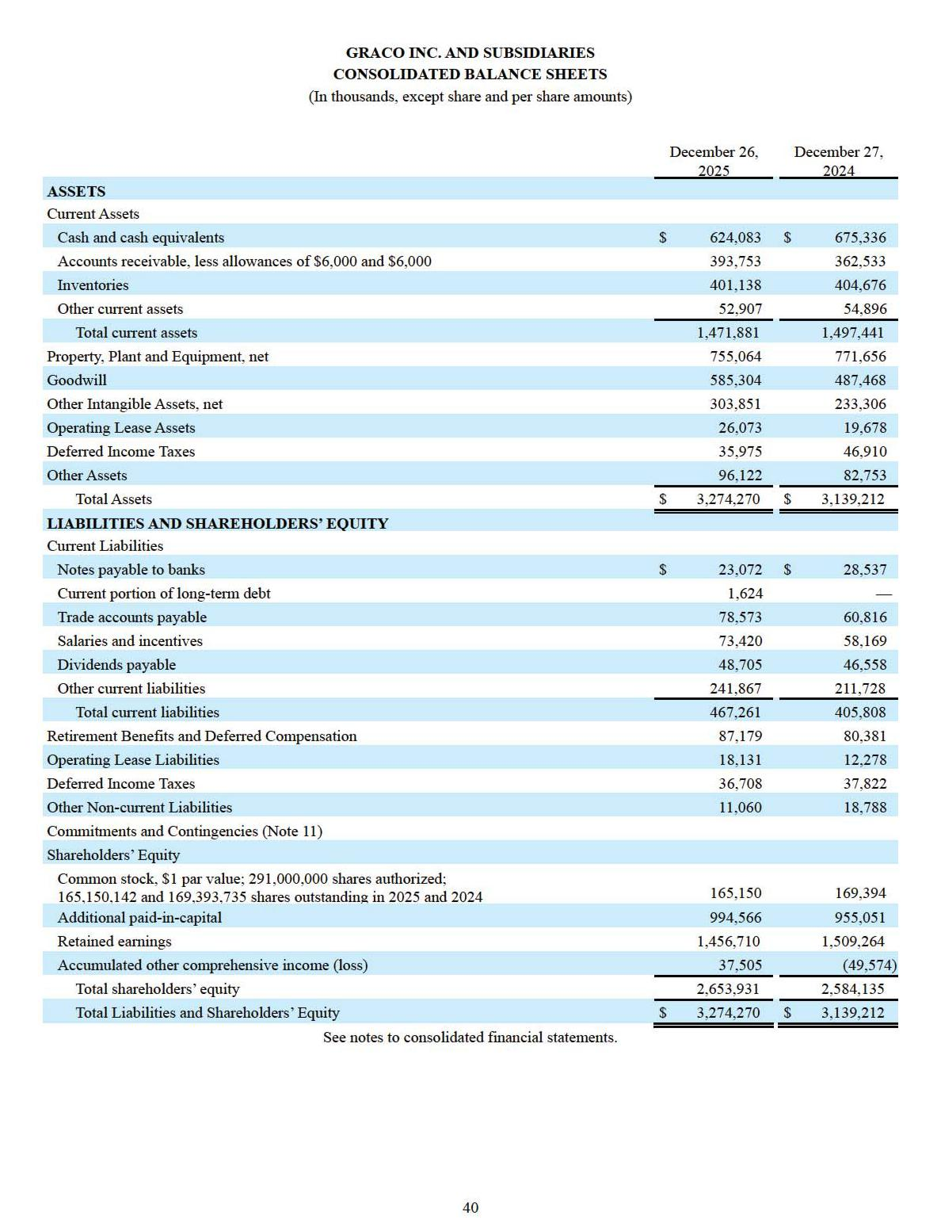

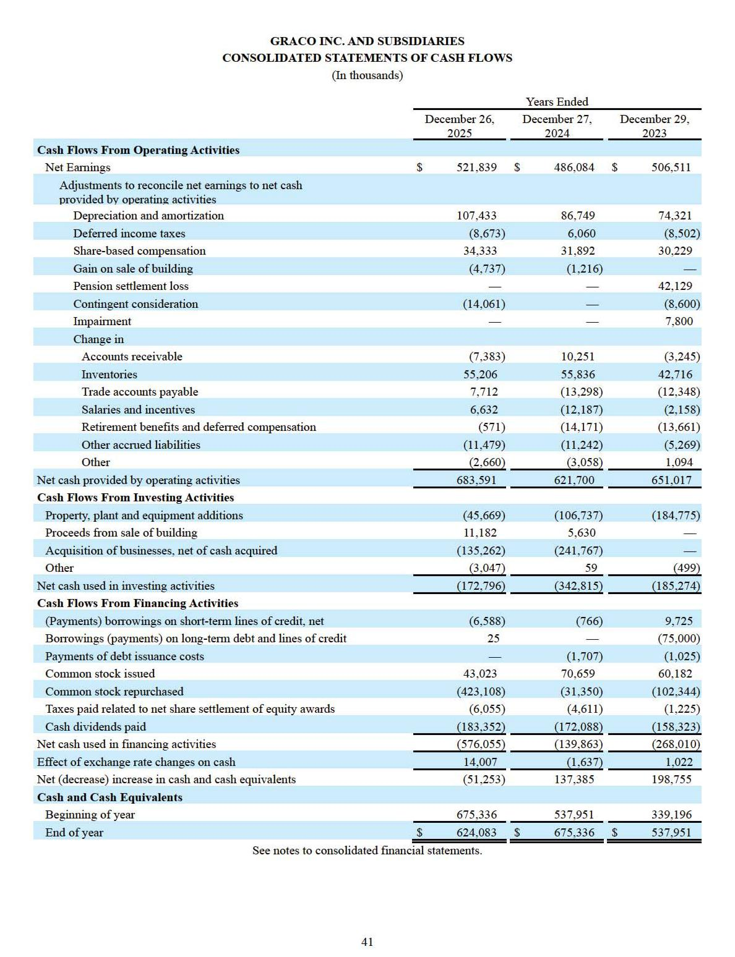

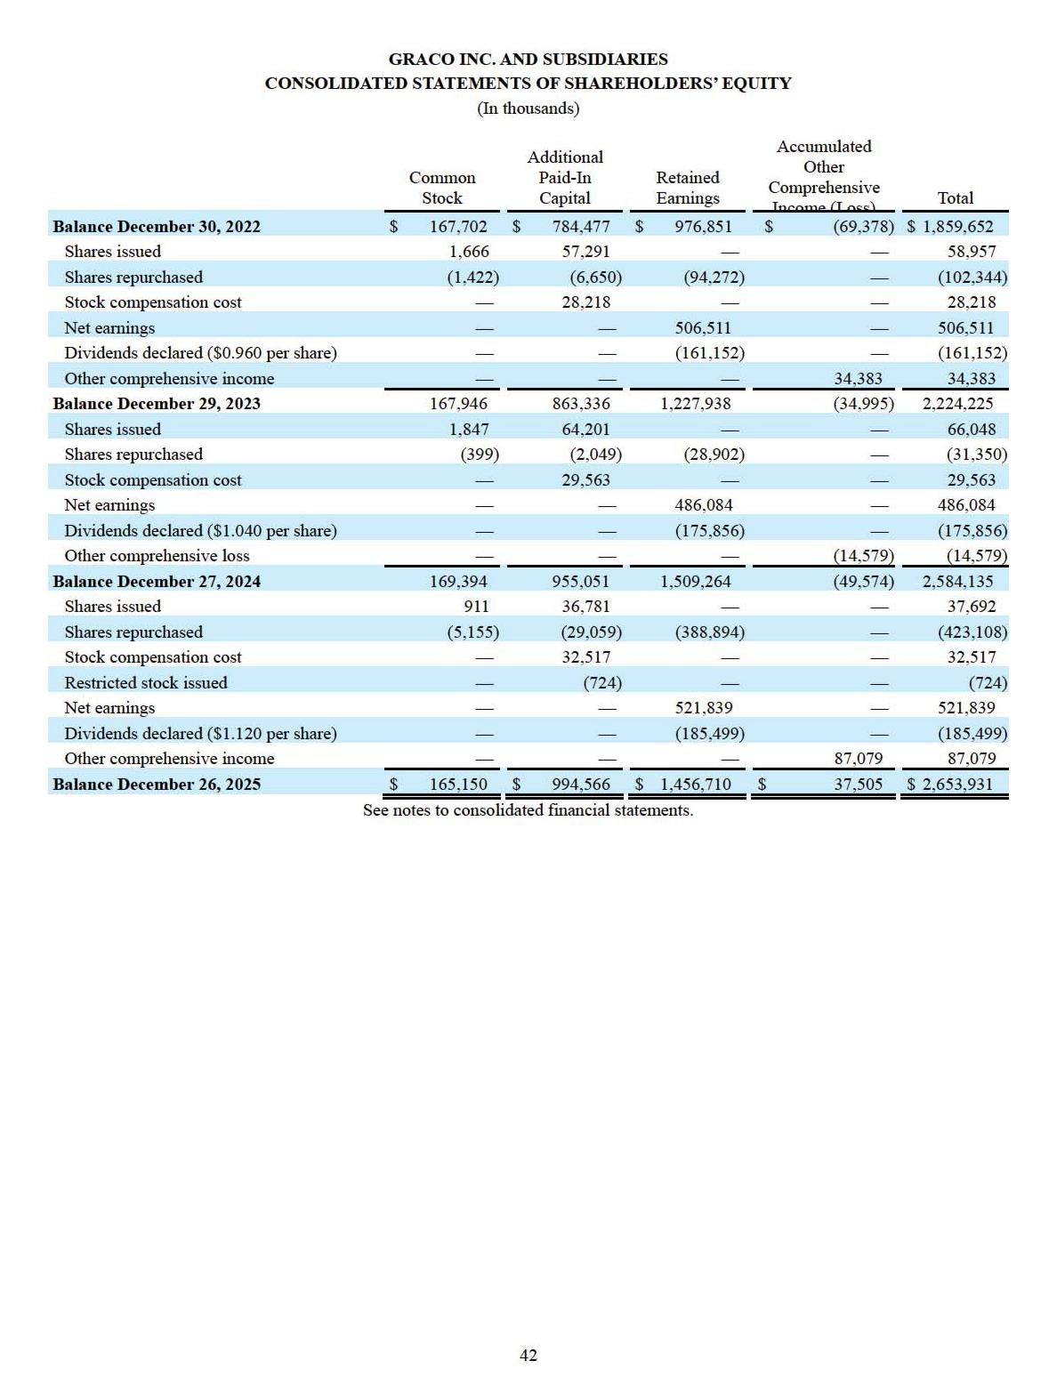

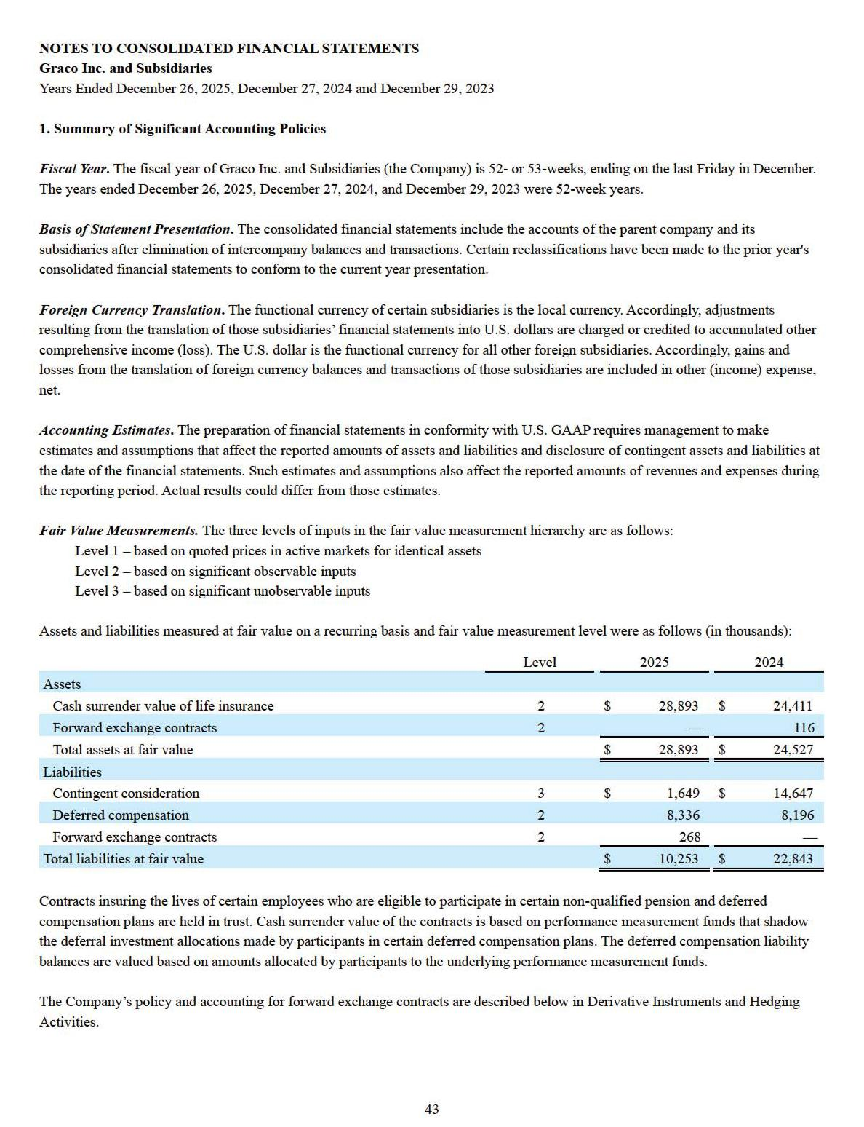

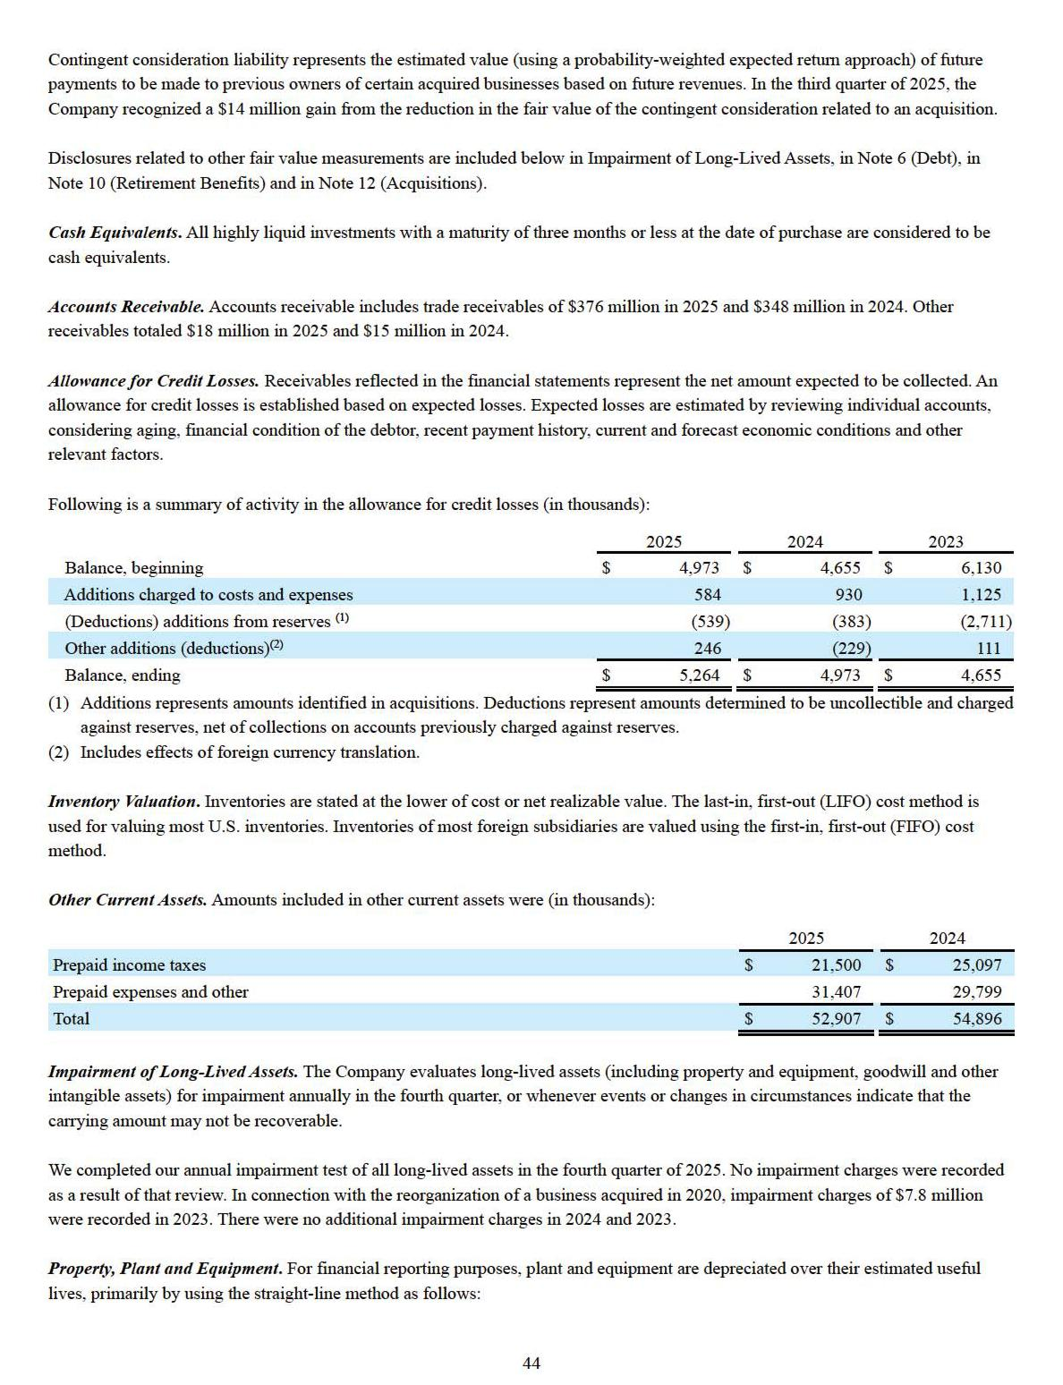

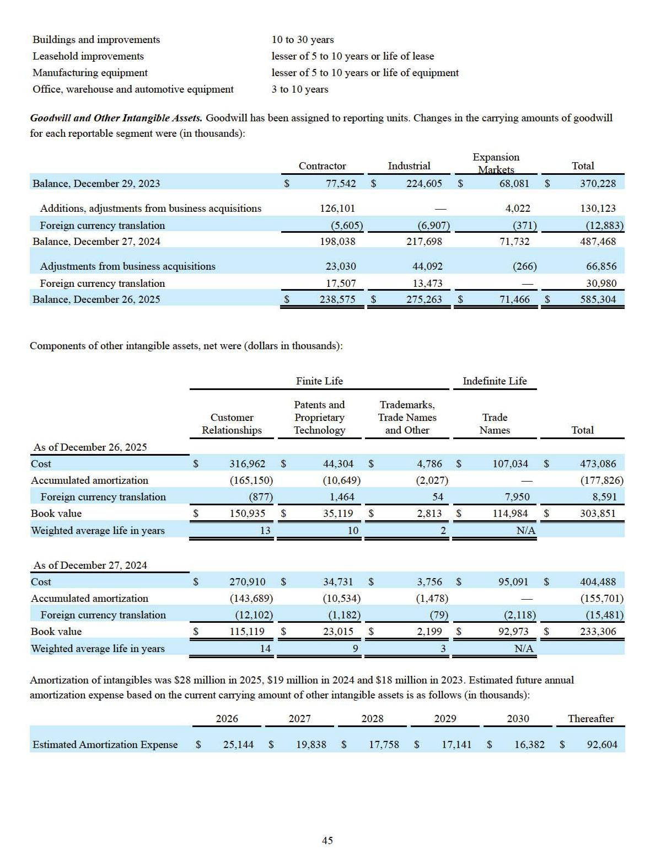

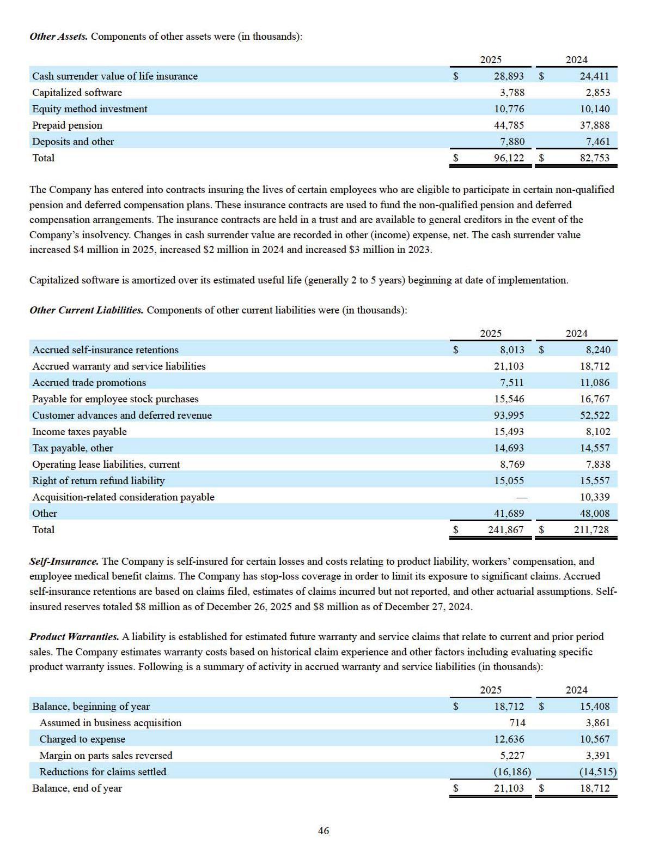

Revenue Recognition. Revenue is recognized at a single point in time upon the satisfaction of performance obligations, which occurs when control of the goods or service transfers to the customer. This is generally on the date of shipment for product sales; however certain sales have terms requiring recognition when the goods are received by the customer. In cases where there are specific customer acceptance provisions, revenue is recognized at the later of customer acceptance or shipment (subject to shipping terms). Payment terms are established based on the type of product, distributor capabilities and competitive market conditions, and do not exceed one year. Standalone selling prices are determined based on the prices charged to customers for all material performance obligations.

Variable consideration is accounted for as a price adjustment (sales adjustment). The following are examples of variable consideration that affect the Company’s reported revenue. Early payment discounts are provided to certain customers and within certain regions. Rights of return are typically contractually limited and amounts are estimable. The Company records a refund liability and establishes a recovery asset for the value of product expected to be returned at the time revenue is recognized. This includes promotions when, from time to time, the Company may promote the sale of new products by agreeing to accept returns of superseded products. Provisions for sales returns are recorded as a reduction of net sales, and provisions for warranty claims are recorded in selling, marketing and distribution expenses. Historically, sales returns have been approximately 2 percent of sales. Trade promotions are offered to distributors and end users through various programs, generally with terms of one year or less. Such promotions include rebates based on annual purchases and sales growth, coupons and reimbursement for competitive products. Payment of incentives may take the form of cash, trade credit, promotional merchandise or free product. Rebates are accrued based on the program rates and progress toward the probability weighted estimate of annual sales amount and sales growth.

Additional promotions include cooperative advertising arrangements. Under cooperative advertising arrangements, the Company reimburses the distributor for a portion of its advertising costs related to the Company’s products. Estimated costs are accrued at the time of sale and classified as selling, marketing and distribution expense. The estimated costs related to coupon programs are accrued at the time of sale and classified as selling, marketing and distribution expense or cost of products sold, depending on the type of incentive offered. The considerations payable to customers are deemed as broad based and are not recorded against net sales.

Shipping and handling costs incurred for the delivery of goods to customers are included in cost of goods sold. Amounts billed to customers for shipping and handling are included in net sales.

Revenue is deferred when cash payments are received or due in advance of performance, including amounts which are refundable. This is also the case for services associated with certain product sales. The balance of customer advances and deferred revenue was $94 million as of December 26, 2025 and $53 million as of December 27, 2024. Net sales for 2025 included $51 million that was in customer advances and deferred revenue as of December 27, 2024. Net sales for 2024 included $50 million that was in customer advances and deferred revenue as of December 29, 2023.

Shipping and handling activities that occur after control of the related good transfers are accounted for as fulfillment activities instead of assessing such activities as performance obligations.

Sales taxes related to revenue producing transactions collected from the customer for a governmental authority are excluded from the transaction price.

Revenue standard requirements are applied to a portfolio of contracts (or performance obligations) with similar characteristics for transactions where it is expected that the effects on the financial statements of applying the revenue recognition guidance to the portfolio would not differ materially from applying this guidance to the individual contracts (or performance obligations) within that portfolio.

Promised goods or services are not assessed as performance obligations if they are immaterial in the context of the contract with the customer. If the revenue related to a performance obligation that includes goods or services that are immaterial in the context of the contract is recognized before those immaterial goods or services are transferred to the customer, then the related costs to transfer those goods or services are accrued.

Incremental costs of obtaining a contract are generally expensed when incurred because the amortization period would be less than one year. Such costs primarily relate to sales commissions and are recorded in selling, marketing and distribution expense.

47

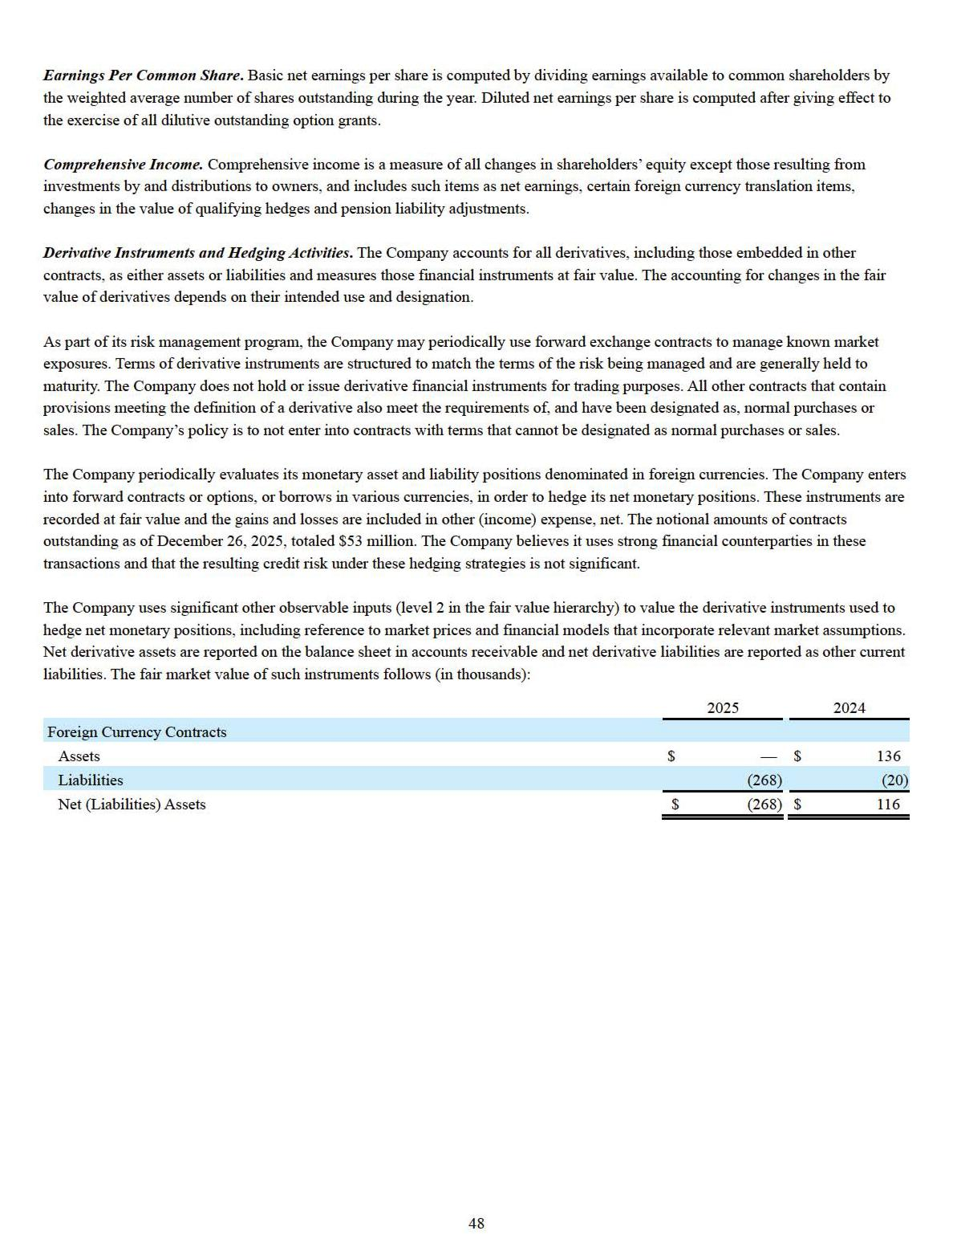

2. Segment Information

Effective January 1, 2025, the Company began to classify its business into three reportable segments: Contractor, Industrial and Expansion Markets. The Industrial segment consists of the newly formed Industrial Division and the Powder Division. The Company’s former Industrial and Lubrication Equipment Divisions, along with the Process Transfer Equipment business that was part of the Company’s former Process Division, were combined to form the new global Industrial Division. The Powder Division remains unchanged. The Expansion Markets segment consists of the Expansion Markets Division. The Company’s environmental, semiconductor, high-pressure valves and electric motors businesses, together with select future ventures and acquisitions, reside within this division. The Contractor segment, consisting of the Contractor Division, remains unchanged as a reportable segment relative to prior periods. Prior year segment information has been recast to conform to the current organizational structure.

The Company has four operating segments which are aggregated into three reportable segments: Contractor, Industrial and Expansion Markets.

The Contractor segment markets sprayers and equipment that apply paint to walls and other structures, texture to walls and ceilings, insulation to building walls and other items, highly viscous coatings to roofs, markings on roads, parking lots, athletic fields and floors and high-performance volumetric and gravimetric dispense, mixing, and shaking equipment.

The Industrial segment includes our Industrial and Powder divisions. The Industrial division designs and manufactures liquid finishing and advanced fluid dispensing equipment; pumps to move chemicals, petroleum, food, and other fluids; and systems, components, and accessories for the automatic lubrication of bearings, gears, and generators. The Industrial division also manufactures and supplies equipment for equipment maintenance and vehicle servicing applications, including supply pumps, hose reels, meters, valves, and accessories used by fast oil change facilities, service garages, fleet service centers, automobile dealerships, auto parts stores, truck builders, and heavy equipment service centers. The Powder division makes powder finishing products and complete powder finishing systems that coat powder on metals. Markets served include automotive and vehicle assembly and components production, including Electro or e-mobility, wood and metal products, rail, marine, aerospace, farm, construction, bus, recreational vehicles and various other industries.

The Expansion Markets segment markets and manufactures pumps for use in the semiconductor industry; high pressure and ultra-high pressure valves used in the oil and natural gas industry; and environmental monitoring and remediation equipment that is used to conduct ground water sampling, ground water remediation, and for landfill liquid and gas management. This segment also provides product design and licensing services for the development of high torque electric motors used in a variety of applications, including heating, ventilation, and air conditioning equipment, pumps, sprayers and other material handling equipment. Markets served include oil and natural gas, environmental, electronics, industrial, renewable energy, semiconductor fabrication and wastewater.

The accounting policies of the segments are the same as those described in the summary of significant accounting policies. The cost of manufacturing for each segment is based on product cost, and expenses are based on actual costs incurred along with cost allocations of shared and centralized functions based on activities performed, sales or space utilization. Depreciation expense is charged to the manufacturing or operating cost center that utilizes the asset and is then allocated to segments on the same basis as other expenses within that cost center. Segments are responsible for development, manufacturing, marketing and sales of their products. This allows for focused marketing and efficient product development. The segments share common purchasing, certain manufacturing, distribution and administration functions.

The Company’s chief operating decision maker is the chief executive officer.

The Company’s chief operating decision maker uses operating earnings excluding unallocated corporate expense to assess the operating performance of each segment. Operating earnings is used to make resource allocation decisions amongst segments and to determine compensation for certain employees. Gross profit is additionally used to evaluate product pricing and operating performance.

49

Unallocated corporate expenses include such items as stock compensation, certain acquisition transaction costs, bad debt expense, charitable contributions and certain facility expenses. Asset information by segment is not reported to the chief operating decision maker and therefore is not disclosed.

50

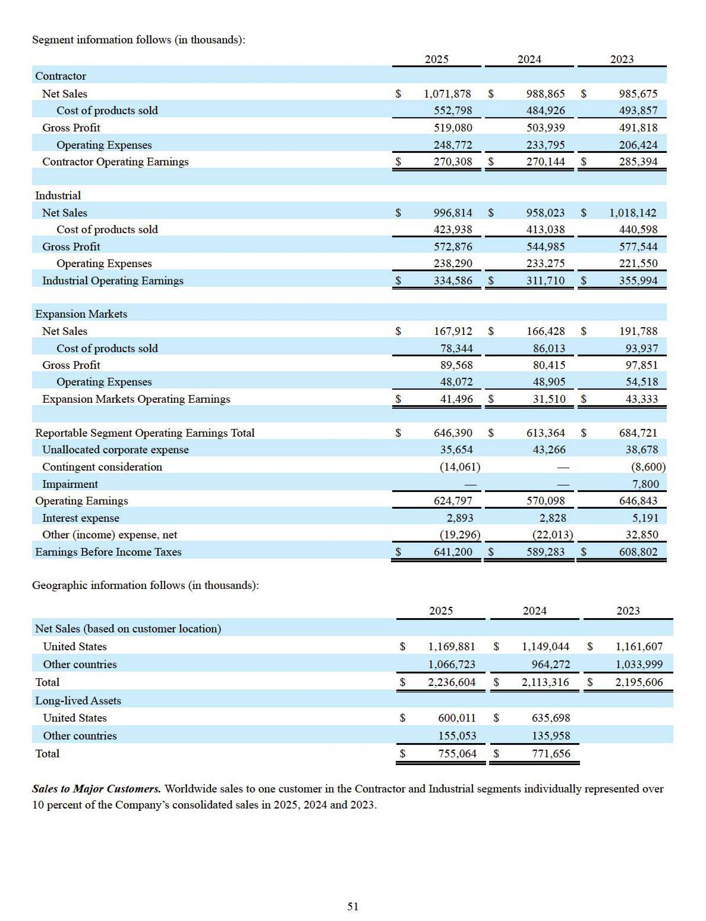

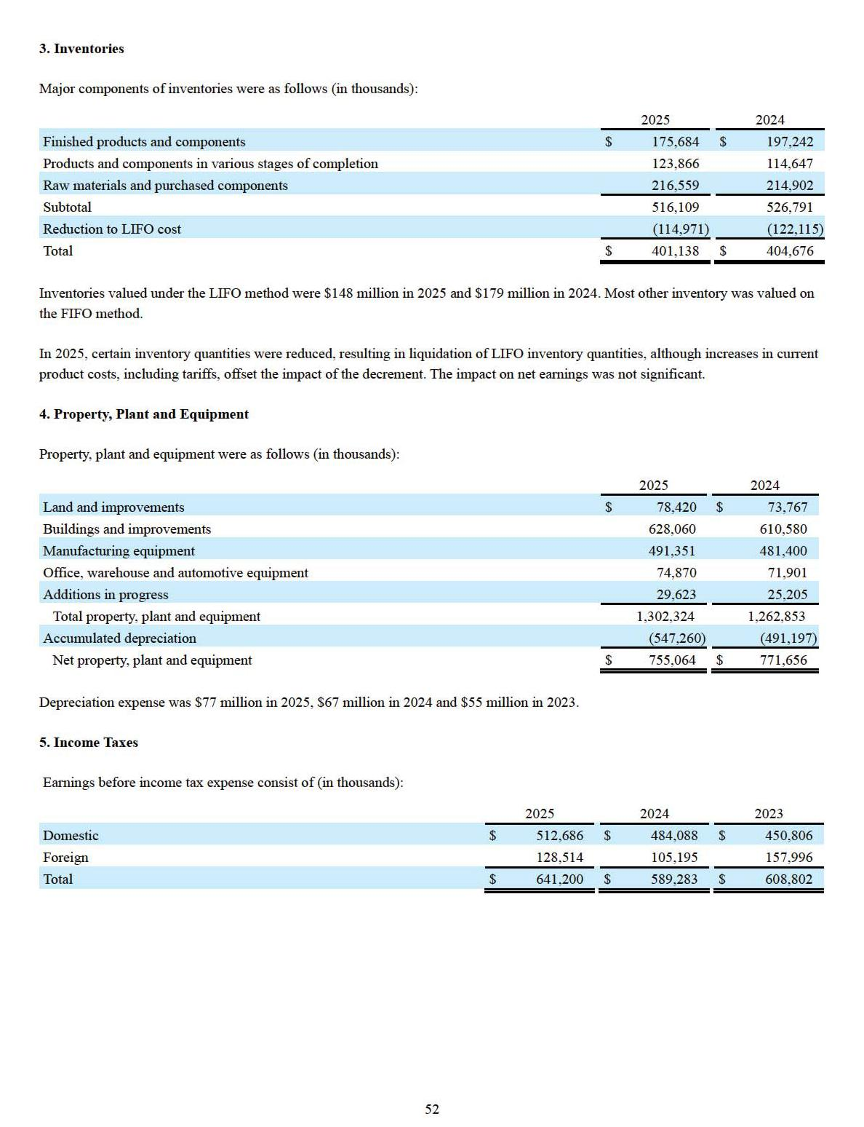

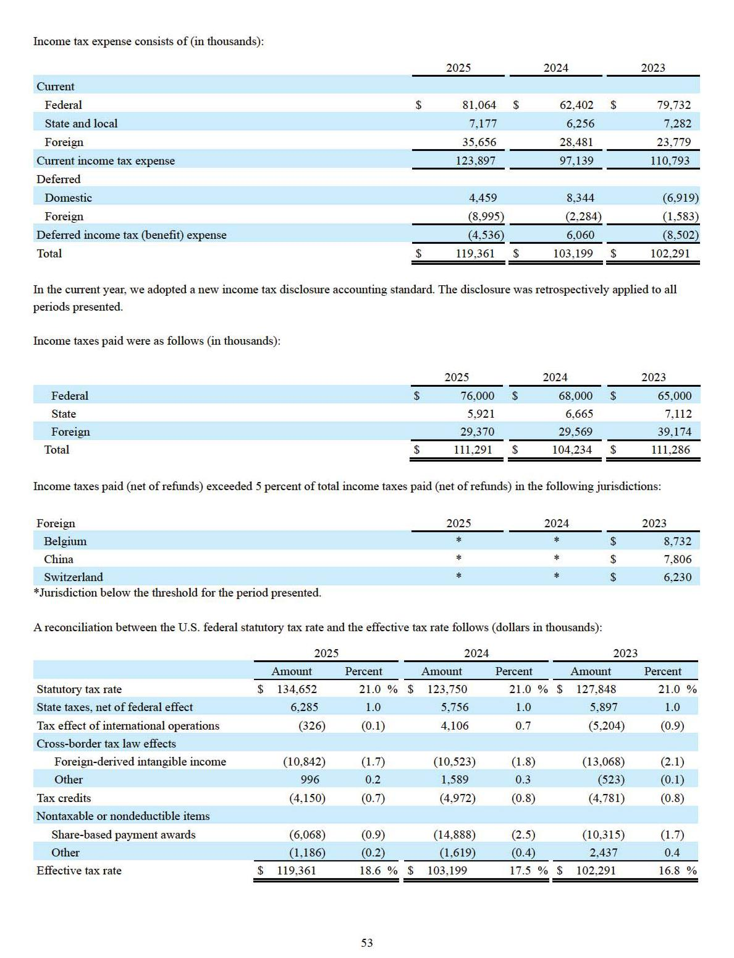

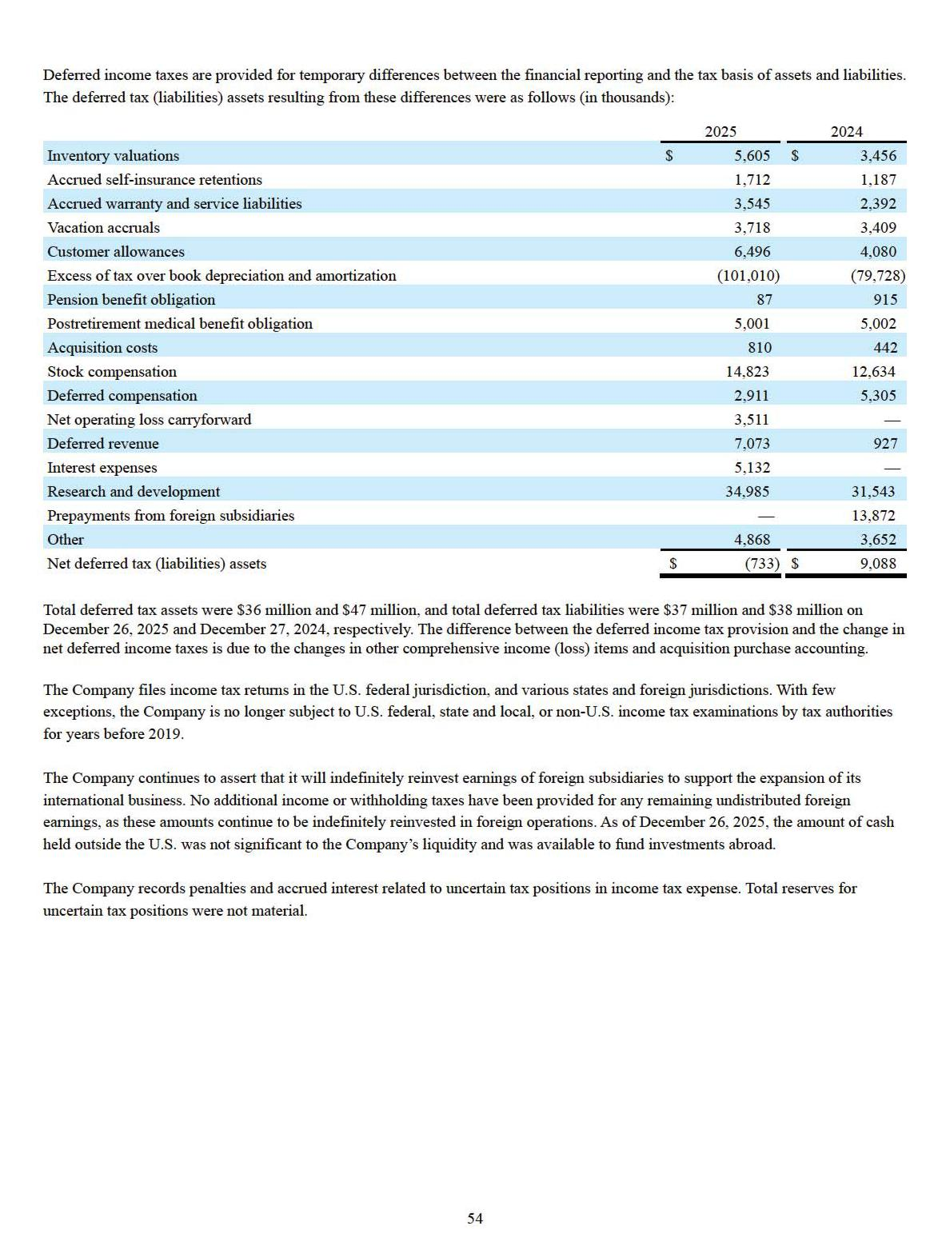

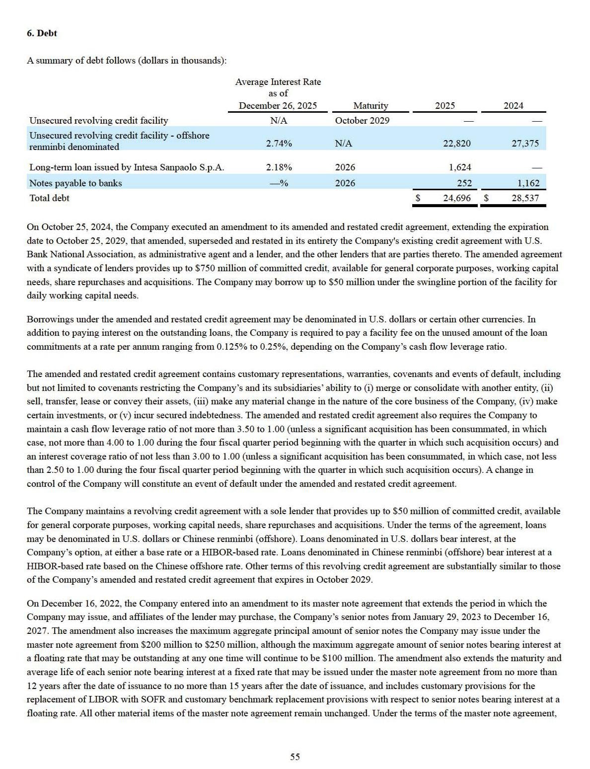

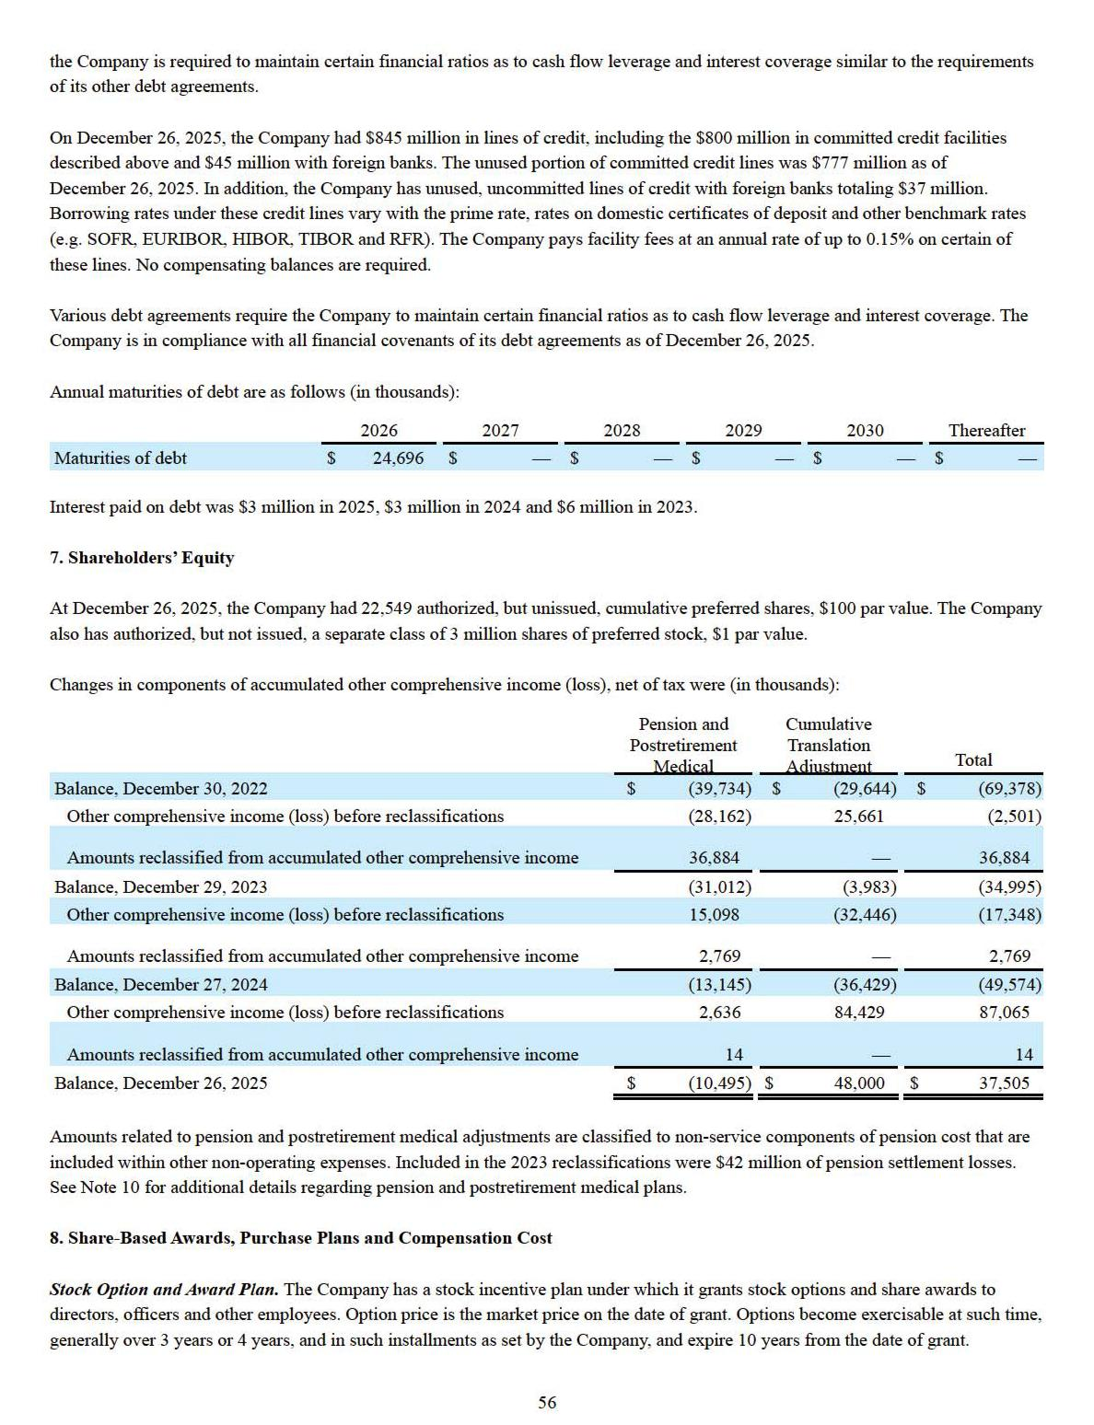

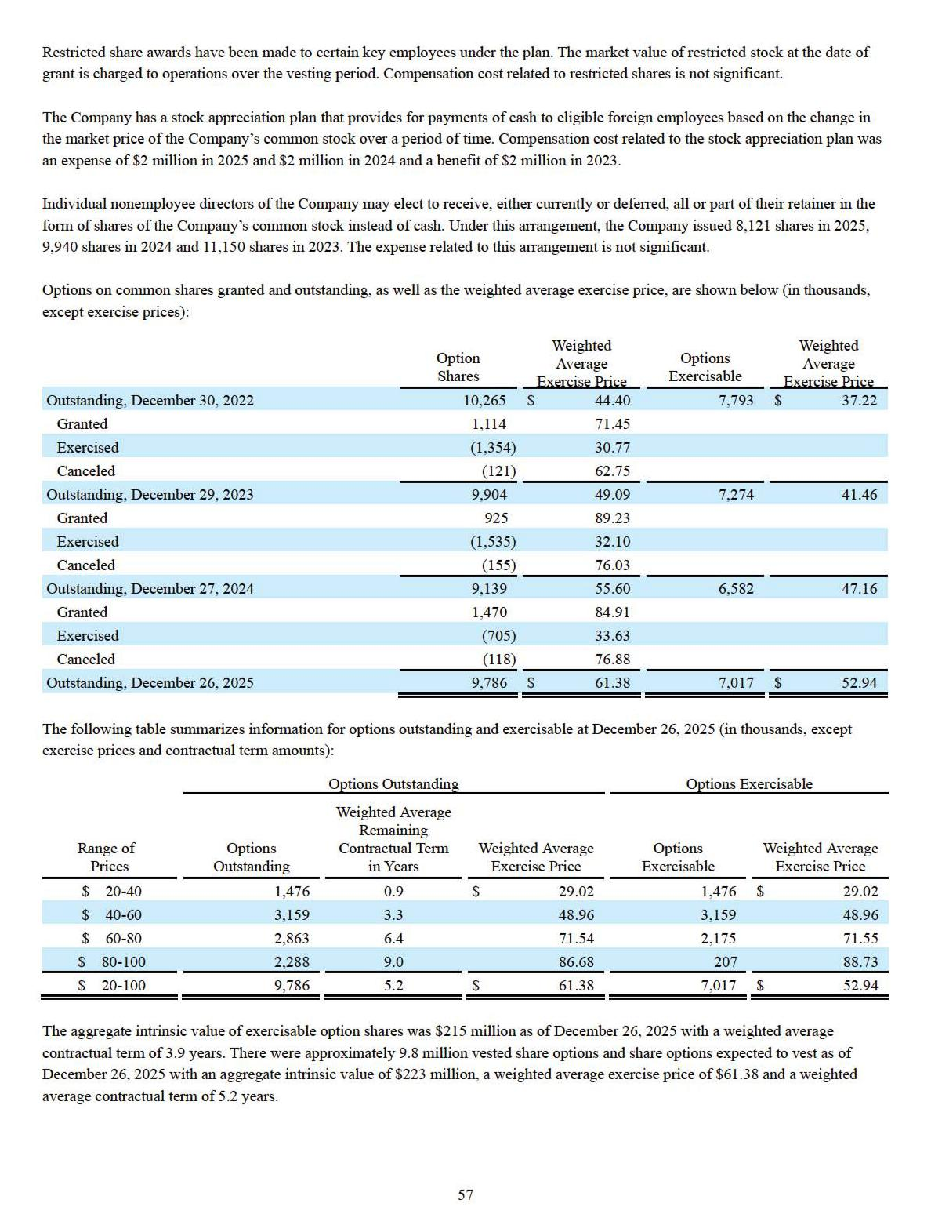

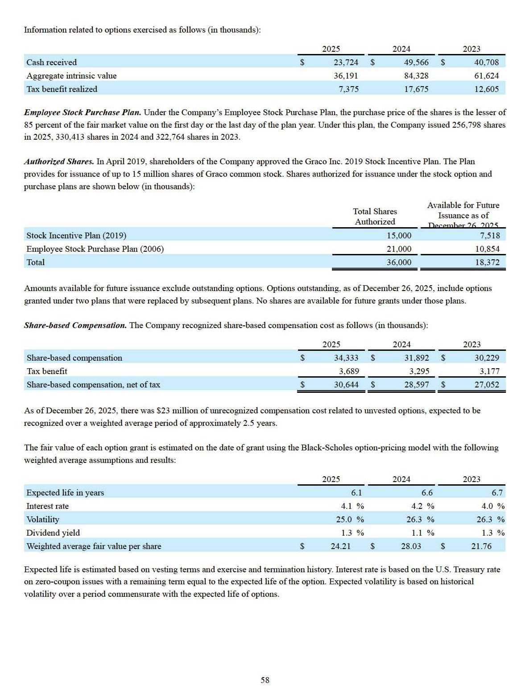

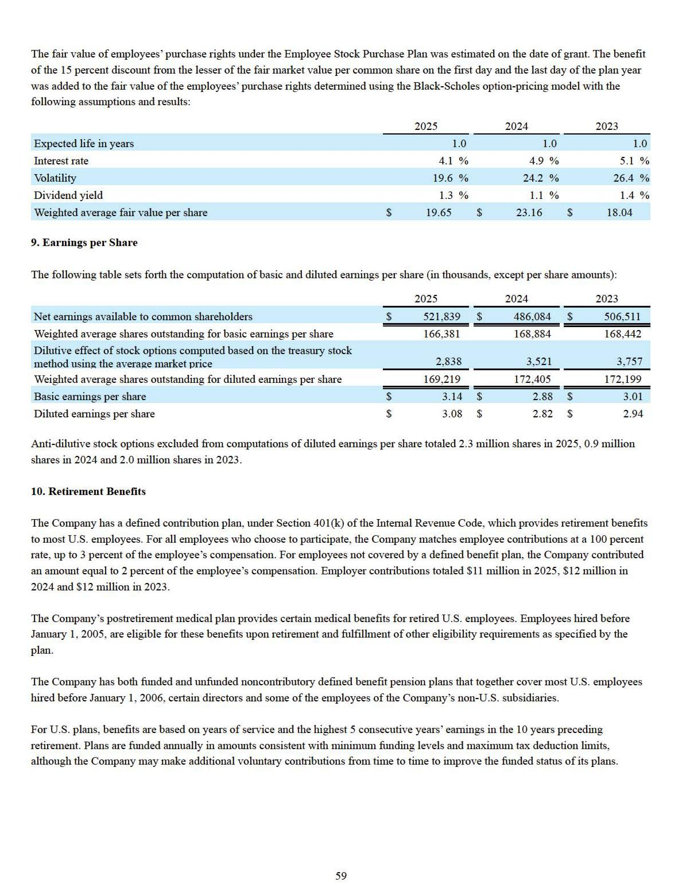

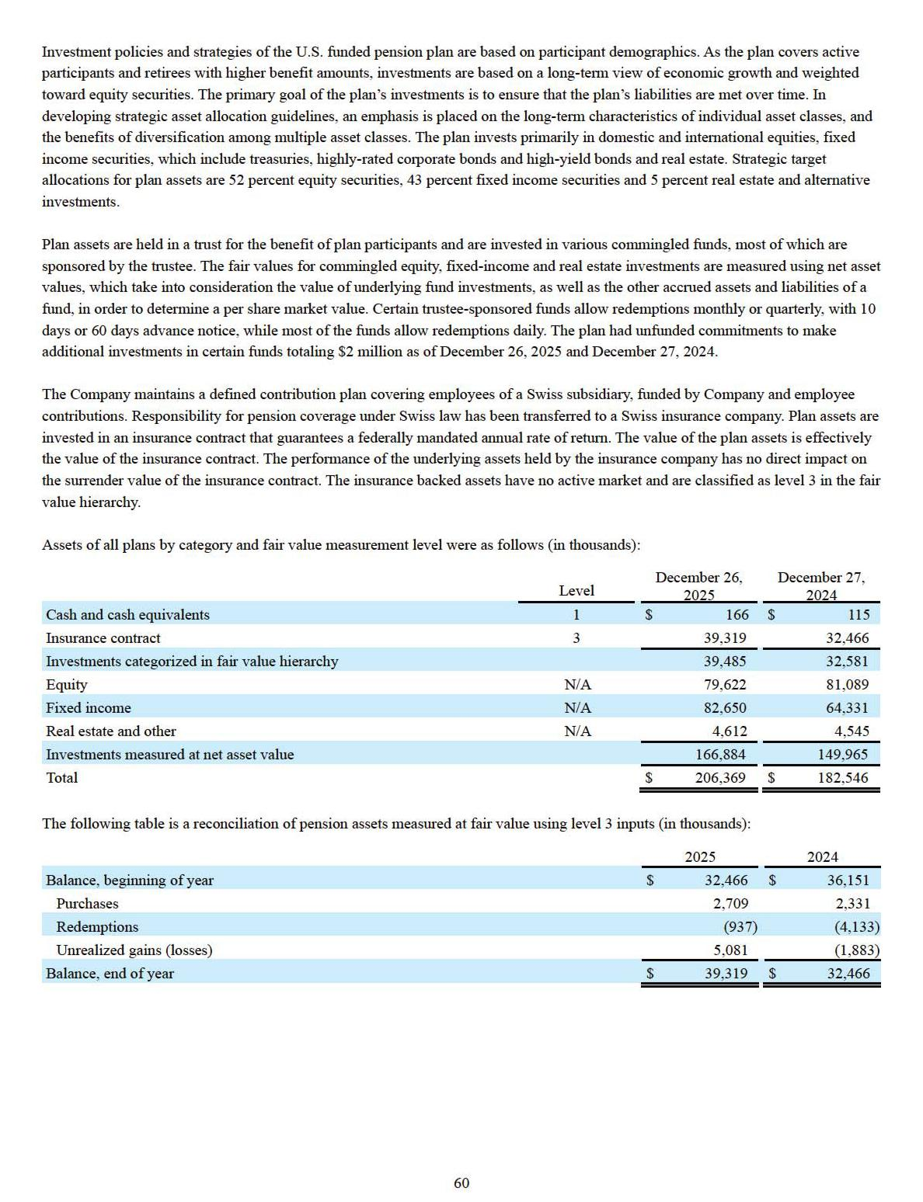

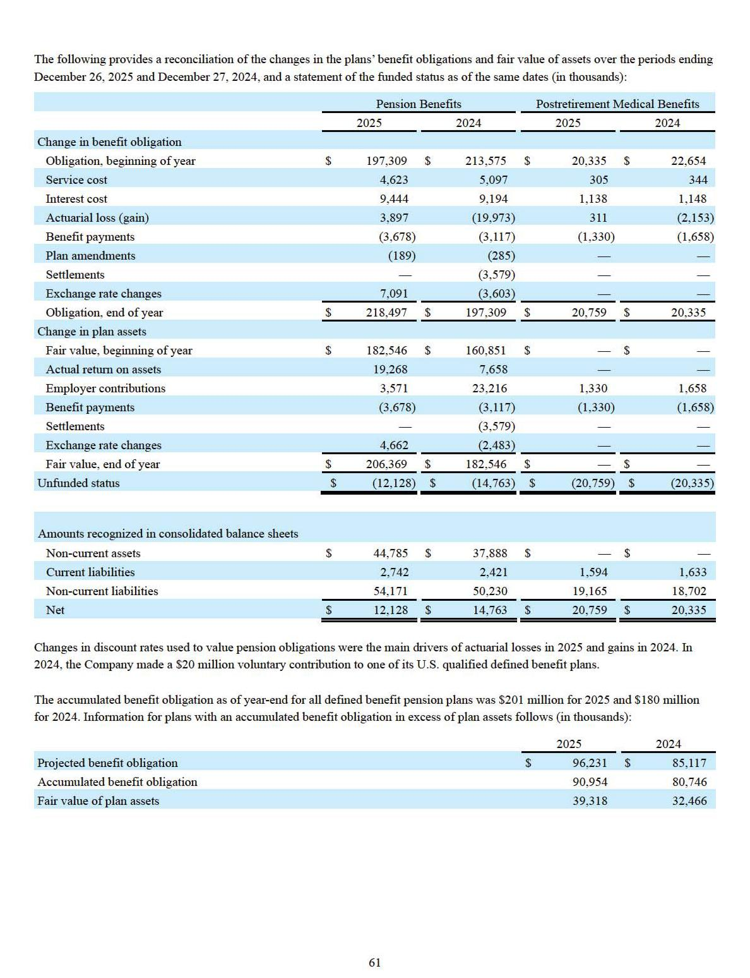

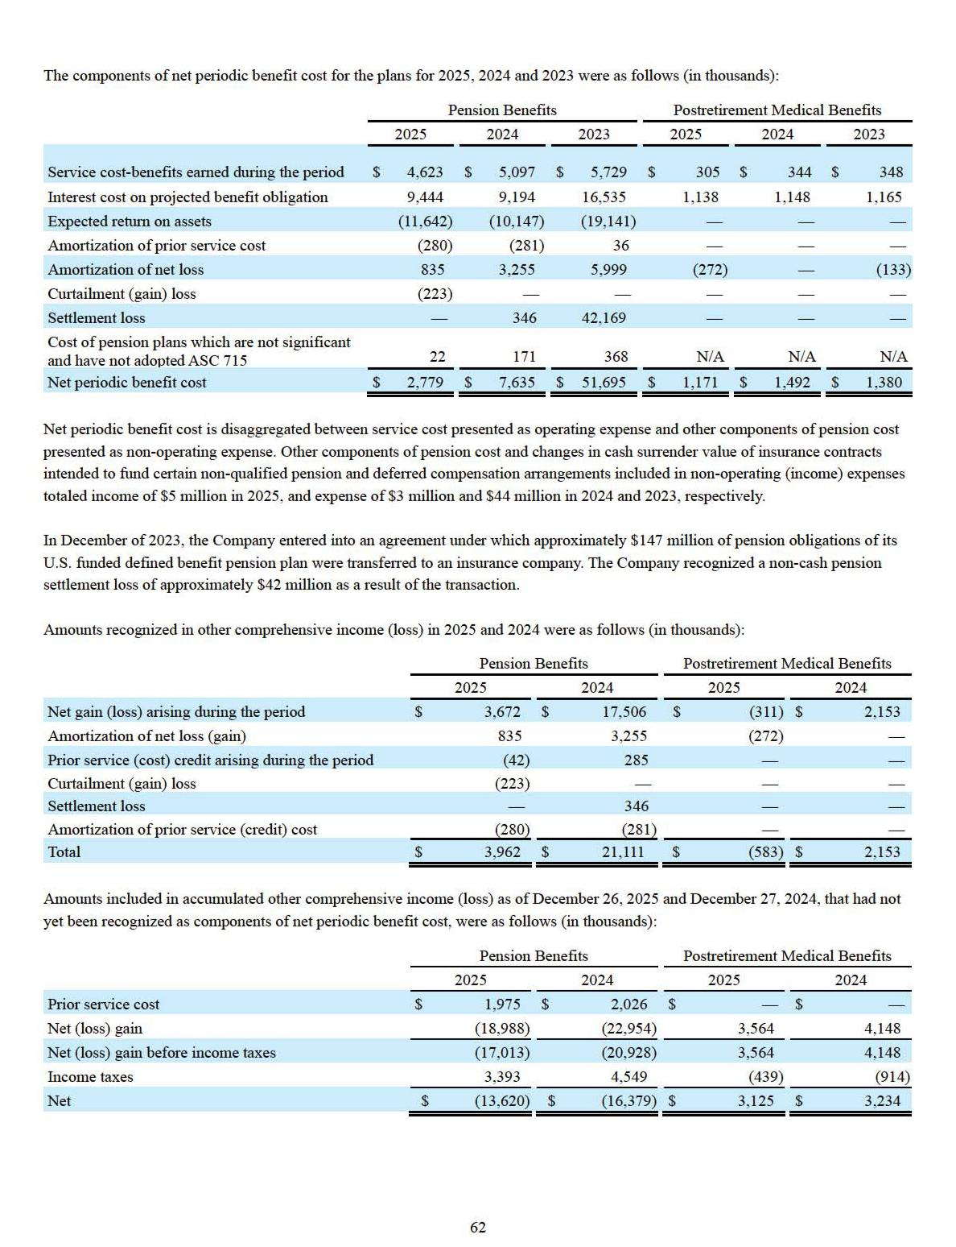

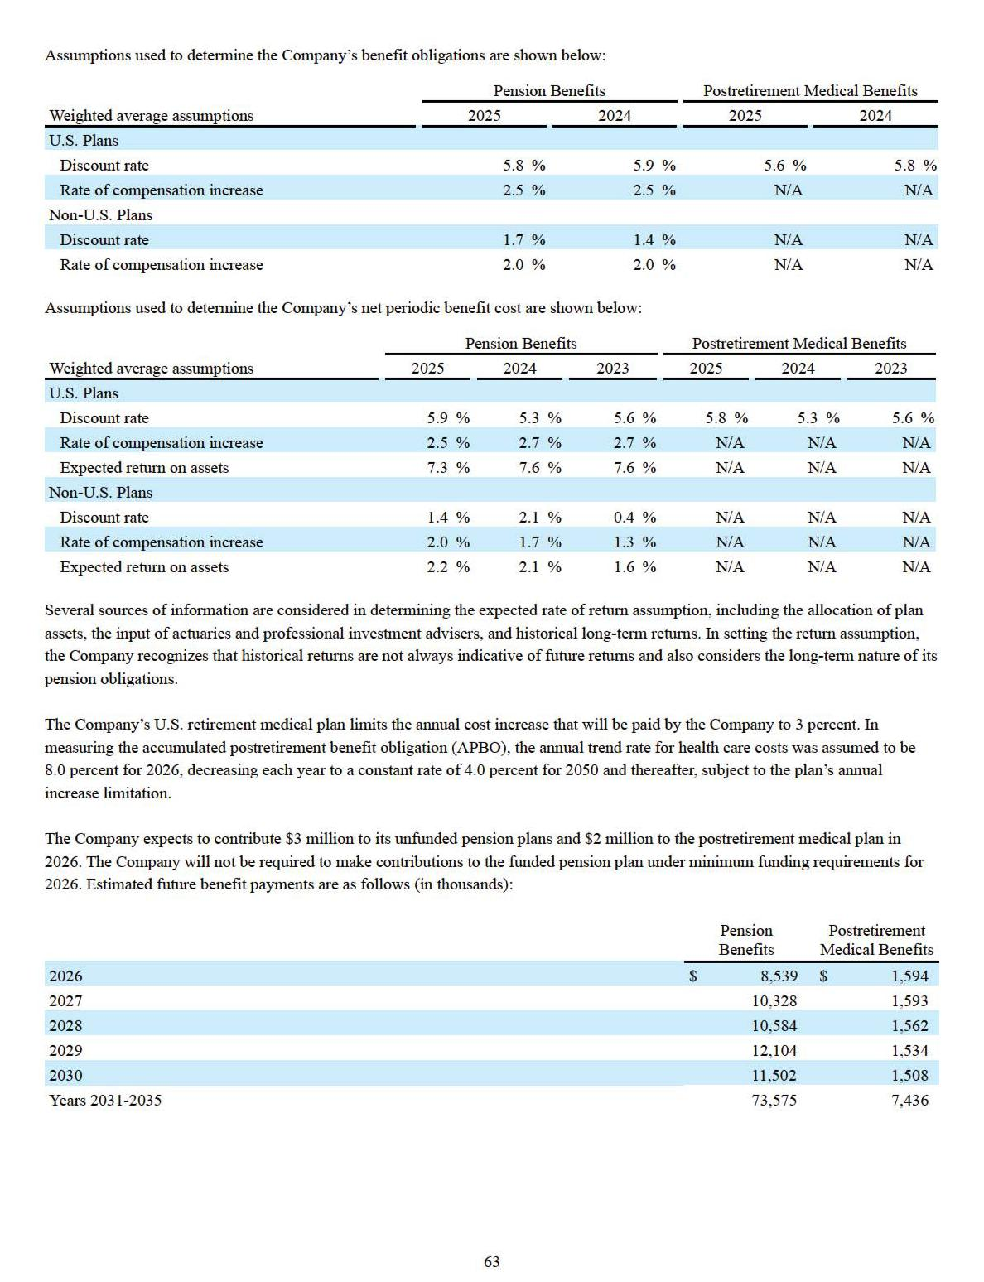

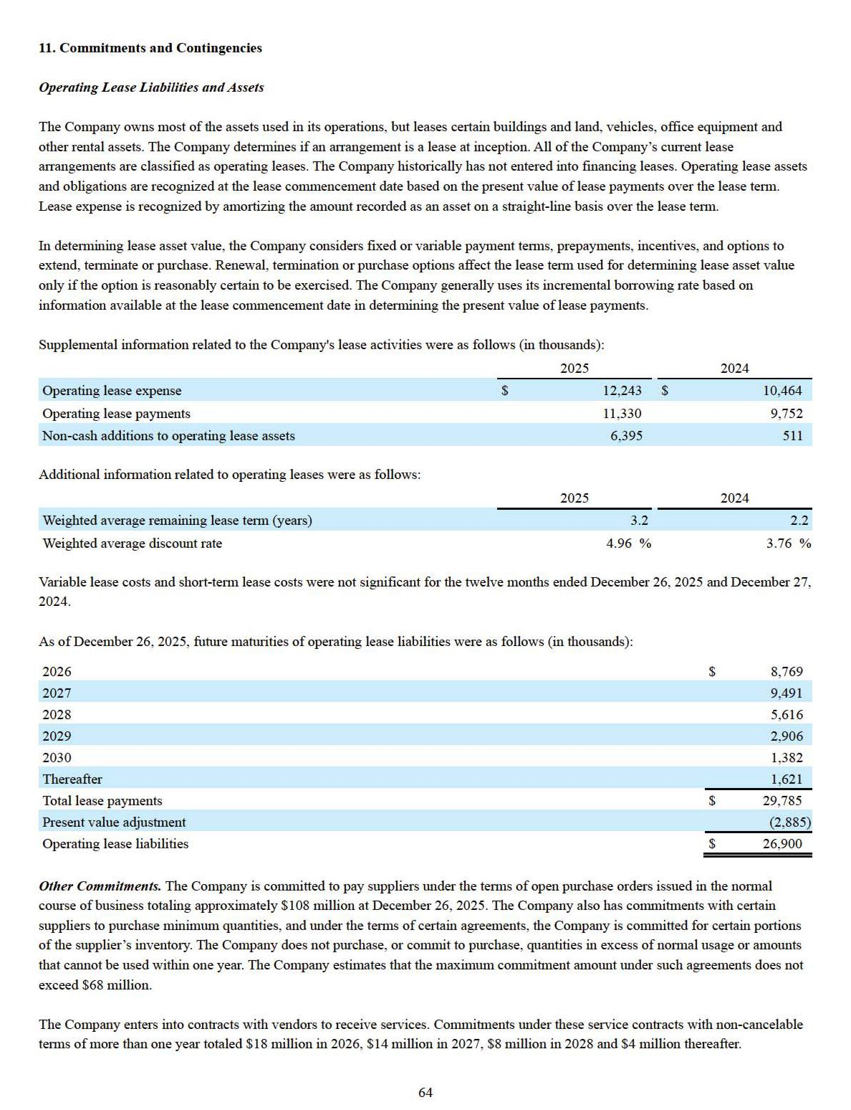

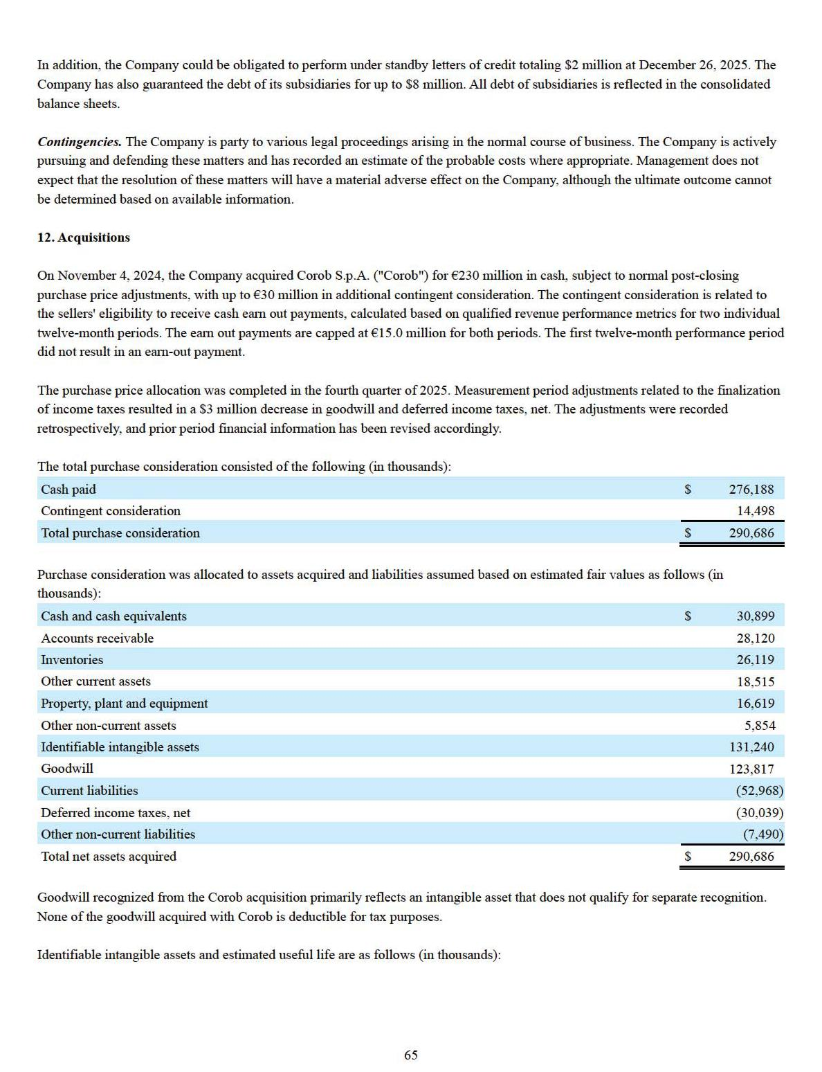

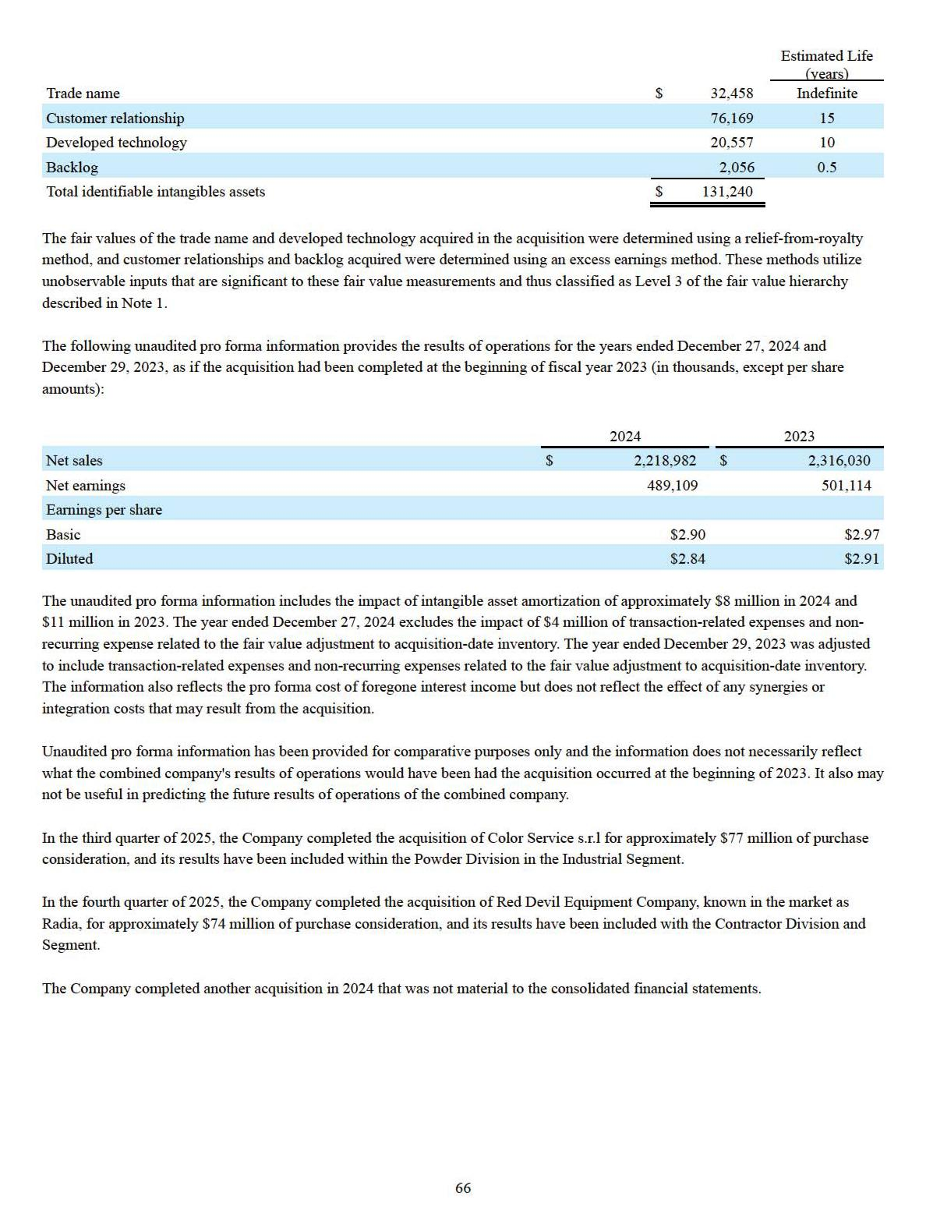

Item 9. Changes in and Disagreements With Accountants on Accounting and Financial Disclosure

None.

Item 9A. Controls and Procedures

Evaluation of Disclosure Controls and Procedures

As of the end of the fiscal year covered by this Form 10-K, the Company carried out an evaluation of the effectiveness of the design and operation of its disclosure controls and procedures (as defined in Rules 13a-15(e) and 15d-15(e)) of the Securities Exchange Act of 1934, as amended. This evaluation was done under the supervision and with the participation of the Company’s President and Chief Executive Officer and the Chief Financial Officer and Treasurer. Based upon that evaluation, the Company’s President and Chief Executive Officer and the Chief Financial Officer and Treasurer concluded that the Company’s disclosure controls and procedures are effective.

Management’s Report on Internal Control Over Financial Reporting

Management is responsible for establishing and maintaining adequate internal control over financial reporting. The internal control system was designed to provide reasonable assurance to management and the board of directors regarding the reliability of financial reporting and preparation of financial statements in accordance with generally accepted accounting principles.

Management assessed the effectiveness of the Company’s internal control over financial reporting as of December 26, 2025. In making this assessment, management used the criteria set forth by the Committee of Sponsoring Organizations of the Treadway Commission (COSO) in Internal Control-Integrated Framework (2013).

Based on our assessment and those criteria, management believes the Company’s internal control over financial reporting is effective as of December 26, 2025.

The Company’s independent auditors have issued an attestation report on the Company’s internal control over financial reporting, which is included herein.

Changes in Internal Control Over Financial Reporting

During the fourth quarter, there was no change in the Company’s internal control over financial reporting that has materially affected or is reasonably likely to materially affect the Company’s internal control over financial reporting.

REPORT OF INDEPENDENT REGISTERED PUBLIC ACCOUNTING FIRM

To the shareholders and the Board of Directors of Graco Inc.

Opinion on Internal Control over Financial Reporting

We have audited the internal control over financial reporting of Graco Inc. and subsidiaries (the “Company”) as of December 26, 2025, based on criteria established in Internal Control — Integrated Framework (2013) issued by the Committee of Sponsoring Organizations of the Treadway Commission (COSO). In our opinion, the Company maintained, in all material respects, effective internal control over financial reporting as of December 26, 2025, based on criteria established in Internal Control — Integrated Framework (2013) issued by COSO.

We have also audited, in accordance with the standards of the Public Company Accounting Oversight Board (United States) (PCAOB), the consolidated financial statements as of and for the year ended December 26, 2025, of the Company and our report dated February 17, 2026, expressed an unqualified opinion on those financial statements.

67

Basis for Opinion

The Company’s management is responsible for maintaining effective internal control over financial reporting and for its assessment of the effectiveness of internal control over financial reporting, included in the accompanying Management's Report on Internal Control Over Financial Reporting. Our responsibility is to express an opinion on the Company’s internal control over financial reporting based on our audit. We are a public accounting firm registered with the PCAOB and are required to be independent with respect to the Company in accordance with the U.S. federal securities laws and the applicable rules and regulations of the Securities and Exchange Commission and the PCAOB.

We conducted our audit in accordance with the standards of the PCAOB. Those standards require that we plan and perform the audit to obtain reasonable assurance about whether effective internal control over financial reporting was maintained in all material respects. Our audit included obtaining an understanding of internal control over financial reporting, assessing the risk that a material weakness exists, testing and evaluating the design and operating effectiveness of internal control based on the assessed risk, and performing such other procedures as we considered necessary in the circumstances. We believe that our audit provides a reasonable basis for our opinion.

Definition and Limitations of Internal Control over Financial Reporting

A company’s internal control over financial reporting is a process designed to provide reasonable assurance regarding the reliability of financial reporting and the preparation of financial statements for external purposes in accordance with generally accepted accounting principles. A company’s internal control over financial reporting includes those policies and procedures that (1) pertain to the maintenance of records that, in reasonable detail, accurately and fairly reflect the transactions and dispositions of the assets of the company; (2) provide reasonable assurance that transactions are recorded as necessary to permit preparation of financial statements in accordance with generally accepted accounting principles, and that receipts and expenditures of the company are being made only in accordance with authorizations of management and directors of the company; and (3) provide reasonable assurance regarding prevention or timely detection of unauthorized acquisition, use, or disposition of the company’s assets that could have a material effect on the financial statements.

Because of its inherent limitations, internal control over financial reporting may not prevent or detect misstatements. Also, projections of any evaluation of effectiveness to future periods are subject to the risk that controls may become inadequate because of changes in conditions, or that the degree of compliance with the policies or procedures may deteriorate.

/s/ DELOITTE & TOUCHE LLP

Minneapolis, Minnesota

February 17, 2026

Item 9B. Other Information

During the three months ended December 26, 2025, none of the Company’s directors or officers (as defined in Rule 16a-1(f) of the Securities Exchange Act of 1934) adopted, terminated or modified a Rule 10b5-1 trading arrangement or non-Rule 10b5-1 trading arrangement (as such terms are defined in Item 408 of Regulation S-K of the Securities Act of 1933).

Item 9C. Disclosure Regarding Foreign Jurisdictions that Prevent Inspections

Not applicable.

68

PART III

Item 10. Directors, Executive Officers and Corporate Governance

The information under the heading “Information About Our Executive Officers” in Part I of this Form 10-K and the information under the heading “Board of Directors” in our Company’s Proxy Statement for its 2026 Annual Meeting of Shareholders to be held on April 24, 2026 (the “Proxy Statement”), is incorporated herein by reference.

Audit Committee Members and Audit Committee Financial Expert

The information under the heading “Committees of the Board of Directors” in our Company’s Proxy Statement is incorporated herein by reference.

Corporate Governance Guidelines, Committee Charters and Code of Ethics

Our Company has adopted Corporate Governance Guidelines and Charters for each of the Audit, Governance, and Management Organization and Compensation Committees of the Board of Directors. We have also issued a Code of Ethics and Business Conduct (“Code of Ethics”) that applies to our principal executive officer, principal financial officer, principal accounting officer, all officers, directors, and employees of Graco Inc. and all of its subsidiaries, representative offices and branches worldwide. The Corporate Governance Guidelines, Committee Charters, and Code of Ethics, with any amendments or waivers thereto, may be accessed free of charge by visiting the Graco website at www.graco.com.

Our Company intends to post on the Graco website any amendment to, or waiver from, a provision of the Code of Ethics that applies to our principal executive officer, principal financial officer, principal accounting officer, controller and other persons performing similar functions within four business days following the date of such amendment or waiver.

Insider Trading Arrangements and Policies

The information under the heading “Corporate Governance Documents—Insider Trading Policy and Procedures and Prohibition on Hedging and Pledging” in our Company’s Proxy Statement is incorporated herein by reference.

Item 11. Executive Compensation

The information contained under the headings “Director Compensation” and “Executive Compensation” (other than under the subheading "Pay Versus Performance") in the Proxy Statement is incorporated herein by reference.

Item 12. Security Ownership of Certain Beneficial Owners and Management and Related Stockholder Matters

The information contained under the headings “Equity Compensation Plan Information” and “Beneficial Ownership of Shares” in the Proxy Statement is incorporated herein by reference.

Item 13. Certain Relationships and Related Transactions, and Director Independence

The information under the headings “Related Person Transaction Approval Policy,” “Director Independence” and "Committees of the Board of Directors" in the Proxy Statement is incorporated herein by reference.

Item 14. Principal Accountant Fees and Services

The information under the headings “Independent Registered Public Accounting Firm Fees and Services” and “Pre-Approval Policies” in the Proxy Statement is incorporated herein by reference.

69

PART IV

Item 15. Exhibits and Financial Statement Schedules

- The following documents are filed as part of this report:

Page

(1) Financial Statements 39

- Financial Statement Schedule

All financial statement schedules are omitted as the required information is inapplicable or the information is presented in the consolidated financial statements or related notes.

(3) Management Contract, Compensatory Plan or Arrangement. (See Exhibit Index) 71 Those entries marked by an asterisk are Management Contracts, Compensatory Plans or Arrangements.

70

Exhibit Index

Exhibit
^{Number} Description

3.1 Restated Articles of Incorporation as amended December 8, 2017. (Incorporated by reference to Exhibit 3.1 to the Company’s Report on Form 8-K filed December 8, 2017.)

3.2 Restated Bylaws as amended February 17, 2023. (Incorporated by reference to Exhibit 3.2 to the Company’s 2024 Annual Report on Form 10-K.)

4.1 Description of Our Securities. (Incorporated by reference to Exhibit 4.1 to the Company’s 2019 Annual Report on Form 10-K.)

*10.1 Graco Inc. Incentive Bonus Plan. (Incorporated by reference to Exhibit 10.1 to the Company's Report on Form 8-K filed September 19, 2019.)

*10.2 Graco Inc. 2015 Stock Incentive Plan. (Incorporated by reference to Appendix A to the Company’s Definitive Proxy Statement on Schedule 14A filed March 11, 2015.)

*10.3 Graco Inc. Amended and Restated 2019 Stock Incentive Plan. (Incorporated by reference to Appendix A to the Company’s Definitive Proxy Statement on Schedule 14A filed March 13, 2024.)

*10.4 Deferred Compensation Plan (2005 Statement) as amended and restated on April 4, 2005. (Incorporated by reference to Exhibit 10.1 of the Company’s Report on Form 10- Q for the thirteen weeks ended July 1, 2005.) Second Amendment dated November 1, 2005. (Incorporated by reference to Exhibit 10.8 to the Company’s 2005 Annual Report on Form 10-K.) Third Amendment adopted on December 29, 2008. (Incorporated by reference to Exhibit 10.8 to the Company’s 2008 Annual Report on Form 10-K.) Second Amendment dated October 25, 2012. (Incorporated by reference to Exhibit 10.9 to the Company’s 2012 Annual Report on Form 10-K.)

*10.5 Graco Restoration Plan (2005 Statement). (Incorporated by reference to Exhibit 10.1 to the Company’s Report on Form 10-Q for the thirteen weeks ended September 29, 2006.) First Amendment adopted December 8, 2006. (Incorporated by reference to Exhibit 10.12 to the Company’s 2006 Annual Report on Form 10-K.) Second Amendment adopted August 15, 2007. (Incorporated by reference to Exhibit 10.1 to the Company’s Report on Form 10-Q for the thirteen weeks ended September 28, 2007.) Third Amendment adopted March 27, 2008. (Incorporated by reference to Exhibit 10.1 to the Company’s Report on Form 10-Q for the thirteen weeks ended March 28, 2008.) Fourth Amendment adopted December 29, 2008. (Incorporated by reference to Exhibit 10.11 to the Company’s 2008 Annual Report on Form 10-K.) Fifth Amendment adopted September 16, 2010. (Incorporated by reference to Exhibit 10.1 to the Company’s Report on Form 10-Q for the thirteen weeks ended September 24, 2010.) Sixth Amendment adopted February 15, 2018 (Incorporated by reference to Exhibit 10.7 to the Company’s 2017 Annual Report on Form 10- K.) Seventh Amendment adopted December 6, 2018. (Incorporated by reference to Exhibit 10.6 to the Company’s 2018 Annual Report on Form 10-K.)

*10.6 Graco Inc. Retirement Plan for Non -Employee Directors. (Incorporated by reference to Exhibit 10.7 to the Company’s 2018 Annual Report on Form 10-K.) (Initially filed by the Company in paper form as Attachment C to Item 5 to the Company’s Report on Form 10-Q for the thirteen weeks ended March 29, 1991.) First Amendment adopted on December 29, 2008. (Incorporated by reference to Exhibit 10.10 to the Company’s 2008 Annual Report on Form 10-K.)

*10.7 Stock Option Agreement. Form of agreement used for award of non-incentive stock options to nonemployee directors under the Graco Inc. 2015 Stock Incentive Plan commencing in 2016. (Incorporated by reference to Exhibit 10.1 to the Company’s Report on Form 10-Q for the thirteen weeks ended June 24, 2016.)

*10.8 Stock Option Agreement. Form of agreement used for award of non-incentive stock options to executive officers under the Graco Inc. 2015 Stock Incentive Plan commencing in 2016. (Incorporated by reference to Exhibit 10.2 to the Company’s Report on Form 10-Q for the thirteen weeks ended March 25, 2016.)

*10.9 Stock Option Agreement. Form of agreement used for award of non-incentive stock options to Chief Executive Officer under the Graco Inc. 2015 Stock Incentive Plan commencing in 2016. (Incorporated by reference to Exhibit 10.1 to the Company’s Report on Form 10-Q for the thirteen weeks ended March 25, 2016.)

*10.10 Stock Option Agreement. Form of agreement used for award of non-incentive stock options to nonemployee directors under the Graco Inc. 2019 Stock Incentive Plan commencing in 2019. (Incorporated by reference to Exhibit 10.2 to the Company’s Report on Form 10-Q for the thirteen weeks ended June 28, 2019.)

71

*10.11 Stock Option Agreement. Form of agreement used for award of non-incentive stock options to executive officers under the Graco Inc. 2019 Stock Incentive Plan commencing in 2020. (Incorporated by reference to Exhibit 10.22 to the Company’s 2019 Annual Report on Form 10-K.)

*10.12 Stock Option Agreement. Form of agreement used for award of non-incentive stock options to Chief Executive Officer under the Graco Inc. 2019 Stock Incentive Plan commencing in 2020. (Incorporated by reference to Exhibit 10.21 to the Company’s 2019 Annual Report on Form 10-K.)

*10.13 Stock Option Agreement. Form of agreement used for award of non-incentive stock options to nonemployee directors under the Graco Inc. 2019 Stock Incentive Plan commencing in 2025. (Incorporated by reference to Exhibit 10.16 to the Company’s 2024 Annual Report on Form 10-K.)

*10.14 Stock Option Agreement. Form of agreement used for award of non-incentive stock options to executive officers under the Graco Inc. 2019 Stock Incentive Plan commencing in 2025. (Incorporated by reference to Exhibit 10.17 to the Company’s 2024 Annual Report on Form 10-K.)

*10.15 Stock Option Agreement. Form of agreement used for award of non-incentive stock options to Chief Executive Officer under the Graco Inc. 2019 Stock Incentive Plan commencing in 2025. (Incorporated by reference to Exhibit 10.18 to the Company’s 2024 Annual Report on Form 10-K.)

*10.16 Nonemployee Director Stock and Deferred Stock Program (2019 Restatement). (Incorporated by reference to Exhibit 10.3 to the Company’s Report on Form 10-Q for the thirteen weeks ended June 28, 2019.)

*10.17 Key Employee Agreement. Form of agreement used with Chief Executive Officer and other executive officers. (Incorporated by reference to Exhibit 10.1 to the Company’s Report on Form 8-K filed April 27, 2021.) Key Employee Agreement. Form of agreement to be offered to all persons hired or promoted to be executive officers of the Company after November 30, 2023 where local legal requirements warrant a different form. (Incorporated by reference to Exhibit 10.18 to the Company's 2023 Annual Report on Form 10-K).

*10.18 Executive Group Long-Term Disability Policy as revised in 1995. (Incorporated by reference to Exhibit 10.23 to the Company’s 2004 Annual Report on Form 10-K.) Enhanced by Supplemental Income Protection Plan in 2004. (Incorporated by reference to Exhibit 10.28 to the Company’s 2007 Annual Report on Form 10-K.)

10.19 Amended and Restated Credit Agreement, dated March 25, 2021, among Graco Inc., the borrowing subsidiaries from time to time party thereto, the banks from time to time party thereto and U.S. Bank National Association, as administrative agent. (Incorporated by reference to Exhibit 10.1 to the Company’s Report on Form 8-K filed March 26, 2021.)

10.20 Amendment No. 1 to Amended and Restated Credit Agreement, dated May 23, 2023, among Graco Inc., the borrowing subsidiaries from time to time party thereto, the banks from time to time party thereto and U.S. Bank National Association, as administrative agent. (Incorporated by reference to Exhibit 10.1 to the Company's Report on Form 8-K filed May 23, 2023.)

10.21 Amendment No. 2 to Amended and Restated Credit Agreement, dated June 8, 2023, among Graco Inc., the borrowing subsidiaries from time to time party thereto, the banks from time to time party thereto and U.S. Bank National Association, as administrative agent. (Incorporated by reference to Exhibit 10.1 to the Company's Report on Form 8-K filed June 8, 2023.)

10.22 Amendment No. 3 to Amended and Restated Credit Agreement dated October 25, 2024, among Graco Inc., the borrowing subsidiaries from time to time party thereto, the banks from time to time party thereto and U.S. Bank National Association as administrative agent (Incorporated by reference to Exhibit 10.1 to the Company's Report on Form 8-K filed October 25. 2024.)

72

10.23 Note Agreement, dated March 11, 2011, between Graco Inc. and the Purchasers listed on the Purchaser Schedule attached thereto, which includes as exhibits the form of Senior Notes. (Incorporated by reference to Exhibit 10.1 to the Company’s Report on Form 8- K filed March 16, 2011.) Amendment No. 1 dated May 23, 2011. (Incorporated by reference to Exhibit 10.2 to the Company’s Report on Form 10-Q for the thirteen weeks ended July 1, 2011.) Amendment and Restatement No. 1 to Note Agreement dated as of March 27, 2012. (Incorporated by reference to Exhibit 10.2 to the Company’s Report on Form 8-K filed April 2, 2012.) Amendment No. 2 dated as of June 26, 2014 to Note Agreement dated as of March 11, 2011. (Incorporated by reference to Exhibit 10.1 to the Company’s Report on Form 10-Q for the thirteen weeks ended June 27, 2014.) Amendment No. 3 dated as of December 15, 2016 to Note Agreement dated as of March 11, 2011. (Incorporated by reference to Exhibit 10.28 to the Company’s 2016 Annual Report on Form 10-K.) Amendment No. 4 dated May 23, 2017 to Note Agreement dated as of March 11, 2011. (Incorporated by reference to Exhibit 10.1 to the Company’s 10-Q for the thirteen weeks ended June 30, 2017.) Amendment No. 5 dated April 17, 2020 to Note Agreement dated as of March 11, 2011. (Incorporated by reference to Exhibit 10.4 to the Company’s 10-Q for the thirteen weeks ended March 27, 2020.)

10.24 Master Note Agreement, dated January 29, 2020, between Graco Inc. and NYL Investors LLC. (Incorporated by reference to Exhibit 10.1 to the Company’s Report on Form 8-K filed February 3, 2020.) First Amendment to Master Note Agreement, dated December 16, 2022. (Incorporated by reference to Exhibit 10.1 to the Company’s Report on Form 8-K filed December 16, 2022.)

11 Statement of Computation of Earnings per share included in Note 9 on page 59

- Insider Trading Policy Insider Trading Policy. (Incorporated by reference to Exhibit 19 to the Company’s 2024 Annual Report on Form 10-K.)

21 Subsidiaries of the Company

- Independent Registered Public Accounting Firm’s Consent

- Power of Attorney

31.1 Certification of President and Chief Executive Officer pursuant to Rule 13a-14(a)

31.2 Certification of Chief Financial Officer pursuant to Rule 13a-14(a)

- Certification of President and Chief Executive Officer and Chief Financial Officer pursuant to Section 1350 of Title 18, U.S.C.

- Graco Inc. Incentive Recovery Policy (Incorporated by Reference to the Company's 2023 Annual Report on Form 10-K.)

- Interactive data files pursuant to Rule 405 of Regulation S-T formatted in iXBRL (Inline eXtensible Business Reporting Language).

  - Cover Page Interactive Data File (formatted as iXBRL and contained in Exhibit 101).

- Management Contracts, Compensatory Plans or Arrangements.

Pursuant to Item 601(b)(4)(iii) of Regulation S-K, copies of certain instruments defining the rights of holders of certain long-term debt of the Company and its subsidiaries are not filed as exhibits because the amount of debt authorized under any such instrument does not exceed 10 percent of the total assets of the Company and its subsidiaries. The Company agrees to furnish copies thereof to the Securities and Exchange Commission upon request.

Item 16. Form 10-K Summary

None.

73

Signatures

Pursuant to the requirements of Section 13 or 15(d) of the Securities Exchange Act of 1934, the Registrant has duly caused this report to be signed on its behalf by the undersigned, thereunto duly authorized.

Graco Inc.
/s/ Mark W. Sheahan |  | February 17, 2026
Mark W. Sheahan
President and Chief Executive Officer

Pursuant to the requirements of the Securities Exchange Act of 1934, this report has been signed by the following persons on behalf of the Registrant and in the capacities and on the dates indicated.

/s/ Mark W. Sheahan February 17, 2026

Mark W. Sheahan

President and Chief Executive Officer

(Principal Executive Officer)

/s/ David M. Lowe February 17, 2026

David M. Lowe

Chief Financial Officer and Treasurer

(Principal Financial Officer)

/s/ Christopher D. Knutson February 17, 2026

Christopher D. Knutson

Vice President, Controller & Chief Accounting Officer

(Principal Accounting Officer)

J. Kevin Gilligan Heather L. Anfang Archie C. Black Eric P. Etchart Jody H. Feragen Martha A. Morfitt Mark W. Sheahan Andrea H. Simon Kevin J. Wheeler

Director, Chairman of the Board

Director

Director

Director

Director

Director

Director

Director

Director

Mark W. Sheahan, by signing his name hereto, does hereby sign this document on behalf of himself and each of the above named directors of the Registrant pursuant to powers of attorney duly executed by such persons.
/s/ Mark W. Sheahan |  | February 17, 2026
Mark W. Sheahan
(For himself and as attorney-in-fact)

74



g r a c o . c o m


